**V3.1**

**HTTP methods, status codes and response types**

**Introduction**

You already know that HTTP methods and status codes play an essential role in REST APIs. It is important to keep to the conventions for HTTP methods and status codes for two reasons. Firstly, if you follow conventions from the developing phase, it will be much easier to avoid bugs in your code and deploy the final project on the production server. Secondly, it makes it easier for other developers to use your APIs. This reading highlights the most important HTTP methods, status codes and API response types that you will use when working on API projects.

**HTTP methods**

In the world of REST APIs, one endpoint can perform multiple tasks. It can deliver a resource, create a new resource, update or delete it. The endpoint remains the same while the action varies. When a client invokes an API, how does the API developer know which of the multiple actions should be performed?  This is where HTTP methods come in.

HTTP methods or request types tell the API endpoint what it should do with the resources. It defines the action. The API developer makes decisions and manipulates resources appropriately based on the HTTP methods in an HTTP request. Here is a list of the most used HTTP methods and which action you should initiate for those calls.

| **HTTP method** | **Action** |
| --- | --- |
| **GET** | Returns the requested resource. If not found, returns a **404 Not Found** status code. |
| **POST** | Creates a record. The **POST** request always comes with an HTTP request body containing JSON or Form URL encoded data, which is also called a payload. If the data is valid, the API endpoint will create a new resource based on these data. Although you can create multiple resources with a single **POST** call, it is not considered a best practice to do so. |
| **PUT** | Instructs the API to replace a resource. Like a **POST** request, the **PUT** request also comes with data. A **PUT** request usually supplies all data for a particular resource so that the API developer can fully replace that resource with the provided data. A **PUT** request deals with a single resource. |
| **PATCH** | Tells the API to update a part of the resource. Note the difference between a **PUT** and a **PATCH** call. A **PUT** call replaces the complete resource, while the **PATCH** call only updates some parts. A **PATCH** request also deals with a single record. |
| **DELETE** | Instructs the API to delete a resource. |

**Example calls**

| **HTTP method** | **Sample endpoints** | **Query string / payload** |
| --- | --- | --- |
| **GET** | **/api/menu-items**  **/api/meu-items/1**  **/api/menu-items?category=appetizers**  **/api/menu-items?perpage=3&page=2** | A **GET** call doesn’t need a payload. However, **GET** calls can be accompanied by query string parameters and their values to filter the API output. |
| **POST** | **/api/menu-items**  **/api/orders** | Here’s a sample JSON payload for the **/api/menu-items** endpoint to create a new resource:  **{**  **"title":"Beef Steak",**  **"price": 5.50,**  **"category":"main",**  **}** |
| **PUT** | **/api/menu-items/1**  **/api/orders/1** | Here's a sample JSON payload for this endpoint **/api/menu-items/1** to completely replace it. Note that you need to supply all data for a **PUT** request.  **{**  **"title":"Chicken Steak",**  **"price": 2.50,**  **"category":"main",**  **}** |
| **PATCH** | **/api/menu-items/1**  **/api/orders/1** | Here’s a sample JSON payload for this endpoint **/api/menu-items/1** to partially update this resource  **{**  **"price": 3.00**  **}** |
| **DELETE** | **/api/menu-items**  **/api/menu-items/1**  **/api/orders**  **/api/orders/1** | When the **DELETE** call is sent to a collection endpoint, like **/api/menu-items** the API developer should delete the entire collection. When it is sent to a particular resource, like this, **/api/menu-items/1**, then the API developer should delete only that resource. |

**Status codes**

Sending appropriate status codes with every API response is essential. And as a developer, you should not just pick any code. Every status code has meaning, so you should choose the most appropriate one based on the situation. Here’s a list of the status code ranges and their purposes.

| **Status code range** | **Purpose** |
| --- | --- |
| **100-199** | This range is mainly used to pass on some information. For example, sometimes an API needs time to process the request and it can’t instantly deliver the result. In such a case, the API developer can set it to keep returning **102 – Processing** until the result is ready. This way, the client understands that the result isn’t ready and should be checked again. |
| **200-299** | These are the success codes. If the client requests something and the API acts successfully, it should deliver the output with one of these status codes.  For example, for a  **PUT**, **PATCH**, or **DELETE** call, you can return **200 – Successful** if the operation was successful. For a successful **POST** call, you can set it to return a **201 – Created** status code when the resource has been created successfully. |
| **300-399** | These are the redirection codes. Suppose as an API developer, you changed the API endpoint from **/api/items to api/menu-items**. If the client makes an API call to **/api/items**, then you can redirect the client to this new endpoint **/api/menu-items** with a **301 – Permanently moved** status code so that the client can make new calls to that endpoint next time. |
| **400-499** | 4xx status codes are used in the following situation: if the client requests something that does not exist, sends an invalid payload with insufficient data, or wants to perform an action that the client is not authorized for.  For the above scenarios, the appropriate status codes will be:  ·       **404 - Not Found** if the client requests something that doesn’t exist,  ·       **400 - Bad Request** if a client sends an invalid payload with insufficient data,  ·       **401 - Unauthorized**,  ·       **403 - Forbidden** if the client tries to perform an action it's not authorized for. |
| **500-599** | These alarming status codes are usually automatically generated on the server side if something goes wrong in the code, and the API developer doesn't write code to deal with those errors. For example, a client requests a non-existing resource, and the API developer tries to display that resource without adequately checking if that resource exists in the database. Or if the API developer didn't validate the incoming data and attempted to create a new resource with invalid or insufficient data. You, as an API developer, should always avoid 5xx errors. |

**Response types**

These days, the most common response types involved with REST APIs are JSON, XML, plain text, and sometimes YAML. Frameworks like DRF come with built-in renderer classes that can convert the data into an appropriate format and display it correctly.

There are also third-party renderers available for this job. While making an API call, the client can specify its desired response format with the **Accept** HTTP header. And that header should be considered to deliver the result in that format using the render classes. Here’s a list of HTTP headers for different response types.

| **Response type** | **Request header** |
| --- | --- |
| HTML | **Accept: text/html** |
| JSON and JSONP | **Accept: application/json** |
| XML | **Accept: application/xml**  **Accept: text/xml** |
| YAML | **Accept: application/yaml**  **Accept: application/x-yaml**  **Accept: text/yaml** |

**Conclusion**

In this reading, you learned about different types of HTTP methods, status codes, and API response types.

**V5.1**

**Good routes versus bad routes**

**Introduction**

Naming your API properly is the first step in designing a good API. When the API name follows a convention, it provides lots of information about the API and its purpose. To create a meaningful API endpoint, you need to follow some simple guidelines and rules.

In this reading, you will learn about API naming conventions and familiarize yourself with good API endpoints vs. bad API endpoints, or good and bad routes.

**Rule 01: Everything in lowercase, with hyphens and not abridged**

The URI of your API should always be in lowercase. Do not use camelCase, PascalCase or Title case when you design your API. Also, separate multiple words using hyphens, not underscores. Do not keep abridged, or shortened, words in your URI; always use the full and meaningful form.

If your API accepts a variable, you should always represent it in camelCase, and wrap it inside a set of curly braces **{}**.

Let’s examine the following examples.

| **URI** | **Status** | **Why** |
| --- | --- | --- |
| **/customers** | Good | Plural and lowercase |
| **/customers/16/phone-number** | Good | Lowercase and hyphen used to separate words |
| **/customers/16/address/home** | Good | Lowercase, no trailing slash, displays the hierarchical relationship with forward slashes. |
| **/users/{userId}** | Good | Variable in camelCase, and no hyphen in the variable name |
| **/Customers** | Bad | Title case |
| **/generalMembers** | Bad | camelCase, no hyphens to separate words |
| **/MenuItems**  **/GeneralMembers** | Bad | Pascal case |
| **/customers/16/tel-no** | Bad | Abbreviation |
| **/customers/16/phone\_number** | Bad | Underscores |
| **/customers/16/phonenumber** | Bad | No separation of words |
| **/users/{user-id}** | Bad | Variable should be in camelCase, and hyphen between words |

**Rule 02: Use a forward slash to indicate a hierarchical relationship**

In your API URI, always use the forward slash to indicate a hierarchical relationship. To understand this rule, consider the following scenarios and the relationship from the API endpoints.

A store can have customers who have placed many orders and each of these orders can have delivery addresses, menu items and bills.

| **URI** | **Status** |
| --- | --- |
| **/store/customers/{customerId}/orders** | Good |
| **/store/orders/{orderId}** | Good |
| **/store/orders/{orderId}/menu-items** | Good |

Similarly, a library can have books from many authors. Each of these books has an ISBN number.

| **URI** | **Status** |
| --- | --- |
| **/library/authors/books** | Good |
| **/library/book/{bookId}/isbn** | Good |

**Rule 03: Use nouns for resource names, not verbs**

One of the most prominent features of REST APIs is that it uses nouns to indicate resources, not verbs. And you should always stick to this rule when designing your API. You should also use plural nouns to indicate a collection.

| **URI** | **Expects** | **Status** | **Why** |
| --- | --- | --- | --- |
| **/orders** | Collection | Good | Uses a noun, not a verb |
| **/users/{userId}** | Single user | Good | Uses a noun and proper hierarchical relationship and naming convention |
| **/order** | Collection | Bad | Uses plural nouns for collections |
| **/getOrder** | Single resource | Bad | Uses a verb, camelCase |
| **/getUser/{userId}** | Single user | Bad | Uses a verb, camelCase |

**Rule 04: Avoid special characters**

You should always avoid special characters in your API endpoints. They can be confusing and technically complex for your users. Consider the following bad examples.

| **URI** | **Status** | **Why** |
| --- | --- | --- |
| **/users/12|23|23/address** | Bad | Special character | |
| **/orders/16/menu^items** | Bad | Special character ^ |

If your API can accept multiple user ids, then they should be separated using a comma, as demonstrated below.

| **URI** | **Status** | **Why** |
| --- | --- | --- |
| **/users/12,23,23/address** | Good | Uses a comma for separation |

**Rule 05: Avoid file extensions in URI**

You should always avoid file extensions in your API names. For example, if your API can deliver an output in both JSON and XML format, it should never look like this.

| **URI** | **Status** | **Why** |
| --- | --- | --- |
| **/sports/basketball/teams/{teamId}.json** | Bad | File extension at the end |
| **/sports/basketball/teams/{teamId}.xml** | Bad | File extension at the end |

Instead, your client should be able to indicate its expected format in a query string, just like this.

| **URI** | **Status** | **Why** |
| --- | --- | --- |
| **/sports/basketball/teams/{teamId}?format=json** | Good | No file extension |
| **/sports/basketball/teams/{teamId}?format=xml** | Good | No file extension |

Similarly, if your API is serving a static file, for example, CSS or JavaScript files, you should use endpoints like the following to deliver the minified and original source file. You can also use a query string to get the minified or original version. Some API developers use the output format like file extension at the end of the regular API endpoints, which is also bad practice.

| **URI** | **Status** | **Why** |
| --- | --- | --- |
| **/assets/js/jquery/3.12/min** | Good | No file extension |
| **/assets/js/jquery/3.12/source** | Good | No file extension |
| **/assets/js/jquery/3.12/?format=min** | Good | No file extension |
| **/assets/js/jquery/3.12/?format=source** | Good | No file extension |
| **/menu-items?format=json** | Good | Perfectly named endpoint with expected output format in a query string |
| **/menu-items.json** | Bad | Uses the expected output format as the file extension |

**Rule 06: Use query parameters to filter when necessary**

When designing your API, you should always perform data filtering using a query string. This is the same when you expect some extra parameters, like the number of items per page and page number.

Consider this example of a travel site. You want to find which locations a particular user has traveled to. And then you want to know which locations in the USA the user has already seen.

| **URI** | **Status** | **Why** |
| --- | --- | --- |
| **/users/{userId}/locations** | Good | Hierarchical |
| **/users/{userId}/locations?country=USA** | Good | camelCase, no separation of words |
| **/articles?per-page=10&page=2** | Good | Proper use of query string |
| **/users/{userId}/locations/USA** | Bad | Doesn't use a query string to filter data |
| **/articles/page/2/items-per-page/10** | Bad | Redundant and obscure |

**Rule 07: No trailing slash**

When sharing your API endpoint with others in your team, or in public, avoid using a trailing slash at the end of your API endpoints. Consider the following examples.

| **URI** | **Status** | **Why** |
| --- | --- | --- |
| **/users/{userId}** | Good | No trailing slash |
| **/articles/{articleId}/author** | Good | No trailing slash |
| **/users/{userId}/** | Bad | Trailing slash |
| **/articles/{articleId}/author/** | Bad | Trailing slash |

**Conclusion**

Now you understand how to create REST API endpoints with good names. Remember, a consistent naming strategy for your API is one of the most important design decisions for the whole project!

# V7.1

# Optional: Creating a Django project (steps and code)

## Introduction

This Reading will give you an overview of the steps to be taken while working with VS Code using pipenv as your virtual environment while creating a Django project. The project structure can be variable according to the learner preferences, but the one suggested can also be used for ease.

**Note:** The instructions in this reading may vary slightly from the instructions in the video about creating a Django project because the video presumes a preconfigured Pipfile.

**Note:** The commands added below are specific to MacOS. The learner will have to make OS specific changes such as using keyword **python** instead of **python3** for Windows OS.

### Step 1

Open VS Code on your computer and click on **File**. In the drop-down menu select **Open Folder** and select the folder you have created for the project.

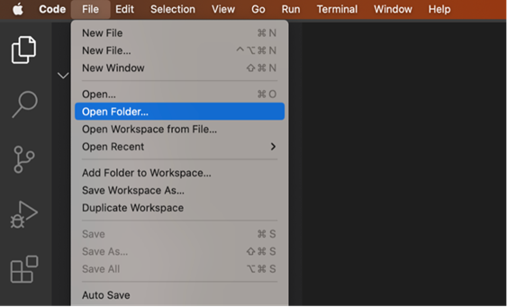

Now click on **Terminal** and select **New Terminal** from the drop-down menu. This is the main folder that contains all your files for the Django project you are going to create.

### Step 2

Create a directory for the Django project by running the following command:

**mkdir LittleLemon**

### Step 3

Step inside the LittleLemon directory with the command:

**cd LittleLemon**

### Step 4

Run the following command to create a project in this directory:

**django-admin startproject BookList .**

### Step 5

Run a command to activate **pipenv**:

**pipenv shell**

**Note:** It is expected that pipenv is installed using pip in your local machine.

### Step 6

Open the file labeled **Pipfile** that was created inside the project directory. This file contains details of the dependencies for the project. Update it with the following code and save the file.

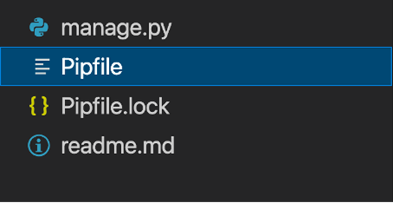

[[source]]

url = "https://pypi.org/simple"

verify\_ssl = true

name = "pypi"

[packages]

django = "\*"

djangorestframework = "\*"

djangorestframework-xml = "\*"

djoser = "\*"

[dev-packages]

[requires]

python\_version = "3.9"

### Step 7

Run this command to install the dependencies using the updated **Pipfile**:

**pipenv install**

**Note:** Alternatively, you can also use commands such as **pipenv install django** to install specific packages. This will also update the Pipfile.

### Step 8

Now run this command to create a Django app:

**python3 manage.py startapp LittleLemonDRF**

### Step 9

Run the command to start the server to test if the installation was successful.

**python3 manage.py runserver**

Stop the server by pressing **Ctrl** + **C** while you are in the Terminal window.

### **Step 10**

Create the **urls.py** file in the app-level **LittleLemonDRF** directory.

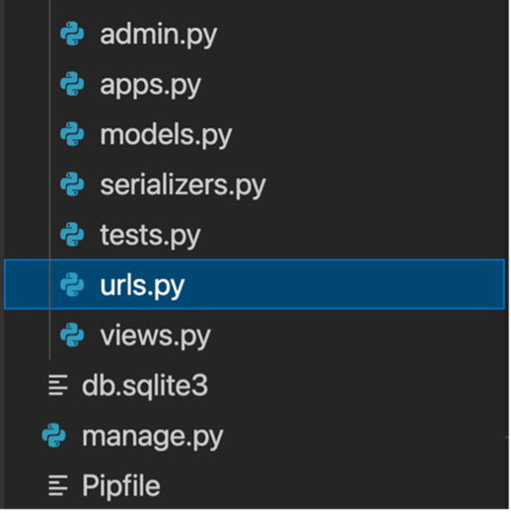

Paste the following code inside it:

from django.urls import path

from . import views

urlpatterns = [

    path('ratings', views.RatingsView.as\_view()),

]

### **Note:** The specific url configurations will differ according to the views created

### **Step 11**

Open the **urls.py** file in the project-level directory and update the code as follow:

from django.contrib import admin

from django.urls import path, include

urlpatterns = [

    path('admin/', admin.site.urls),

    path('api/',include('LittleLemonDRF.urls')),

]

**Note:** The specific url configurations at the project-level will vary according to the name of the app created.

### Concluding Thoughts

In this reading, you learnt about the initial setup you need to make on your local machine while running VS Code with pipenv for creating a Django project.

# V7.2

# Exercise: Know your tools

## Introduction

In this exercise, you are going to use the REST API client **Insomnia** to make HTTP Requests so make sure you’ve installed it on your computer. You will also use the Request and Response Service [httpbin.org](https://httpbin.org/). Httpbin.org is an open-source web service that allows you to make HTTP calls without any additional installations or dependencies.

You will be exploring the different functionalities available in Insomnia such as:

* Creating a **GET** request
* Creating a **POST** request with Form Data
* Creating a **POST** request with JSON Data

## Instructions

 To get started, open **Insomnia** on your local device and navigate to the tab labeled **DEBUG.**

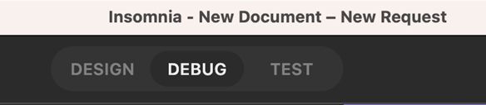

If you haven't installed Insomnia yet, you can download the install files at <https://insomnia.rest/>

## Create a GET request

Open the <https://httpbin.org/> website and click on **HTTP Methods**. A menu with different HTTP methods will expand which you can add to your endpoints.

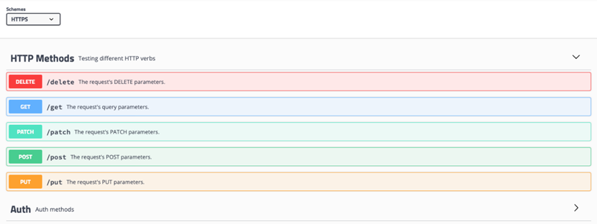

### Step 1:

In Insomnia, click on the **+** icon on the left-hand side of the screen and select **HTTP Request** from the drop-down menu.

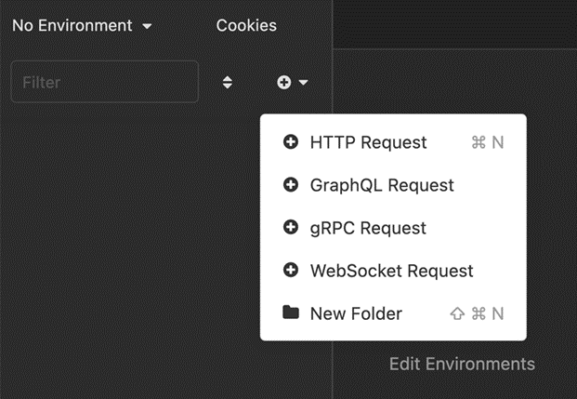

### **Step 2:**

Double-click the request to change its title to **GET request using Insomnia**.

Play Video

### Step 3:

Click on the **GET** dropdown to see a list of available options and re-select **GET**.

Update the URL endpoint with the value: <https://httpbin.org/get>

Press the **Send** button and notice the JSON output.

Play Video

### Step 4:

From the **Body** drop-down option, select **Multipart Form**.

Add the following values under **New name** and **New value**:

* New name: title
* New value: Lord of the Rings

 Press the **Send** button once again and observe the changes.

Play Video

Notice that the value of **Content-Length** has been updated to include the changes.

### Step 5:

Update a form entry with the following details:

* New name: author
* New value: JRR Tolkien

Press the **Send** button once again. Notice that **Content-Length** has further been updated.

Play Video

### Step 6:

You can **Filter** your output using the Filter response body at the section in the bottom right-hand side of **Insomnia** as indicated in the screenshot below.



Add the following filter inside it:

**$.origin**

It should update the **Preview**. The output will appear similar to what is displayed in the screenshot below.

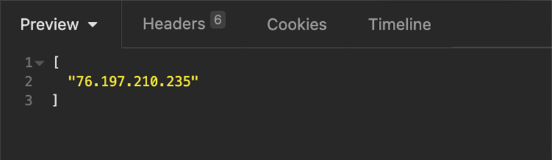

### Step 7:

Modify the filter incrementally as below which should produce the respective outputs.

**$.headers**

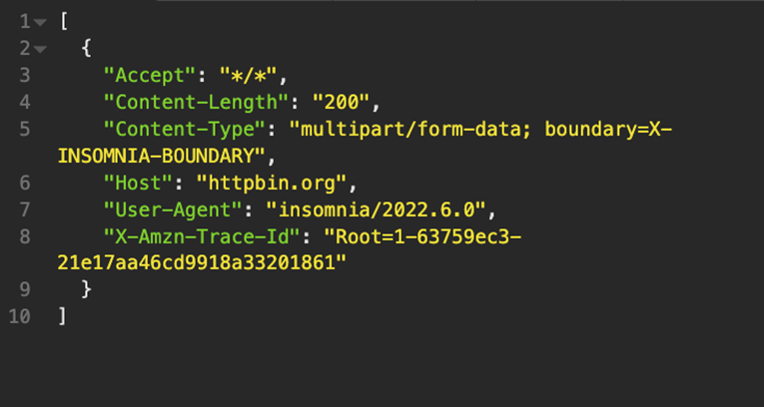

**$.headers.Content-Type**

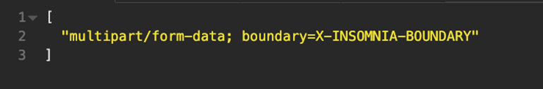

**Note:** The dot operator is used here to explore the contents of the JSON output. Also notice the value of the Content-Type is ***form-data*** because you selected Multipart form.

 Clear the contents of the **Filter response body**.

### Step 8:

Now deselect the option for the name **title** and re-create the **GET** request.

Loaded: 0%

Progress: 0%

Play

Current Time 0:07

/

Duration 0:07

Settings

Full Screen

Notice the change in the **Content-Length** again.

**Additional step**

Now that you know the steps to create a **GET** request in **Insomnia**, you can explore different configuration settings by following the steps discussed to get more accustomed to the tool.

## Create a POST request with Form Data

### **Step 1:**

Keeping the contents of the form data the same, update the request type to **POST** and update the URL endpoint to:

<https://httpbin.org/post>

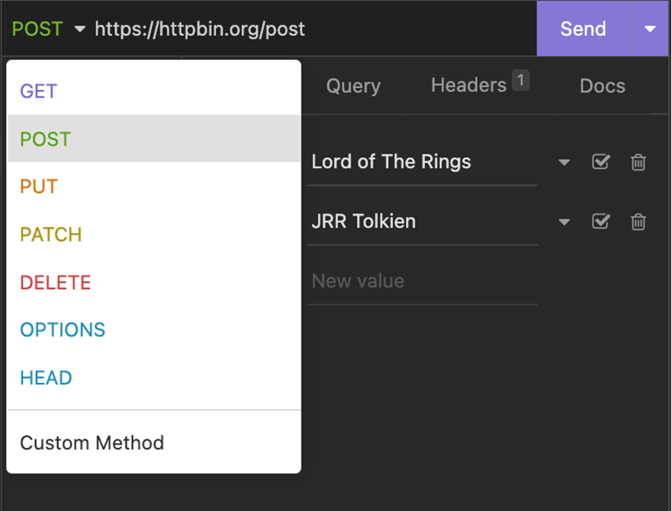

Press the **Send** button again. The output should appear as below:

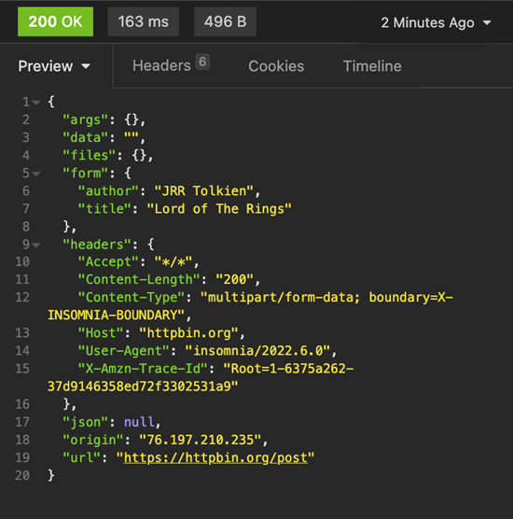

Notice that the contents of the form are updated inside the output for the **POST** request.

### Step 2:

Explore the other tabs under the output such as **Headers**, **Cookies** and **Timeline**.

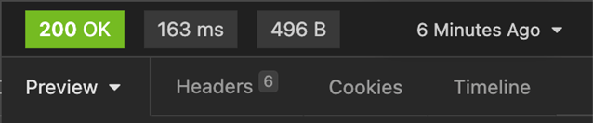

### Step 3:

Since you have modified the same HTTP request, update the changes for the title of the request in the left-hand section to **POST request using Insomnia.**

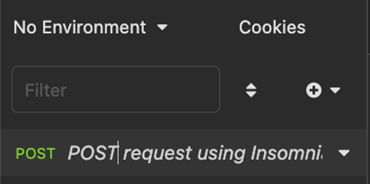

## Create a POST request with JSON Data

### Step 1:

Now further create another HTTP Request like the one at the beginning by pressing the **+** icon and selecting **HTTP Request**.

### Step 2:

Update the request type to **POST** and the request label as:

**POST request using JSON object**

**Note:** The labels are for reference and independent of the request type.

Paste the same URL endpoint that you used earlier in the URL **text-box**:

**https://httpbin.org/post**

The updated view should appear as below:

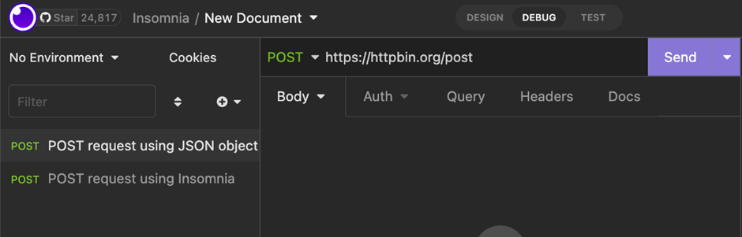

### Step 3:

Under the **Body** dropdown option, select JSON as the text input.

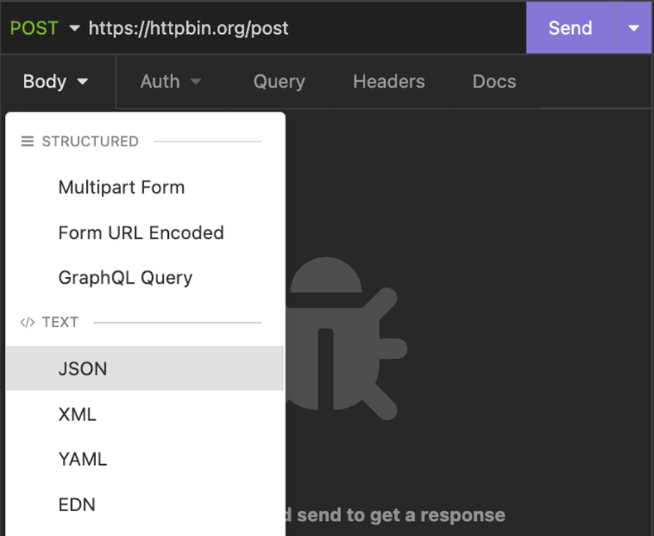

A text input area should appear as below.

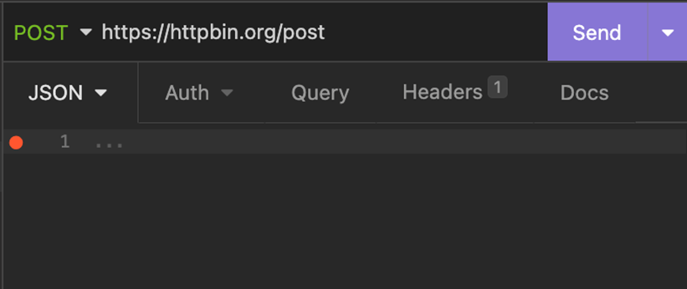

### **Step 4:**

Enter the following content inside the text input area:

{

            "title": "Lord of the Rings",

            "author": "JRR Tolkien",

            "published" : {

                        "year": 1954,

                        "month": "july",

                        "day" : 29

            }

}

 Press the **Send** button.

 The output for the JSON input should appear as below:

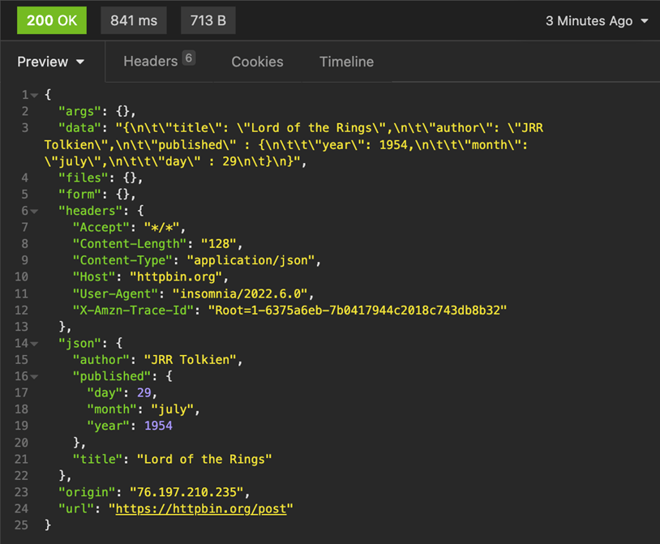

Notice the contents entered as JSON object in both the **data** and **json** field inside the JSON output.

### **Step 5:**

* Add the following line to Filter response body:

**$.json.published.year**

 The output will be as follows:

[

    1954

]

* Modify the **Filter response body** as follow:

**$[json][published][day]**

 The output will be as follows:

[

    29

]

### Concluding Thoughts

There are several configuration options inside Insomnia. While using a REST API client it is good to explore these. You can also get help from other free and open-source API services that provide options to make API calls to access public data.

# Additional resources

The following resources will be helpful as additional references in dealing with different concepts related to the topics you have covered in this section.

[Curl command line tool and library for transferring data with URLs](https://curl.se/)

[HTTPie for web and desktop](https://httpie.io/)

[Postman API platform for building and using APIs](https://www.postman.com/)

[Postman Echo service to test REST clients and make sample API calls](https://postman-echo.com/)

[Insomnia homepage](https://insomnia.rest/)

[Getting started with Insomnia](https://docs.insomnia.rest/insomnia/get-started)

[Httpbin HTTP request and response service](https://httpbin.org/)

[Python homepage](https://python.org/)

[Visual Studio Code](https://code.visualstudio.com/)

[Python Indent by Kevin Rose](https://marketplace.visualstudio.com/items?itemName=KevinRose.vsc-python-indent)

[Djaneiro by Scott Barkman](https://marketplace.visualstudio.com/items?itemName=thebarkman.vscode-djaneiro)

[pipenv](https://pipenv.pypa.io/en/latest/)

[Django](https://www.djangoproject.com/)

[List of HTTP status codes](https://developer.mozilla.org/en-US/docs/Web/HTTP/Status)

# V10.1

# Authentication versus authorization

## Introduction

You need to secure your APIs because they provide third-party clients access to your backend data. If you don’t secure your APIs properly, anyone can tamper with the data and access sensitive information. But even if a client is allowed to access the data, you need to control who can do what. This is where authentication and authorization come in. You now know that although they sound similar, they are not the same. In this reading, you will learn about the difference between authentication and authorization and how you can use it to protect your API endpoints.

## Authentication

Authentication is the process of verifying the credentials of a user. Logging into websites with a username and password is a typical example of authentication. When the username and password match, the website recognizes the user and sets some cookies in the user’s browser. When the user visits another page on that website, the browser sends those cookies within the HTTP request header. The website recognizes the cookies as well as server-side session data and therefore doesn’t ask for credentials until the user logs out again.

So, how does this work? Token-based authentication usually involves two steps in the API Architecture. First, the client identifies itself with a username and password. Then the API server gives it a bearer token. From there, the client includes the bearer token with every API call that it places. The API server verifies it and then allows the client to perform the action or not. This is where authorization comes in, but more on this later.

If the credentials are not valid, the client will receive a **401 - Unauthorized** HTTP status code.

This is like coming to the office on the first day, submitting all your papers and documents, and then receiving your employee card. After that, only your employee card will be sufficient to get inside. Authentication works just like that!

The two steps in the API authentication process can be represented by the following two diagrams.

### **Authentication process: Getting an access token**

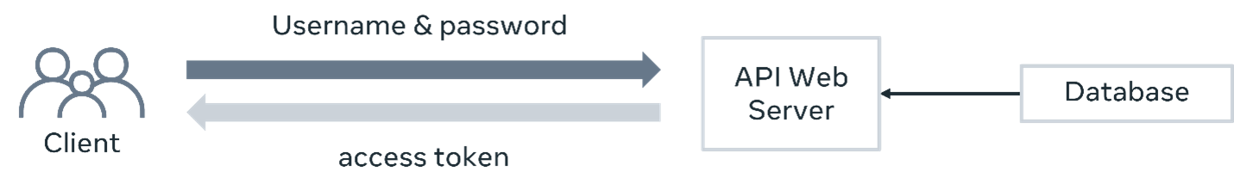

### **Authenticated API calls**

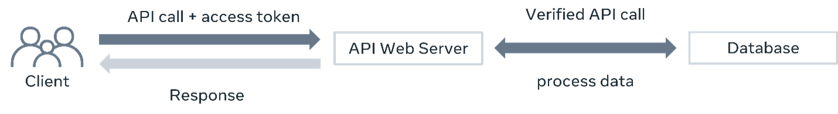

## Authorization

However, even with your employee card, you will not be able to access all the rooms or spaces in the office. There are some places that are only accessible to a certain group of people who have been given that privilege. Authorization is exactly like that. Authentication lets you in, authorization lets you act. It checks after authentication if the user has the proper privileges to perform some tasks.

On the server side, this is typically done by assigning the user to a group or a set of groups. Then, after verifying the token, the code checks if the user belongs to the appropriate group to perform that task. If not, the client will receive a **403 - Forbidden** HTTP status code.

### **API authorization**

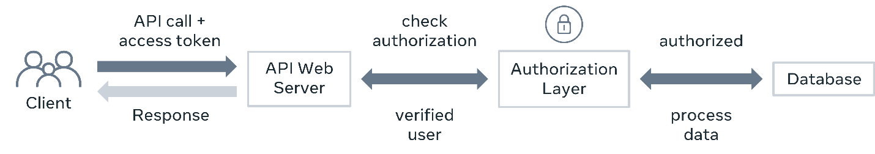

This extra authorization layer in the API architecture ensures that only people with proper privileges can access and modify data. An authorization system in an API project is very important because it prevents data corruption and data breaches.

## Implementing authorization

Privileges are the tasks that an API user performs, and they are the building blocks of an authorization layer. First, as an API developer, you identify the required privileges in your project. For example, for a bookshop, there might be the following types of privileges:

* Browse the books
* Add new books
* Edit books
* Delete books
* Place orders

There can be many other privileges like this. And not every user will have every privilege. For instance, regular customers are not allowed to add and edit books, even if they are properly authenticated. Only managers are allowed to perform those operations.

So, after identifying the privileges, you carefully distribute all these privileges into multiple roles. And then, the authorization check is done in the backend code of each API endpoint that requires a user role check. The developer verifies if the user belongs to the appropriate group or roles, and then makes the decision to allow or deny the action.

## User groups in Django

The Django admin panel comes with excellent support for the user group system. If you log into the admin panel, you will find two distinct sections – users and groups.

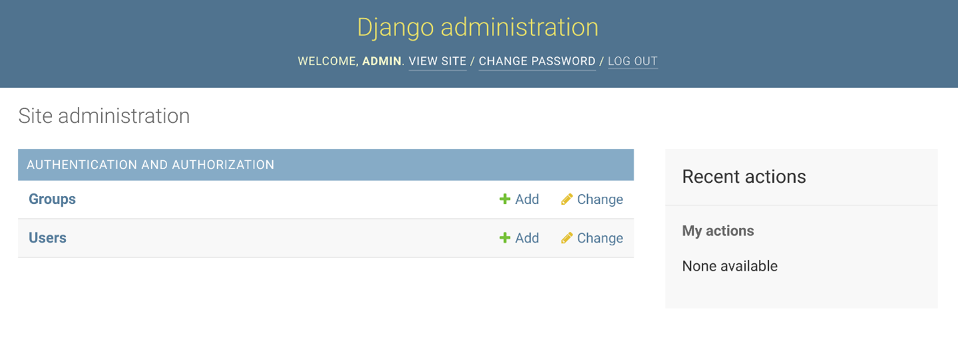

From here, you can create groups or roles like Manager, Editor, Customer, Admin and so on and assign privileges to these groups. If you click on the Add button next to the groups, you will be taken to a screen where you can create new groups. The Django admin panel will list all the necessary privileges based on the models in your project. Here is a screen that indicates the available privileges for a bookshop.

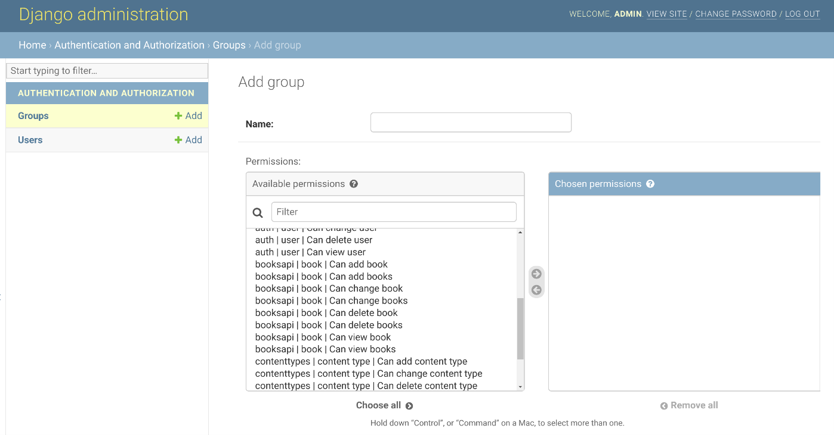

On this screen, you can create an Editor role, for instance, and add privileges to it.

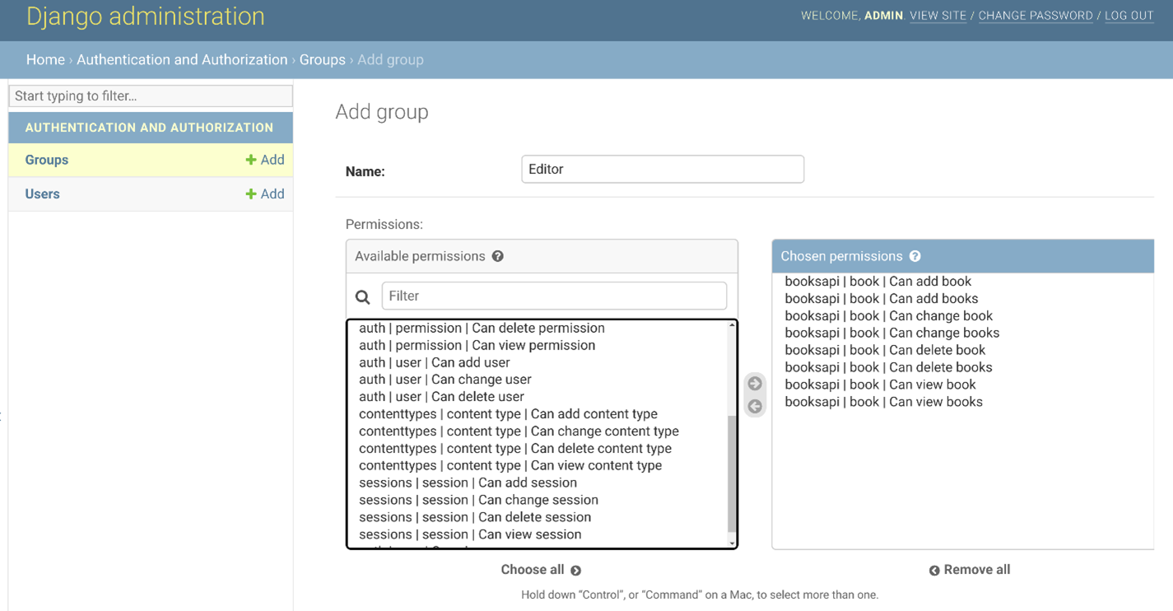

Or you can create a Customer role that will have different privileges.

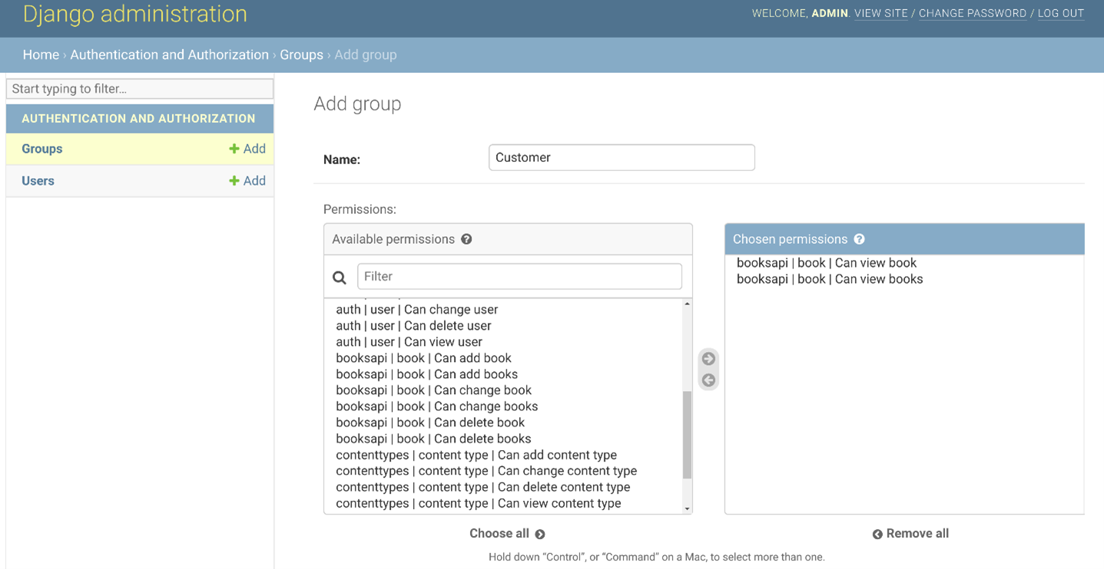

The Django admin panel allows you to manage groups throughout the project. You can add and remove privileges to groups as the project grows.

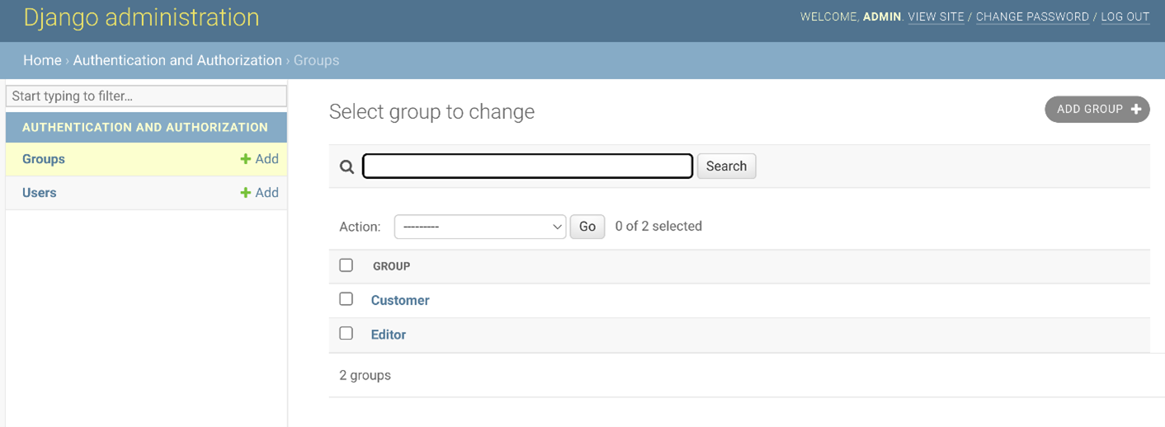

But creating groups with privileges is not enough. After creating these groups and assigning users to them, you need to write some code in the function or class-based views that determine if authenticated users belong to those groups and then make decisions based on that. But you will learn to do this later in the course.

## Conclusion

Authentication and authorization are concepts that differ in function and how they are set up in an API architecture. The knowledge you gained in this reading about user groups, roles and privileges lay the groundwork for all the steps that you will learn later on for setting up a proper security layer in your API projects.

**V12.1**

**Consequences of a poorly designed API project**

**Introduction**

Creating a good API project can be challenging. You need to stick to the conventions, write proper error checks in your code, perform security checks, and make sure that your APIs are using processing power and bandwidth optimally. This all takes time and proper planning. But what happens if you don’t properly plan and execute your APIs?

Let’s examine some of the consequences of a poorly designed API project.

**Data breach**

| **Reasons** | **Consequences** |
| --- | --- |
| Poor security checks in the code, no authentication or authorization checks, improper file permission, and not using SSL | The most significant risk of a poorly designed API project is a data breach. Sensitive data can leak if you don’t have proper security checks in your code or if you didn’t implement proper permissions for the files stored on the server.  Also, if you are not using SSL for your API endpoints, attackers can steal user data before it reaches your API web server.  Such mistakes can cause severe financial damage and trust issues. |

**Fix**: Add proper security checks in your code and create a solid authorization layer to prevent unauthorized access to your data. Always double-check these sensitive API endpoints before deploying them to production.

**Data corruption**

| **Reasons** | **Consequences** |
| --- | --- |
| Poor security, no authentication or authorization checks, absence of data validation and sanitization of input data | Improper security checks and lack of a solid authorization layer can let any user with a valid authentication token access sensitive APIs and modify the data unexpectedly. Also, creating resources without proper validation checks can create malformed data in the database.  Such mistakes can cause severe data corruption and data loss beyond repair. |

**Fix**: Besides security checks and a solid authorization layer, an API developer must validate and sanitize user data before processing and saving it.

**Wastage of computing power and memory**

| **Reasons** | **Consequences** |
| --- | --- |
| Unoptimized code, improper business logic, lack of data validation, unoptimized SQL queries or model relationships, lack of database indexes, and no caching. | Poorly written API code can consume unnecessary computing power and memory with unoptimized code, algorithms and business logic. Unoptimized code, lack of proper database indexing and absence of caching can cause a huge load on the database server by running redundant SQL queries, which slows the whole system down.  Such mistakes can end up increasing the cost of your API infrastructure. |

**Fix**: To avoid this, always spend time optimizing the code and double-checking your database-related code before deploying your APIs to production.

**Wastage of bandwidth**

| **Reasons** | **Consequences** |
| --- | --- |
| Absence of necessary caching header API code, lack of caching policy on the reverse proxy and on the web server, and lack of pagination and filtering. | If your API project doesn’t follow good API development practices like implementing caching, filtering and pagination can cause your APIs to deliver unnecessary data more times than what is required.  Such mistakes can cause bandwidth wasting and end up charging extra bills in your monthly invoice, as well as poor performance from your API endpoints. Besides, the client applications need to spend more resources and time filtering unnecessary data every time. |

**Fix**: To avoid this, always send proper caching headers with your API responses and implement filtering and pagination features so that the client application can request and receive only what they need.

**Bad user experience**

| **Reasons** | **Consequences** |
| --- | --- |
| Not following the proper naming convention, not sending proper HTTP codes, not accepting **Accept** headers, absence of pagination, sorting, searching and filtering, and lack of proper error checking in code. | It creates a bad user experience. The client application developers must go through extra processing of the API data, extra code to create the final output, and a steeper learning curve to use your API, which was not necessary if the API was designed by following the standard conventions and best practices.  Not accepting the **Accept** headers means that the API client is not getting the API output in its required format. That will cause bad experiences because clients need extra time and unnecessary code to process the data on their end.  Also, sending wrong HTTP status codes can cause unexpected errors on the client applications and a bad experience for the users who will use those applications. |

**Fix**: To avoid this, always follow the proper naming convention and implement data filtering, searching, sorting, searching and pagination features for your API endpoints. Always keep proper error checking in the code and write tests so that it doesn’t create unexpected 5XX errors on the server side.

**Breaking client applications**

| **Reasons** | **Consequences** |
| --- | --- |
| Not following the proper versioning system | If you don't maintain the proper versioning system for your API project, it can immediately break backward compatibility, and the client application can stop working instantaneously.  The API can cause failure in the current client applications because your new API requires new request data and delivers new responses. So, their old code will not work anymore. They must refactor it and release a new version of their application as soon as possible.  Such disruption can cause a bad reputation and financial damage for both the API and client application developers. |

**Failure to manage the app**

| **Reasons** | **Consequences** |
| --- | --- |
| Keeping everything in one big Django app, adding all business logic in the views. | Django apps can become big and become unmanageable over time if you keep adding functionalities in one single app. And then, adding new features or debugging an error will be painful and take extra time and effort.  Also, adding all business logic in the views file can lead to writing redundant code across multiple classes and function-based views.  Failure to manage an app over time leads to bad coding, patching of errors without test coverage and ultimately, poor performance from the APIs. |

**Fix**: Distribute the features and functionalities to multiple smaller Django apps in a decoupled way. Additionally, put some business logic in the models which can be reused by the other parts of your API project.

**Conclusion**

Taking the time to properly design an API project from the start will save you time and effort over the course of a project. The consequences of a poorly designed API affect everyone who uses your API, including the API developers and client application developers.

The knowledge you gained in this reading will hopefully remind you of everything you need to keep in mind to make your future API projects successful.

**V12.2**

**XML and JSON response types**

**Introduction**

When it comes to displaying output, an API developer should always allow the client to request the preferred content type, such as JSON or XML. Clients can do this by supplying an additional header called **Accept** in the request header. You learned about this in the reading, [HTTP methods, status codes and response types](https://www.coursera.org/learn/apis/supplement/epTtA/http-methods-status-codes-and-response-types). In this way, the client has full flexibility to use the content in the way they want to. In this reading, you’ll learn more about the two data formats that you will encounter the most in requests from clients, JSON and XML.

**Request headers**

Client applications need to send **Accept** request headers with every HTTP request to receive the output in JSON or XML. For example:

| **Response type** | **Request header** |
| --- | --- |
| JSON | **Accept: application/json** |
| XML | **Accept: application/xml**  **Accept: text/xml** |

The client can send an **Accept** header in an HTTP **GET** request and depending on the request header, the same data will be displayed differently in JSON and XML. Below is a screenshot of an API request for a JSON response.

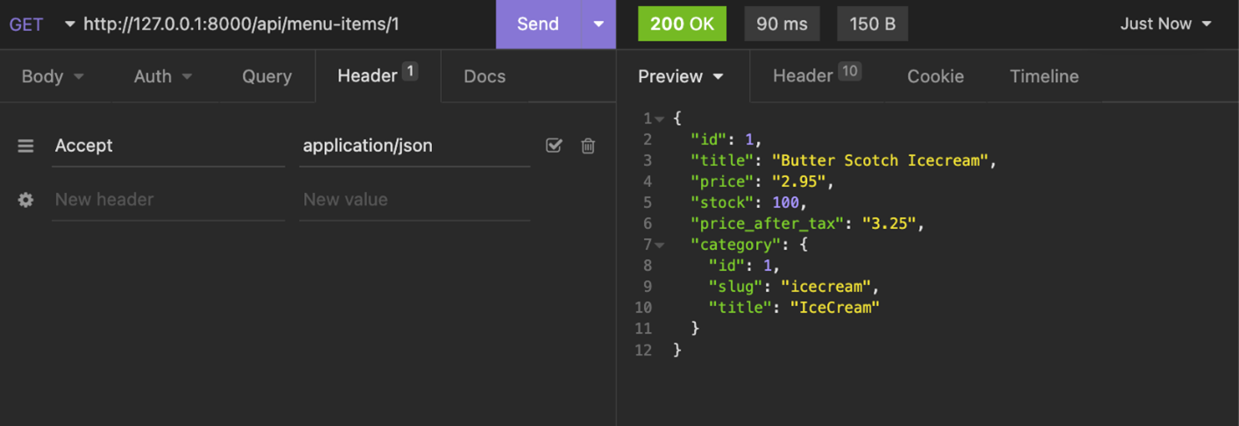

And here is the same API request but for an XML response.

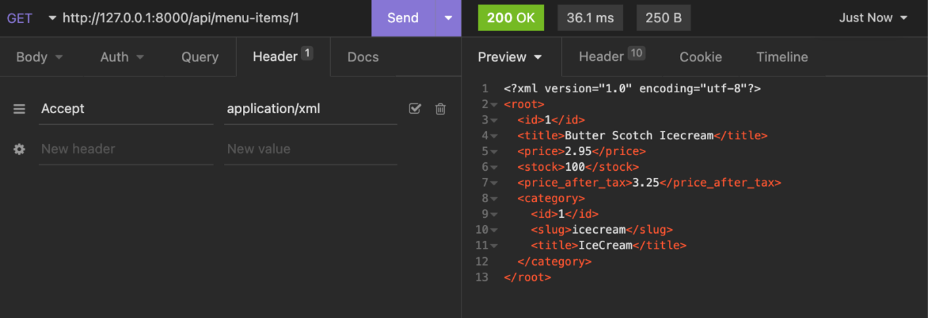

**Data conversion**

In this course, you will build APIs using Django and Django REST framework, also called DRF. DRF has built-in renderers that can convert your data to JSON and represent it in an interactive, browsable API viewer. There are also third-party renderer classes that can convert these data to XML or YAML. You will learn about these features and write actual code later in this course.

**JSON versus XML**

JSON gained popularity because it’s very simple and lightweight. And creating JSON data or parsing it is easier than XML. However, XML has its own advantages too. XML is more readable and supports data attributes that are not possible in JSON. And you can represent complex data in XML and still keep it readable. JSON is very popular among JavaScript developers because they can instantly read and write JSON data just like a regular object.

The table below compares some of the features of both formats.

| **JSON** | **XML** |
| --- | --- |
| JSON or **JavaScript Object Notation** is a lightweight and dependency-free data format. | XML or **Extensible Markup Language** is a powerful, tag-based data format. It is similar to HTML. XML data can be fairly complex. |
| The size of JSON data is smaller than XML. So, it takes less bandwidth. | XML data is lengthier than JSON and takes up more bandwidth. |
| JSON data is like keys and values.  **{**  **"author": "Jack London",**  **"title": "Seawolf"**  **}** | XML is completely tag-based, it does not have key-value pairs like JSON.  **<?xml version="1.0" encoding="UTF-8"?>**  **<root>**  **<author>Jack London</author>**  **<title>Seawolf</title>**  **</root>** |
| Representing array elements is simpler in JSON. Here’s an example:  **{**  **"items": [1,2,3,4,5]**  **}** | You can still display array elements in XML but it’s very verbose.  **<?xml version="1.0"**  **encoding="UTF-8"?>**  **<root>**  **<items>**  **<element>1</element>**  **<element>2</element>**  **<element>3</element>**  **<element>4</element>**  **<element>5</element>**  **</items>**  **</root>** |
| Generating and parsing JSON data is faster than XML and this conversion process requires less memory and computing power. | Generating and parsing XML is a complex process, and it usually takes more processing power and memory than processing JSON. |
| There is no way to include comments in JSON data. | XML data can include comments. |

**Conclusion**

It is clear that JSON and XML both have benefits and limitations. Later in this course, you will learn how to display API output in both formats, but you will mostly use JSON in this course because it’s very simple and lightweight.

**Exercise: Your first API**

Open Lab

**Instructions**

**Introduction**

In the lesson, you learned about creating and organizing a **Booklist API** project and you now know the consequences of a poorly designed API project. You will now have the opportunity to apply what you've learned. In this exercise, you will create a Book list project using plain Django. This means that you will need to create all the API endpoints. These include APIs to add new books, list available books and search for a specific book.

**Goal**

Your goal for this exercise is to create your project using plain Django and implement the features discussed in the video, Book list API project.

**Objectives**

* Practice creating a Django model for a database table
* Create a function-based view
* Run the server to display the output of your APIs
* Use GET and POST methods to update a database table built from the model

**Scenario**

You've been hired by the manager of a bookshop to create a website and mobile application to streamline the management of their books. The manager should be able to add books on both the app and the website. And the manager and visitors should be able to browse the available selection of books and search for a specific book. So, for this project, you will develop the necessary APIs to support these features.

**Setup**

This lab will require you to modify the following files:

* models.py
* views.py
* admin.py
* urls.py (app-level)
* urls.py (project-level)

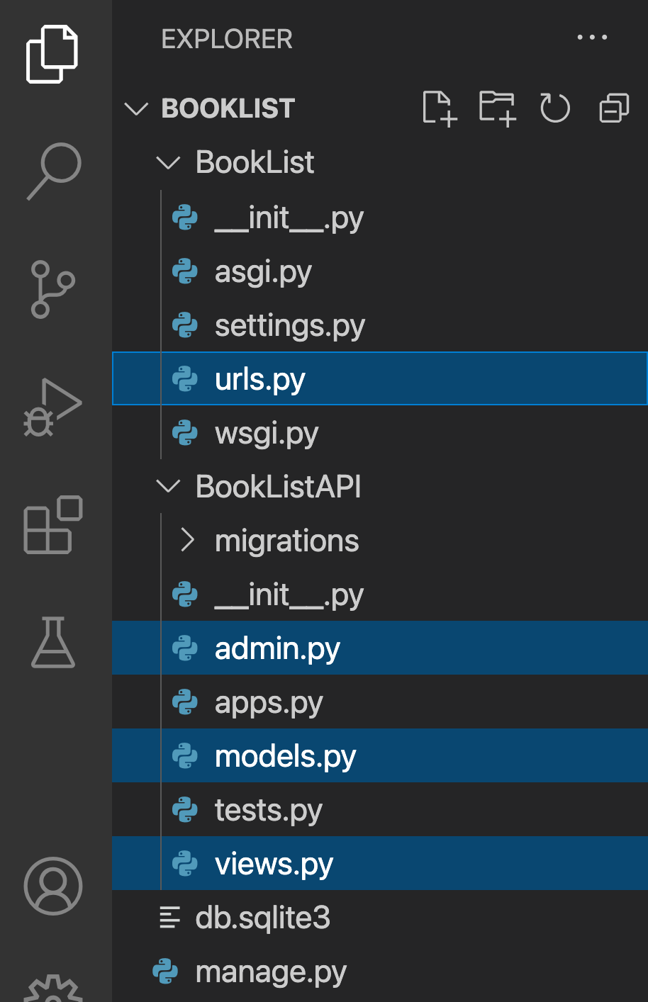

Additionally, you are required to use the command line console inside the terminal of VS Code.

Go to VS Code inside the Coursera lab environment. If not open already, go to **Terminal** on the menu bar at the top of your screen and select **New Terminal**.

You have already built the project named **BookList** and added an app inside the project called **BookListAPI**.

Follow the instructions below and ensure you check the output at every step and update the necessary files to create different views.

**Note:** Before you begin, make sure you understand how to work with the Coursera Code Lab for the [APIS course](https://www.coursera.org/learn/apis/supplement/WXiq5/working-with-labs-in-this-course).

**Steps**

**Step 1:**

Open the **models.py** file and create a class called Book inside it and pass models.Model to it as a parameter.

**Step 2:**

Create the three attributes you need in the model and assign the respective form fields to them.

Additionally, pass the following arguments to those form fields.

| **Attribute** | **Form field type** | **Arguments** |
| --- | --- | --- |
| title | CharField | max\_length = 255 |
| author | CharField | max\_length = 255 |
| price | DecimalField | max\_digits=5, decimal\_places=2 |

**Tip:** *Recall that the form fields are imported from the models package.*

**Step 3:**

Create a class inside the model class Book called Meta.

Inside the Meta class, create a variable called indexes and assign a list to it that contains one element as below.

models.Index(fields=['price']),

**Note:** *This is contrary to the use of elements present in a typical Python list but you should keep the comma (,) as also shown in the code in case of urlpatterns*

**Step 4:**

Open the file **admin.py** and remove the comments from the following lines **#2** and **#4**:

1

2

3

# from .models import Book

# admin.site.register(Book)





**Step 5:**

Now go to the terminal and run the two commands to perform migrations. The result will be similar to the screenshots below.

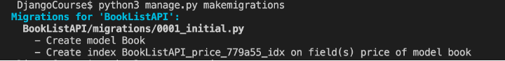

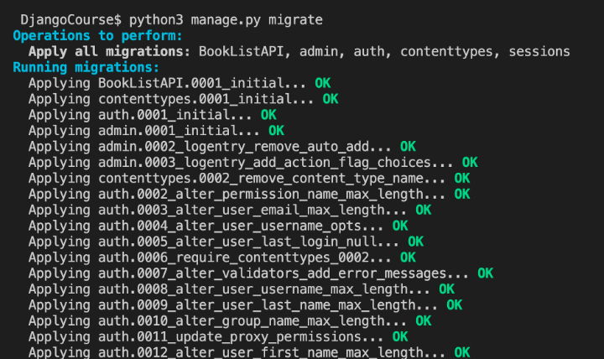

**Note:** *There is likely misconfiguration in some of the code if the migrations are not performed as expected. Explore the error stack trace to detect the file that may be in conflict.*

**Step 6:**

Once the migrations are performed, you are ready to run the server. Go to the terminal and run the server.

**Note:** It should generate a URL for the localhost such as: [**http://127.0.0.1:8000**](http://127.0.0.1:8000/api/books)

**Step 7:**

Now go to the URL [**http://127.0.0.1:8000/admin**](http://127.0.0.1:8000/api/books) admin and run the enter the credentials on the login page for the Django-admin panel as below:

**username: admin**

**password: books@123!**

**Note:** The login for a superuser account with the username admin for the Django admin using the command createsuperuser.

**Step 8**

* 8.1 On the homepage of the Django admin, select the option Books as visible in the image below:

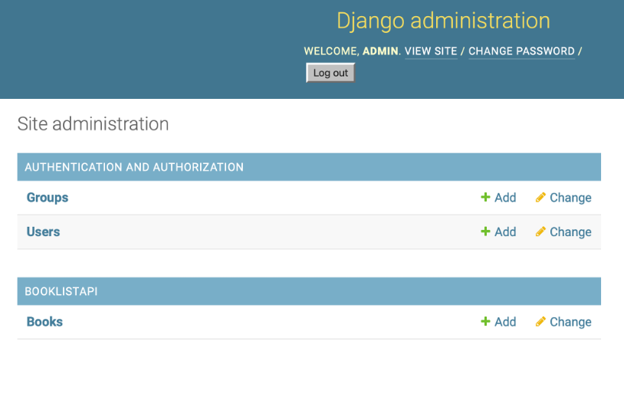

* 8.2 Select the option ADD BOOK in the right hand corner:

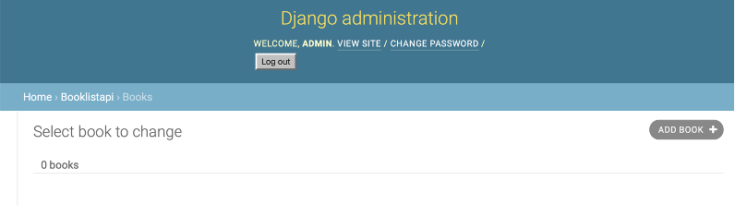

* 8.3 You need to enter the details of the books you want to create in the text boxes shown below:

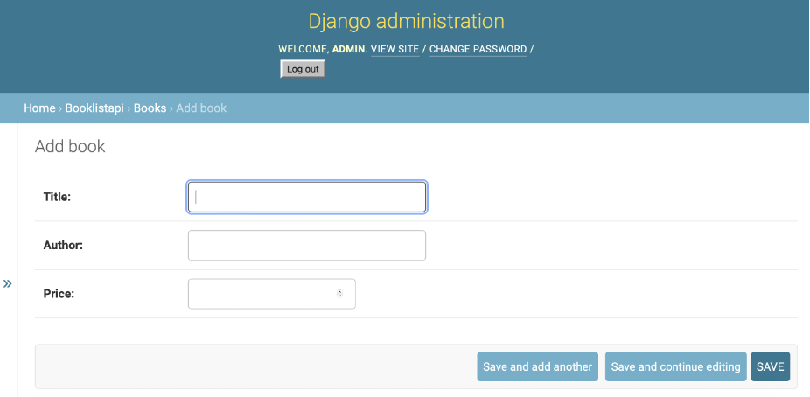

Create the following entries and SAVE both the book details entered.

**- Title: Northanger Abbey** **- Author: Jane Austen** **- Price: 18.20**

**- Title: Siddhartha** **- Author: Hermann Hesse** **- Price: 6.50**

**Step 9:** Create a file in the BookListAPI directory called **urls.py** and add the following code inside it.

from django.urls import path

from . import views

urlpatterns = [

# Add URL configuration for the path() function here

]

Replace the comment inside the urlpatterns with the path() function with two arguments passed inside it:

* A URL configuration for the path such as a string called books
* A relative path for the view function books that you are going to create

**Step 10:** Go to the project-level **urls.py** inside the **BookList** and observe the URL configurations already added in-place. Remove the commenting of the line **#21**:

# path('api/', include('BookListAPI.urls')),

**Step 11:** Go to the file **views.py** inside the **BookListAPI** directory and import the following:

* TheIntegrityErrorexception from thepackage django.db
* JsonResponsefunction from thepackage django.http
* TheBookmodel from the**models.py**file present inside the same directory
* Thecsrf\_exemptdecorator function from the packagedjango.views.decorators.csrf
* Themodel\_to\_dictfunction from the packagedjango.forms.model

**Tip:** Note that when importing a file inside the same directory, you need to use a dot operator in front of the file while importing. For example, a package named xyz from inside file called abc will be imported as follows:

from .abc import xyz

**Step 12:**

Add the decorator for csrf\_exempt before you begin writing the view function.

**Tip:** *The decorators are helper functions used in Python that have @ as the suffix. For reference, the decorators will be used over the view function as below:*

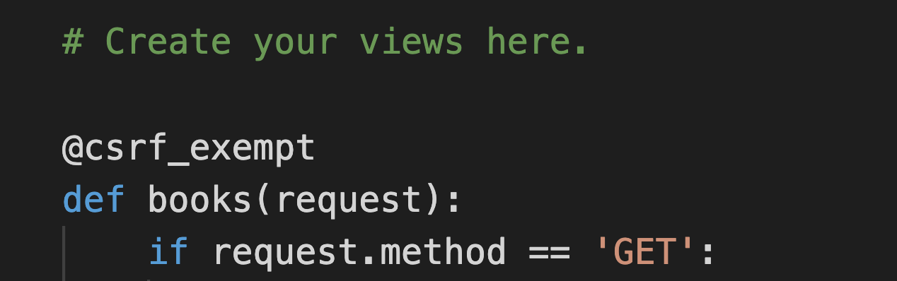

**Step 13:**

On the next line, define a view function called books and pass a request object to it as a parameter. Implement the code by following the steps in the pseudo-code below.

If the value of request.method is 'GET':

* Assign the value ofBook.objects.all().values()to a variable calledbooks
* Return theJsonResponse()from the view that has a dictionary passed inside it whose key is the string'books'and whose value is the variablebookstypecasted to a*list*object

Else if the value of request.method is 'POST':

* Assign request.POST.get('title') to a variable title
* Assign request.POST.get('author') to a variable author
* Assign request.POST.get('price') to a variable price
* Now create another variable called book and assign it a Book object that has three arguments passed for title, author and price in a format that follows variable assignment such as: title = title and so on.
* Add a try block:
* Call thesave()function on thebookvariable by using the dot operator.
* Add an except block to check IntegrityError:
* Return the JsonResponse() with the following code present inside it:{'error':'true','message':'required field missing'},status=400
* Return a JsonResponse() that contains two arguments passed to it: model\_to\_dict(books) and status=201

***Note:****Double-check the code created for the view function to ensure there are no errors. Errors may occur in one or more places, but Python and Django will flag them one at a time. In this example, the views have conditional statements which should be double-checked for accuracy.*

**Step 14:**

Run the server and go to the URL specified in the command line followed by the suffix that you have configured inside the URL configurations. The URL to be accessed on the browser will be:

[**http://127.0.0.1:8000/api/books**](http://127.0.0.1:8000/api/books)

The output will be similar to the screenshot below.

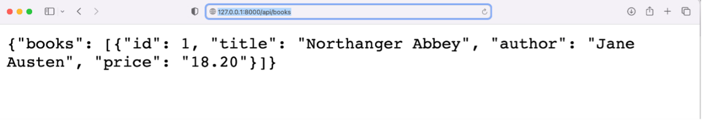

**Additional Step**

Update the code inside the files **models.py** and **views.py** to add another variable called inventory for the books.

You will also have to re-perform migrations for the code and add new entries using the POST method. See if the field inventory displays along with the remaining fields.

**Concluding Thoughts**

In this lab, you practiced creating your first API using Django and you implemented the GET and POST methods to update the database table built from the model. You also practiced creating function- based views, and running the server to access specific entries inside the database.

# Solution: Your first API

## Shell commands

# Activate virtual environment using pipenv

pipenv shell

pipenv install

# Making migrations

python3 manage.py makemigrations

python3 manage.py migrate

## Solution code for models.py

from django.db import models

# Create your models here.

class Book(models.Model):

    title = models.CharField(max\_length=255)

    author = models.CharField(max\_length=255)

    price = models.DecimalField(max\_digits=5, decimal\_places=2)

    class Meta:

        indexes = [

            models.Index(fields=['price']),

        ]

from django.urls import path

from . import views

urlpatterns = [

    path('books',views.books),

    # path('books/<int:pk>',views.book),

]

# Solution code for urls.py (app-level):

## Solution code for urls.py (app-level)

from django.urls import path

from . import views

urlpatterns = [

    path('books',views.books),

]

## Solution code for views.py

from django.db import IntegrityError

from django.http import HttpResponse, JsonResponse

from .models import Book

from django.views.decorators.csrf import csrf\_exempt

from django.forms.models import model\_to\_dict

# Create your views here.

@csrf\_exempt

def books(request):

    if request.method == 'GET':

        books = Book.objects.all().values()

        return JsonResponse({"books":list(books)})

    elif request.method == 'POST':

        title = request.POST.get('title')

        author = request.POST.get('author')

        price = request.POST.get('price')

        book = Book(

            title = title,

            author = author,

            price = price

        )

        try:

            book.save()

        except IntegrityError:

            return JsonResponse({'error':'true','message':'required field missing'},status=400)

        return JsonResponse(model\_to\_dict(book), status=201)

# v14.1

# Mock APIs

## Introduction

When developing APIs, it can take a long time before clients can start using them. Fortunately, as an API developer, you can use the mocking technique to provide the same output as a real API endpoint.

A mock API imitates the real API endpoint with fake data so that the client application developers can start development before the actual API is developed. This allows them to develop their apps without waiting for the production APIs to go live.

In mock API outputs, the data structure remains correct, but the values are fake. And you don’t do any kind of business logic process for these mock data. You just return some pre-generated hard-coded data as a response.

## How it works

When you create the mock API endpoints with fake data, both the API developers and the client application developers can evaluate the output and instantly understand what data they will get from an API call or what data they should deliver.

Then, based on these mock APIs endpoints and their output, these developers can start coding the client applications. They don’t need to wait for the API developers to finish implementing these APIs because they already know what type of data they will get.

And finally, when the actual API is ready, the client application developers will change those mock API endpoints with the real endpoints. Client applications are easier to maintain when using mock API tools.

There are two major steps involved in creating Mock APIs. First, you create mock data that you can deliver from the mock API endpoints. And the second step is to create mock API endpoints and serve those data.

## Mock API tools

You can search for **Mock API Data Generator** in your browser and get plenty of tools that you can use for free. Similarly, searching for **Mock API Endpoints** will give you access to some handy free services too.

Mockaroo is a popular fake data generator service that you can use for free, which is available from [www.mockaroo.com](http://www.mockaroo.com/)

Mockapi is a popular mock API service that you can use to create mock API endpoints for free, which you can access at <https://mockapi.io/>

## Conclusion

In this reading, you learned how mock APIs can speed up development. Mocking APIs play an essential role in API development because client application developers don't need to wait for the actual API to become live. It minimizes the time of development and reduces the dependencies between API developers and client application developers.

# V3.1 mod2

# Different types of routing in DRF

## ****Introduction****

The Django REST framework provides different ways of URL mapping or routing in an API project. Besides the traditional style of routing, there are other routing techniques that can save you time while developing. In this reading, you are going to learn about both traditional and other techniques.

**Note:** All the routings should be done in the **urls.py** file in your Django app.

## ****Regular routes****

The code below maps a function from a **views.py** file to an API endpoint. Don’t forget that you have to import the path function from the **django.urls** module first.

from django.urls import path

from . import views

urlpatterns = [

    path('books’,views.books) ,

]

This URL pattern maps the books function to the **/api/books** endpoint. You already know how to specify which HTTP methods a function view can serve by supplying them in the **api\_decorator** function. The following code allows any function view to serve both HTTP **GET** and **POST** methods.

@api\_view([‘GET’,’POST’])

## ****Routing to a class method****

If you map a specific method from a class, then you need to declare that method as a **@staticmethod** first. After that, you can map it in the **urls.py** file. Here’s an example of a class in the **views.py** file.

class Orders():

    @staticmethod

    @api\_view()

    def listOrders(request):

        return Response({'message':'list of orders'}, 200)

You can also map this **listOrders** method in the **urls.py** file as follows.

from django.urls import path

from . import views

urlpatterns = [

    path('orders', views.Orders.listOrders)

]

## ****Routing class-based views****

You can save a lot of time in DRF by mapping a class that extends the **APIview**. You don’t need to individually map every method of such classes. In an upcoming video, Function and class-based views, you will learn that such classes have HTTP verb-specific methods inside them. When a class extends **APIview** or generic views, you can simply map those classes in the **urls.py** file.

Here’s the code of the class that extends the **APIView**.

class BookView(APIView):

    def get(self, request, pk):

        return Response({"message":"single book with id " + str(pk)}, status.HTTP\_200\_OK)

    def put(self, request, pk):

        return Response({"title":request.data.get('title')}, status.HTTP\_200\_OK)

And here is how you map this class in the **urls.py** file. All you have to do is map the class as a view against an endpoint.

from django.urls import path

from . import views

urlpatterns = [

    path('books/<int:pk>',views.BookView.as\_view())

]

Now you can make HTTP, **GET** and **PUT** calls to the **/api/books/{bookId}** endpoint without issues. If the class has **post()**, **delete()** and **patch()** methods, it will work with HTTP **POST**, **DELETE** and **PATCH** methods too.

## ****Routing classes that extend viewsets****

You can have classes that extend the different types of **ViewSets** in your API project. Just like the classes that extend **APIView**, these classes also have specific methods used to respond to different types of HTTP requests. Here’s an example of a typical class that extends the **viewset.Viewset** class.

Class BookView(viewsets.ViewSet):

    def list(self, request):

        return Response({"message":"All books"}, status.HTTP\_200\_OK)

    def create(self, request):

        return Response({"message":"Creating a book"}, status.HTTP\_201\_CREATED)

    def update(self, request, pk=None):

        return Response({"message":"Updating a book"}, status.HTTP\_200\_OK)

    def retrieve(self, request, pk=None):

        return Response({"message":"Displaying a book"}, status.HTTP\_200\_OK)

    def partial\_update(self, request, pk=None):

        return Response({"message":"Partially updating a book"}, status.HTTP\_200\_OK)

    def destroy(self, request, pk=None):

        return Response({"message":"Deleting a book"}, status.HTTP\_200\_OK)

 You can map this class in the **urls.py** file in your Django app as follows.

urlpatterns = [

    path('books', views.BookView.as\_view(

        {

            'get': 'list',

            'post': 'create',

        })

    ),

    path('books/<int:pk>',views.BookView.as\_view(

        {

            'get': 'retrieve',

            'put': 'update',

            'patch': 'partial\_update',

            'delete': 'destroy',

        })

    )

]

Notice how the HTTP verbs are mapped with each method in this class. Also, note that both the **list()** and **retrieve()** methods are present. The **list()** method is used to display all books, and the **retrieve()** method is used to display a single book.

After this mapping, you can access the **http://127.0.0.1:8000/api/books** endpoint with **GET** and **POST** methods. While you can access the **http://127.0.0.1:8000/api/books/1** endpoint with **GET**, **PUT**, **PATCH** and **DELETE**.

## ****Routing with SimpleRouter class in DRF****

If you have a class that extends **ViewSets** then you can use different types of built-in routers to map those classes in your **urls.py** file. Doing things this way means you don’t have to map the individual methods as you did in the previous section. Initiate a **SimpleRouter** object and map the class in the **urls.py** file in your Django app as follows.

from rest\_framework.routers import SimpleRouter

router = SimpleRouter(trailing\_slash=False)

router.register('books', views.BookView, basename='books')

urlpatterns = router.urls

After mapping, you can access the **api/books** and **api/books/1** endpoints with the same methods as in the previous example.

Did you notice that the argument **trailing\_slash=False** was passed, instantiating the **SimpleRouter** object? Without this argument, your API endpoints will have a trailing slash. And, since you don’t want a trailing slash at the end of your API endpoints, you have to pass this argument.

## Routing with DefaultRouter class in DRF

There is another type of router called **DefaultRouter** which provides an extra benefit over the **SimpleRouter**. It creates an API root endpoint with a trailing slash that displays all your API endpoints in one place. You can use it this way in the **urls.py** file.

from rest\_framework.routers import DefaultRouter

router = DefaultRouter(trailing\_slash=False)

router.register('books', views.BookView, basename='books')

urlpatterns = router.urls

Again, after mapping, you can access the **api/books** and **api/books/1** endpoints with the same methods as in the previous examples.

Additionally, you can access the API root view when you visit the **http://127.0.0.1:8000/api/** endpoint. This will display all the available endpoints as in the screenshot below.

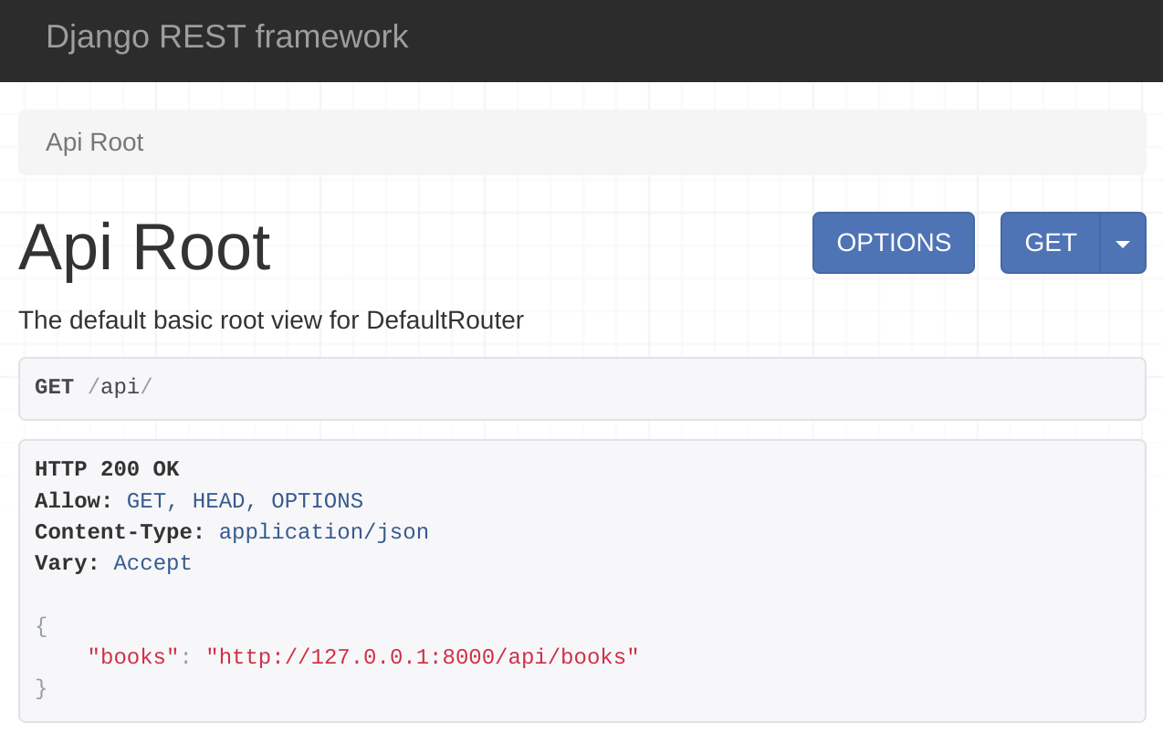

You can read about all of these routers and more in the DRF documentation shared in the additional resources of this lesson.

**Conclusion**

In this reading, you learned about different types of URL routing for your Django REST framework-based API project.

# V3.2

# Generic views and ViewSets in DRF

## Introduction

DRF comes with many generic views and **ViewSet** to speed up API development. When you use these classes, you don’t need to start from scratch and using them will reduce the code in your API project. In this reading, you will learn about different types of generic views and **ViewSet** as well as their purposes and benefits.

## ViewSets

**ViewSets** are simple class-based views, but they come with benefits. There are a few **ViewSets** classes available in DRF that you can use to quickly scaffold a functioning API CRUD project. You can also provide permission classes and throttle classes to allow authenticated API calls and rate limiting.

To use these classes, you must import the **viewsets** module from the **rest\_framework**:

from rest\_framework import viewsets

### ViewSet

There are a few **ViewSet** classes but the foundation is **ViewSet** and it extends the **APIView**. When your class-based views extend a **ViewSet** you get browsable API views out of the box. Except for that, every **ViewSet** comes with a method naming convention for easier one-line routing that saves a lot of time.

When a **ViewSet** is used to deal with a collection of resources, you can write your business logic in **list()** and **create()** methods inside this class.

| **Class method** | **Supported HTTP method** | **Purpose** |
| --- | --- | --- |
| **list()** | **GET** | Display resource collection |
| **create()** | **POST** | Create new resource |

You can use the following methods to write the business logic when a **ViewSet** deals with a single resource.

| **Class method** | **Supported HTTP method** | **Purpose** |
| --- | --- | --- |
| **retrieve()** | **GET** | Display a single resource |
| **update()** | **PUT** | Completely replace a single resource with new data |
| **partial\_update()** | **PATCH** | Partially update a single resource |
| **destroy** | **DELETE** | Delete a single resource |

When you extend a **ViewSet**, you will have to manually write code to perform the database operations. But there are two more **ViewSet** classes that can automatically do that for you. This is how you extend a **ViewSet** class.

class MenuItemViewSet (viewsets.ViewSet)

### ModelViewSet

If the class-based view extends a **ModelViewSet**, it can automatically handle CRUD operations for you. All you must do is give this class a **queryset** and a serializer, and everything else will be done automatically.  You don’t need to write code for all those database operations anymore. Later in this course, you will see a practical example of using **ModelViewSet** to write a functioning CRUD API project with only a few lines of code. Here’s an example of how to extend this **ViewSet**.

class MenuItemView (viewsets.ModelViewSet)

### ReadOnlyModelViewSet

As the name suggests, when your class-based views extend a **ReadOnlyModelViewSet**, it can only display a single resource and resource collection. No write-operation is allowed by such views, so it doesn’t handle **POST**, **PUT**, **PATCH** or **DELETE** methods.  Here’s an example of extending a **ReadOnlyModelViewSet**.

class ReadOnlyMenuItemView (viewsets.ReadOnlyModelViewSet)

## Generic views

Generic views are another way of quickly writing class-based views to scaffold fully functional CRUD API projects. There are several generic views that offer a particular functionality, like displaying resources or creating a new resource and so on. All you must do is extend these generic views to make your API endpoints work.

To use these generic view classes, you must import the generics module from the **rest\_framework**.

from rest\_framework import generics

All generic view classes require a **queryset** and a serializer to work properly.

Here is a list of generic views in DRF and their purposes.

| **Generic view class** | **Supported method** | **Purpose** |
| --- | --- | --- |
| **CreateAPIView** | **POST** | Create a new resource |
| **ListAPIView** | **GET** | Display resource collection |
| **RetrieveAPIView** | **GET** | Display a single resource |
| **DestroyAPIView** | **DELETE** | Delete a single resource |
| **UpdateAPIView** | **PUT** and **PATCH** | Replace or partially update a single resource |
| **ListCreateAPIView** | **GET**, **POST** | Display resource collection and create a new resource |
| **RetrieveUpdateAPIView** | **GET**, **PUT**, **PATCH** | Display a single resource and replace or partially update it |
| **RetrieveDestroyAPIView** | **GET**, **DELETE** | Display a single resource and delete it |
| **RetrieveUpdateDestroyAPIView** | **GET**, **PUT**, **PATCH**, **DELETE** | Display, replace or update and delete a single resource |

### Example code

If you want API endpoints to be capable of displaying resource collection and creating a new resource, you have to extend both **ListAPIView** and **CreateAPIView**, or just **ListCreateAPIView**. Both of the following lines of code do the same job.

class MenuItemView (generics.ListAPIView, generics.CreateAPIView)

And

class MenuItemView (generics.ListCreateAPIView)

Just like **ModelViewSet**, you must give these generic view classes a **queryset** and a serializer and you don’t need to manually write code to perform these database operations.

## Authentication and selective authentication

If you want all API calls to be authenticated in a class-based view that extends the generic views, you can add the **permission\_classes** public attribute in the class.

Permission\_classes = [IsAuthenticated]

If you want to selectively enable authentication for some calls, like **POST**, **PUT**, **PATCH** and **DELETE** then you need to override the **get\_permission** method in your class-based view like this.

def get\_permissions(self):

        permission\_classes = []

        if self.request.method != 'GET':

            permission\_classes = [IsAuthenticated]

        return [permission() for permission in permission\_classes]

This way, anyone will be able to make **GET** call, but other HTTP methods like **POST**, **PUT**, **PATCH** and **DELETE** will require authentication or a valid user token.

## Return items for the authenticated user only

Sometimes in a class-based view that extends a generic view, you may want to return resources created by the authenticated users only. In that case, you need to override the **get\_queryset** method. The following code in a class-based view returns only those orders created by the authenticated user.

class OrderView(generics.ListCreateAPIView):

    queryset = Order.objects.all()

    serializer\_class = OrderSerializer

    permission\_classes = [IsAuthenticated]

    def get\_queryset(self):

        return Order.objects.all().filter(user=self.request.user)

## Override default behavior

Though generic views automate everything, you still have full scope to change the default behavior by overriding any of the default methods. Here is an example that returns a simple static response instead of the resources.

class OrderView(generics.ListCreateAPIView):

    queryset = Order.objects.all()

    serializer\_class = OrderSerializer

    def get(self, request, \*args, \*\*kwargs):

        return Response(‘new response’)

The other methods you can override are **post()**, **put()**, **patch()** and **delete()**.

## Conclusion

In this reading, you explored the **ViewSet** classes and generic view classes which can help you to scaffold a fully functional CRUD API project in a very short time.

**Convert booklist API project to DRF**

Open Lab

**Instructions**

**Goal**

In this lab, you will practice creating a project using serializers in Django Rest Framework (DRF).

**Objectives**

* Use serializers in DRF to model data inside web applications.
* Use the GET and POST methods to update data entries in DRF.

**Introduction**

In the previous lab exercise, you used Django to create APIs for a book list project. For this lab exercise, you will use the same model that you created for the BookList project but instead, you will create an API using DRF.

**Scenario**

You already created APIs for the book list project, but since then you've learned about the advantages of using DRF over just using Django. You informed the manager and they've asked you to improve the APIs you developed to ensure a better end-user experience.

Your task is to improve the book list project by building it in DRF.

**Learner Instructions**

This lab will require you to modify the following files:

* **views.py**
* **urls.py**(at the app level)
* **models.py**
* **serializers.py**

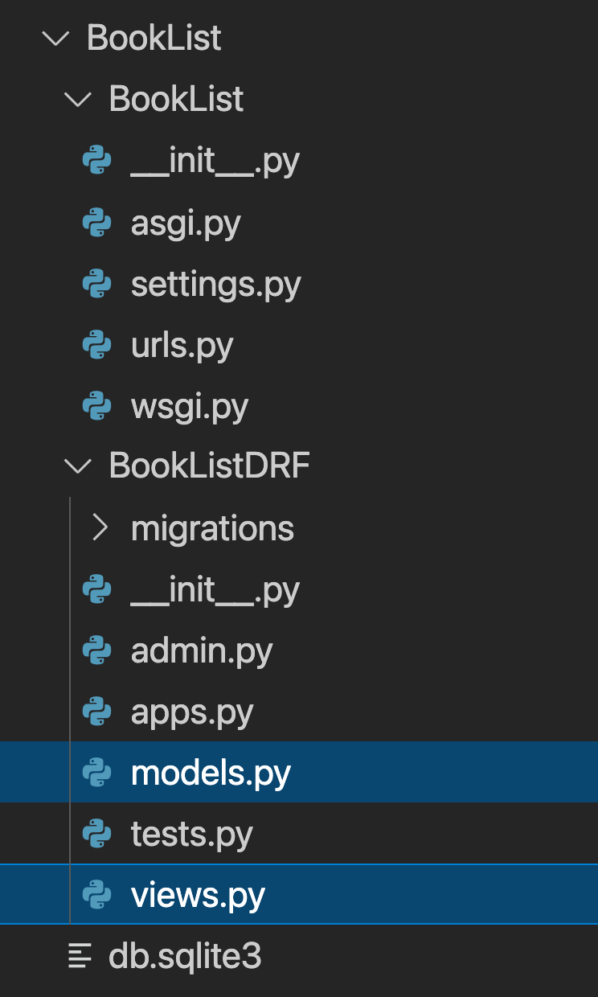

**Note:** In the image above, serializers.py and urls.py (app-level) are not created with the project.

Additionally, you must start the development server on the local host and go to the localhost URL to confirm the desired view on the webpage.

When required, open the **Terminal** by selecting **New Terminal** under **Terminal** in VS Code.

The Django project called **BookList** and Django app called **BookListDRF** are already in place.

**Note:** Before you begin, make sure you understand how to work with the Coursera Code Lab for the [APIS course](https://www.coursera.org/learn/apis/supplement/WXiq5/working-with-labs-in-this-course).

Follow the instructions below and ensure you check the output at every step.

**Step 1:** Create a **'urls.py'** file at the app level, add the path() function inside the urlpatterns list and pass the following arguments to it:

* A URL path string beginning with the suffix'books'
* The relative path of the view function that will be calledBookView   .

**Step 2:**

Open the **urls.py** file at the project level and import the include() function from the package django.urls.

\_ **Tip:** \_ *Do not add round brackets while importing a function in an import statement.*

The final code inside the project-level **urls.py** file will appear as below:

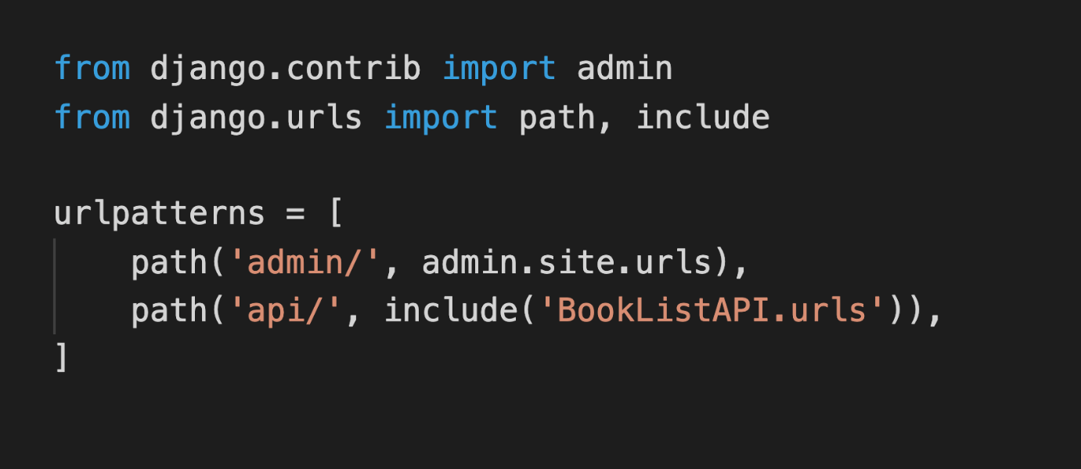

**Step 3:**

Update the urlpatterns list to include the path of the app-level urls by adding a path() function with the following arguments:

* A path string labeled'api/'
* An include function with'BookListDRF.urls'passed as an argument

\_ **Note:** \_ *Make sure you add a comma (,) at the end of the* path() *function.*

**Step 4:**

Open the **models.py** file and create a class called Book inside it and pass models.Model to it as a parameter.

**Step 5:**

Create the three attributes that you need in the model (title, author and price) and assign the respective form fields to them.

Additionally, pass the following arguments to those form fields:

| **Attribute** | **Form field type** | **Arguments** |
| --- | --- | --- |
| title | CharField | max\_length = 255 |
| author | CharField | max\_length = 255 |
| price | DecimalField | max\_digits= 5, decimal\_places= 2 |

**Step 6:**

Now create a file called **serializers.py** inside the app level **BookListDRF** directory.

**Step 7:**

Open the file and import:

* TheBookclass from the**models**file
* Theserializerspackage from therest\_framework

**Step 8:**

Create a class called BookSerializer and pass the class object serializers.ModelSerializer to it as an argument.

**Step 9:**

Inside the BookSerializer class, create another class called Meta and add the following code inside the class:

* Assign theBookmodel to a variable calledmodel
* Create a list of strings with four items namely:'id' ,'author'and'price'and assign this list to a variable calledfields

**Step 10:**

Open the file **views.py** and import the following inside it:

* theBookmodel from the**models**file
* BookSerializerfrom the**serializer**file
* genericsfrom the DRF packagerest\_framework

**Step 11:**

Create a class called BookView and pass generics.ListCreateAPIView to it as an argument.

**Step 12:**

Inside the BookView class:

* Assign the value ofBook.objects.all()to a variable calledqueryset
* Assign the value ofBookSerializerto a variable calledserializer\_class

**Step 13:** Open the Terminal in VS Code and run the two commands to perform the migrations.

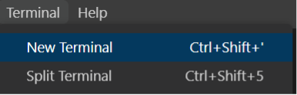

**Step 14:**

Once the migrations are performed successfully, run the command to start the server on the localhost and go to the URL: http://127.0.0.1:8000/api/books

You should be able to see a page and at the bottom see a form such as this:

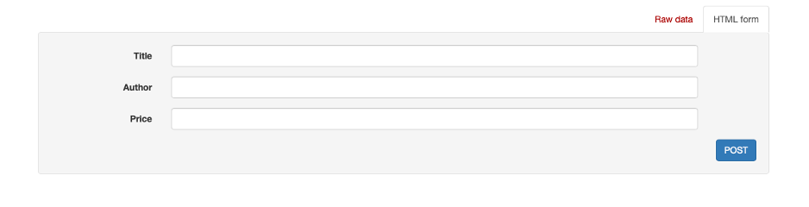

**Step 15:** Now enter the details of the following books in the bottom section, one at a time:

**- Title: The Prophet**

**- Author: Kahlil Gibran**

**- Price: 4.35**

**- Title: Siddhartha**

**- Author: Hermann Hesse**

**- Price: 8.95**

**- Title: The Great Gatsby**

**- Author: Francis Scott Fitzgerald**

**- Price: 6.90**

Press the **POST** button at the bottom of the screen. You should be able to see the result of the **POST** request on the screen as follows:

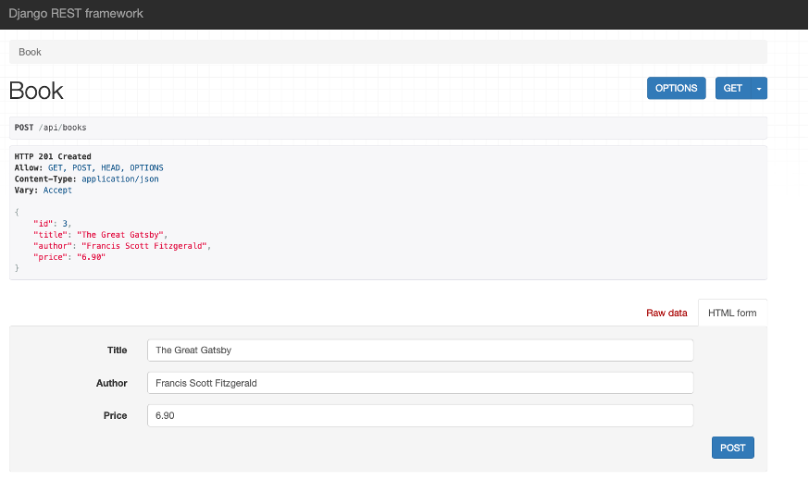

**Step 16:** Click on the Book button at the top left corner of the screen to see all the entries inside the model you have created.

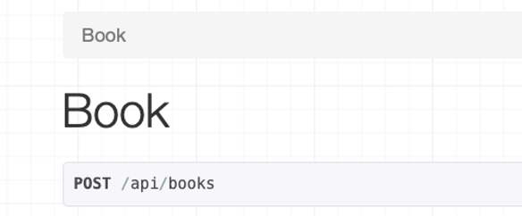

It will open a page that will display all the results. In this way, DRF provides a consolidated and convenient view of the model entries inside your browser.

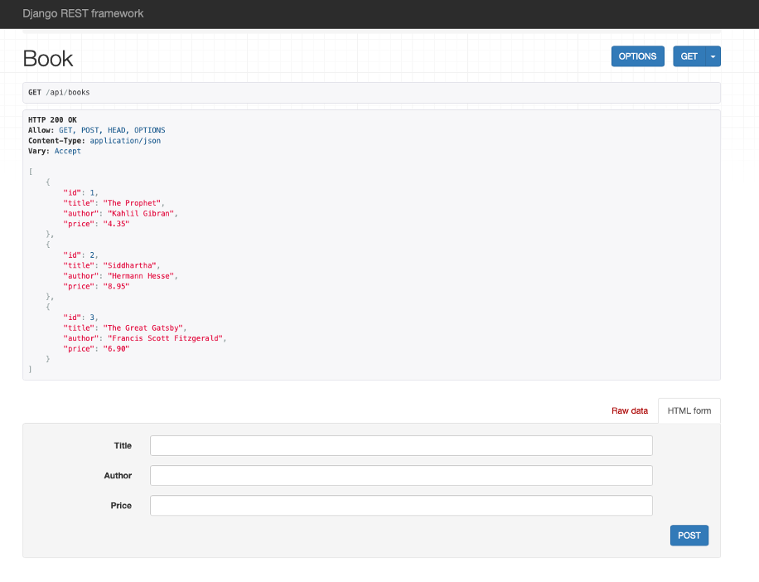

\*\*Additional steps: \*\*

Keep the server running and go to the **views.py** file and add the following code to create a new view called SingleBookView Add the following code inside it:

class SingleBookView(generics.RetrieveUpdateAPIView):

    queryset = Book.objects.all()

    serializer\_class = BookSerializer

Update the app-level **urls.py** and update the urlpatterns with the following entry:

path('books/<int:pk>', views.SingleBookView.as\_view()),

Save both the files and refresh your webpage in the browser.

You can now access individual books by their 'id'. Suffix the URL path with an id of your choice from the entries inside your model such as:

http://127.0.0.1:8000/api/books/2

It should return a view of a single book as below:

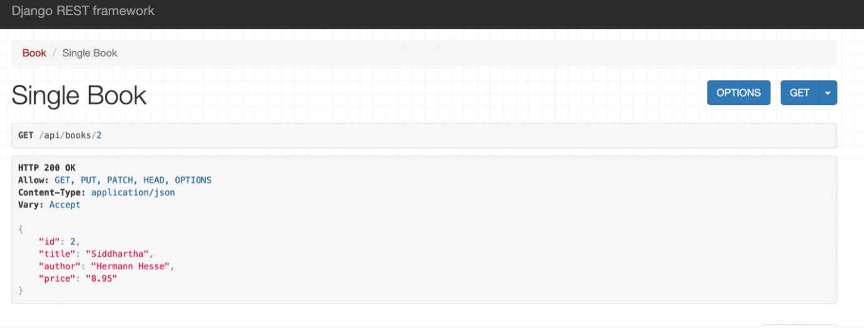

**Concluding Thoughts**

In this lab, you practiced creating a template for a book list using a Serializer in DRF. You also learned how to create and update data entries in a DRF view.

# Solution: Convert booklist API project to DRF

## Shell commands

# Activate virtual environment using pipenv

pipenv shell

pipenv install

# Making migrations

python3 manage.py makemigrations

python3 manage.py migrate

## Solution code for models.py

from django.db import models

# Create your models here.

class Book(models.Model):

    title = models.CharField(max\_length=255)

    author = models.CharField(max\_length=255)

    price = models.DecimalField(max\_digits=5, decimal\_places=2)

**Solution code for views.py**

from django.shortcuts import render

# Create your views here.

from .models import Book

from .serializers import BookSerializer

from rest\_framework import generics

class BookView(generics.ListCreateAPIView):

    queryset = Book.objects.all()

    serializer\_class = BookSerializer

class SingleBookView(generics.RetrieveUpdateAPIView):

    queryset = Book.objects.all()

    serializer\_class = BookSerializer

## Solution code for urls.py (Project-level)

from django.contrib import admin

from django.urls import path, include

urlpatterns = [

    path('admin/', admin.site.urls),

    path('api/', include('BookListDRF.urls')),

]

## Solution code for urls.py (App-level)

from django.urls import path

from . import views

urlpatterns = [

    path('books', views.BookView.as\_view()),

    path('books/<int:pk>', views.SingleBookView.as\_view()),

]

## ****Solution code for serializers.py****

from rest\_framework import serializers

from .models import Book

class BookSerializer(serializers.ModelSerializer):

    class Meta:

        model = Book

        fields = ['id','title','author','price']

# Additional resources

The following resources will be helpful as additional references in dealing with different concepts related to the topics you have covered in this section.

[Django rest framework toolkit for building web APIs](https://www.django-rest-framework.org/)

[Django debug toolbar documentation](https://django-debug-toolbar.readthedocs.io/en/latest/)

[Django Debug toolbar source code](https://github.com/jazzband/django-debug-toolbar)

[DRF router documentation](https://www.django-rest-framework.org/api-guide/routers/)

# V9.1

# Other types of serializers in DRF

## Introduction

You now know about serializers in DRF and you learned how to use model serializers to serialize model relationships. This reading has some interesting tips and tricks regarding serialization, like how to automatically display a nested model field using the depth option of the serializer. You will also learn how to display related model fields as hyperlinks by using the HyperlinkedRelatedField or by using a new type of serializer called the HyperlinkedModelSerializer.

**Note:** The code for this reading builds on what you just learned in the video, [Relationship serializers](https://www.coursera.org/learn/apis/lecture/oCEa9/draft-relationship-serializers).

## Nested fields

If you were to visit the **menu-items** endpoint, you would note the category displays as a nested field with its id, title, and slug.

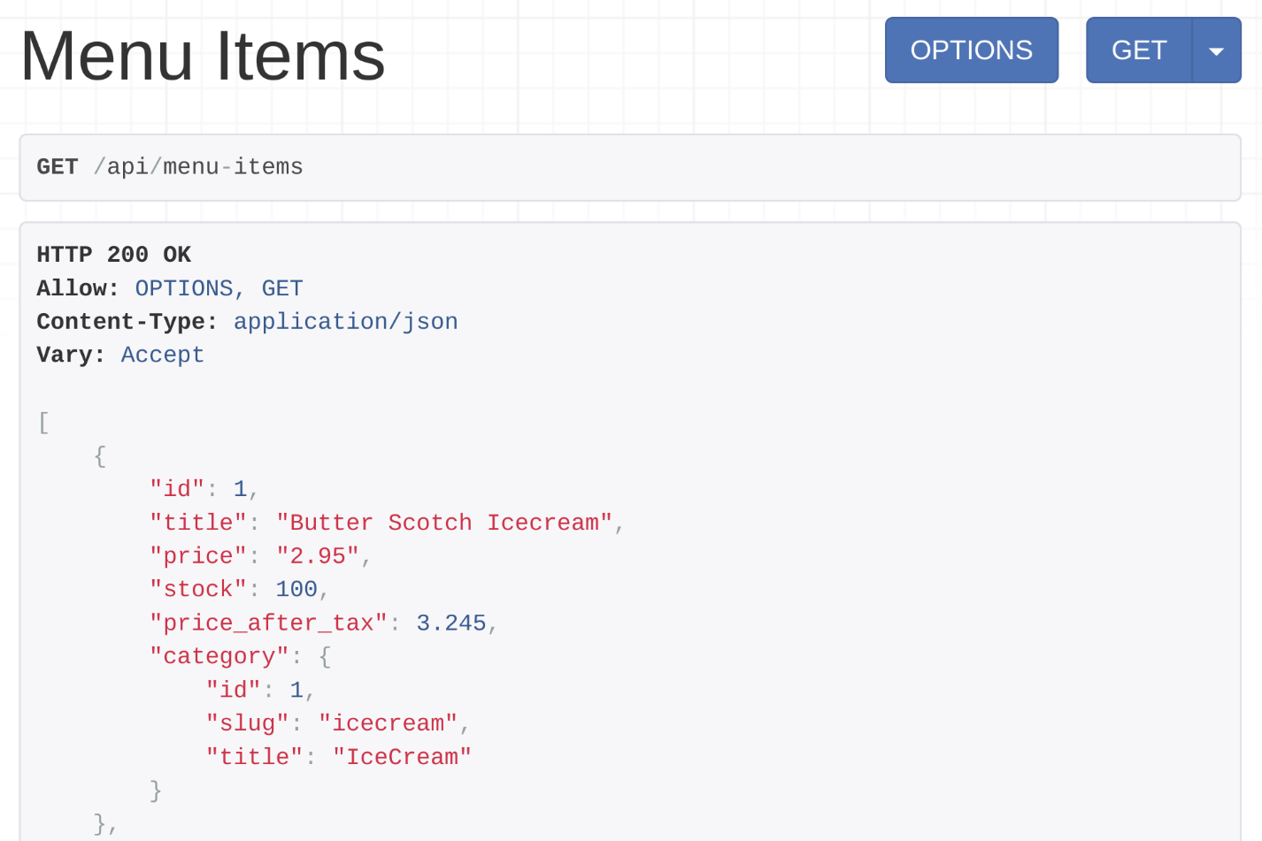

This can be achieved in two ways.

### Method 1

The first way to do this is to create a category serializer in **serializers.py** and include it in the menu item serializer as demonstrated in the code below.

from rest\_framework import serializers

from decimal import Decimal

from .models import MenuItem, Category

class CategorySerializer (serializers.ModelSerializer):

    class Meta:

        model = Category

        fields = ['id','slug','title']

class MenuItemSerializer(serializers.ModelSerializer):

    stock =  serializers.IntegerField(source='inventory')

    price\_after\_tax = serializers.SerializerMethodField(method\_name = 'calculate\_tax')

    category = CategorySerializer()

    class Meta:

        model = MenuItem

        fields = ['id','title','price','stock', 'price\_after\_tax','category']

    def calculate\_tax(self, product:MenuItem):

        return product.price \* Decimal(1.1)

### Method 2

There is another way of doing this. Instead of declaring the category field as **CategorySerializer** you can specify that **depth=1** is in the Meta class in **MenuItemSerializer**. This way, all relationships in this serializer will display every field related to that model.  You can change the code of the **MenuItemSerializer** as below.

class MenuItemSerializer(serializers.ModelSerializer):

    stock =  serializers.IntegerField(source='inventory')

    price\_after\_tax = serializers.SerializerMethodField(method\_name = 'calculate\_tax')

    # category = CategorySerializer()

    class Meta:

        model = MenuItem

        fields = ['id','title','price','stock', 'price\_after\_tax','category']

        depth = 1

    def calculate\_tax(self, product:MenuItem):

        return product.price \* Decimal(1.1)

Note the commented line, **category = CategorySerializer()**. And the new line, **depth = 1**, was added in the Meta class. Now, if you were to visit the menu items endpoint at **http://127.0.0.1:8000/api/menu-items** you’d note that the output is exactly the same as it was before.

Displaying nested fields this way provides more information. It also reduces the amount of code the client application developers need to write. This is because they don't have to make separate API calls to retrieve the details for those nested fields anymore.

Next, let’s focus on different serialization techniques that you can use to display related model fields as hyperlinks.

## Display a related model fields field as a hyperlink

In DRF you can display every related model field as a hyperlink in the API output. Like this: **http://127.0.0.1:8000/api/category/{categoryId}** for the category field. There are two different ways to do this. The first method is to use the serializer field called **HyperlinkedRelatedField** and for the second method you use the **HyperlinkedModelSerializer**.

### Method 1: HyperlinkedRelatedField

**Step 1: Create and map a new view function**

Every **HyperlinkedRelatedField** field in a serializer needs a **queryset** to find the related object and a view name that is used to map the hyperlinked URL pattern.

Thus you have to create a new function in the views.py file that will handle the **categoryId** endpoints.

from .models import Category from .serializers import CategorySerializer

@api\_view()

def category\_detail(request, pk):

    category = get\_object\_or\_404(Category,pk=pk)

    serialized\_category = CategorySerializer(category)

    return Response(serialized\_category.data)

Then you map this function in the **urls.py** file with a view name.

path('category/<int:pk>',views.category\_detail, name='category-detail')

***Tip:*** There is a convention you must follow when you create this view name. The rule is that you have to add **-detail** after the related field name, which is **category** in the **MenuItemSerializer**. This is why the view name was **category-detail** in this code. If the related field name was **user**, the view name would be **user-detail**.

**Step 2: Create a HyperLinkedRelatedField in the serializer**

The next step is to change the **MenuItemSerializer** code. The following code sets the category field as a **HyperLinkedRelatedField** in the **MenuItem** serializer.

from .models import Category

class MenuItemSerializer(serializers.ModelSerializer):

    stock =  serializers.IntegerField(source='inventory')

    price\_after\_tax = serializers.SerializerMethodField(method\_name = 'calculate\_tax')

    category = serializers.HyperlinkedRelatedField(

        queryset = Category.objects.all(),

        view\_name='category-detail'

    )

    class Meta:

        model = MenuItem

        fields = ['id','title','price','stock', 'price\_after\_tax','category']

    def calculate\_tax(self, product:MenuItem):

        return product.price \* Decimal(1.1)

Note how a **queryset** and a view name are provided in the category **HyperlinkedRelatedField**. The code follows the convention so you can remove the line, **view\_name='category-detail**. It is only necessary if you didn’t follow the convention and you created the view name in a different way in the **urls.py** file.

**Step 3: Add context**

The final step is to add context to the **MenuItemSerializer** in the **menu\_items** function, as below.

serialized\_item = MenuItemSerializer(items, many=True, context={'request': request})

**Note**: The argument **context={'request': request}** lets the **menu-items** endpoint display the category field as a hyperlink.

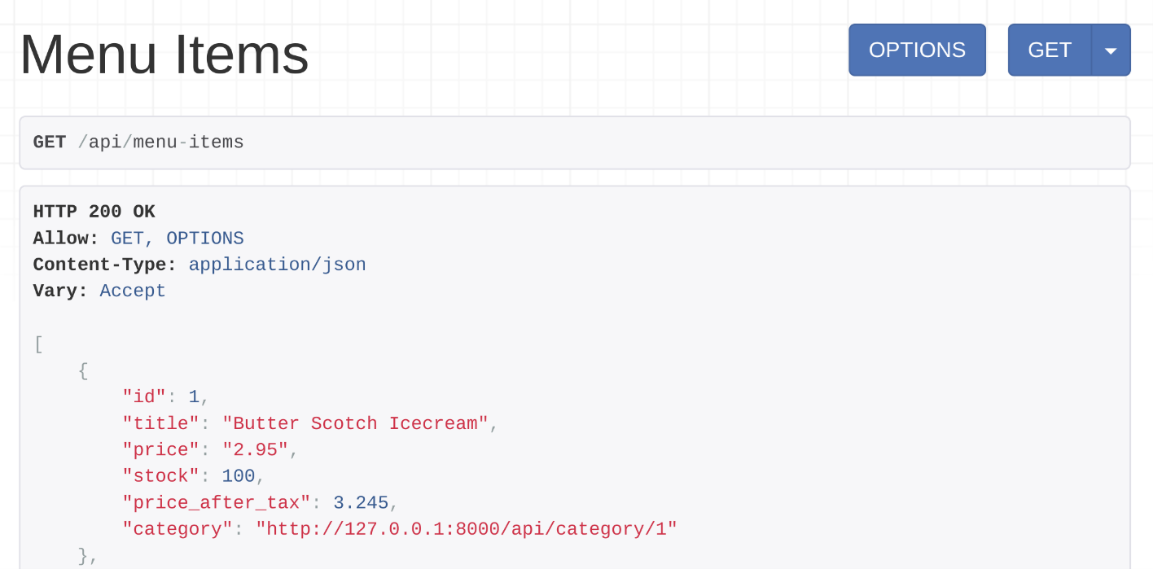

You can click on that hyperlink and check the category details.

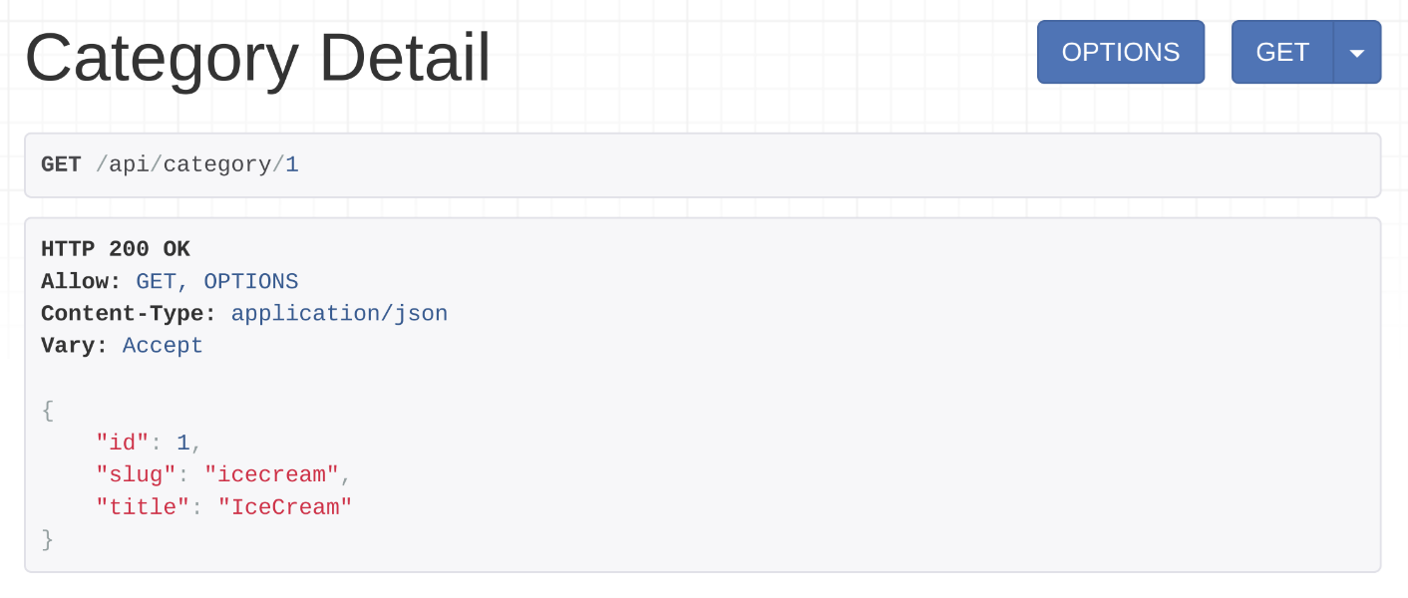

### Method 2: HyperlinkedModelSerializer

But there is another way to display a category field as a hyperlink. With this method, you need to change the code in the **serializers.py** file. so that the **MenuItemSerializer** extends the **serializers.HyperlinkedModelSerializer** class instead of the **serializers.ModelSerializer** class.

class MenuItemSerializer(serializers.HyperlinkedModelSerializer):

    stock =  serializers.IntegerField(source='inventory')

    price\_after\_tax = serializers.SerializerMethodField(method\_name = 'calculate\_tax')

    class Meta:

        model = MenuItem

        fields = ['id','title','price','stock', 'price\_after\_tax','category']

    def calculate\_tax(self, product:MenuItem):

        return product.price \* Decimal(1.1)

When you use the **HyperlinkedModelSerializer** the output of the **menu-items** endpoint produces the same output with a hyperlinked category field like in the screenshot in Method 1 but the code is much cleaner and simpler.

**Note**: When you use a **HyperlinkedModelSerializer**, you still need the URL pattern with a view name as you did in the previous section.

urlpatterns = [

    path('menu-items',views.menu\_items),

    path('menu-items/<int:id>',views.single\_item),

    path('category/<int:pk>',views.category\_detail, name='category-detail')

]

## Conclusion

In this reading, you learned to automatically display a nested model field using the depth option of the serializer. You also learned how to display a related field as a hyperlink using **HyperlinkedRelatedField** and **HyperlinkedModelSerializer**.

# V11.1

# Different types of renderers

## Introduction

Renderers are the core classes in DRF that display the API output in different formats like JSON and XML. You’ve already learned how to use the Browsable API renderer, JSON renderer, and a third-party renderer called XMLRenderer. In this reading, you are going to learn about a few other useful renderers that you can use in your API projects in DRF.

## TemplateHTMLRenderer

Sometimes, even in an API project, it might be required to display HTML output. For example, if you generate an invoicing API, you need to display the transaction and order details in a nicely formatted way using HTML and CSS. In such cases, DRF’s **TemplateHTMLRenderer** can help.

### Step 1

Using the **TemplateHTMLRenderer**, you can pass the data to an HTML file and then display that data using Django’s native templating language called DTL, or Django Templating Language.

To test this **TemplateHTMLRenderer** the menu items need to be displayed in an HTML file instead of JSON. To use this renderer, you first import it from the **rest\_framework.renderers** module in the **views.py** file. You also need to import the **renderer\_classes decorator**.

from rest\_framework.renderers import TemplateHTMLRenderer

from rest\_framework.decorators import api\_view, renderer\_classes

### Step 2

The second step is to create a new function called menu in the **views.py** file.

@api\_view()

@renderer\_classes ([TemplateHTMLRenderer])

def menu(request):

    items = MenuItem.objects.select\_related('category').all()

    serialized\_item = MenuItemSerializer(items, many=True)

    return Response({'data':serialized\_item.data}, template\_name='menu-items.html')

Note how the serialized data is passed as context to the HTML template file named **menu-items.html.** You need to put this HTML file inside the templates directory in your Django app, so the path of this file is: **LittleLemon/LittleLemonAPI/templates/menu-item.html**

### Step 3

The third step is to add the following templating code to this HTML file. This code block accepts the template data and displays them in a HTML table.

<!DOCTYPE html>

<html lang="en">

<head>

    <meta charset="UTF-8">

    <title>Menu Items</title>

</head>

<body>

    <table width="100%" style="text-align: left;">

        <tr>

            <th>Item</th> <!-- item column heading -->

            <th>Price</th> <!-- price column heading -->

            <th>Price After Tax</th> <!-- price after tax column heading -->

            <th>Stock</th> <!-- stock column heading -->

        </tr>

        {% for item in data %}

        <tr>

            <td>{{ item.title }}</td>

            <td>{{ item.price }}</td>

            <td>{{ item.price\_after\_tax }}</td>

            <td>{{ item.stock }}</td>

        </tr>

        {% endfor %}

    </table>

</body>

</html>

### Step 4

The final step is to map this function to an API endpoint in the urls.py file so that it can be browsed as **http://127.0.0.1:8000/api/menu**.

from django.urls import path

from . import views

urlpatterns = [

    path('menu-items',views.menu\_items),

    path('menu-items/<int:id>',views.single\_item)

    path('menu',views.menu),

]

Now the **http://127.0.0.1:8000/api/menu** API endpoint displays all the menu items in a nicely formatted HTML table.

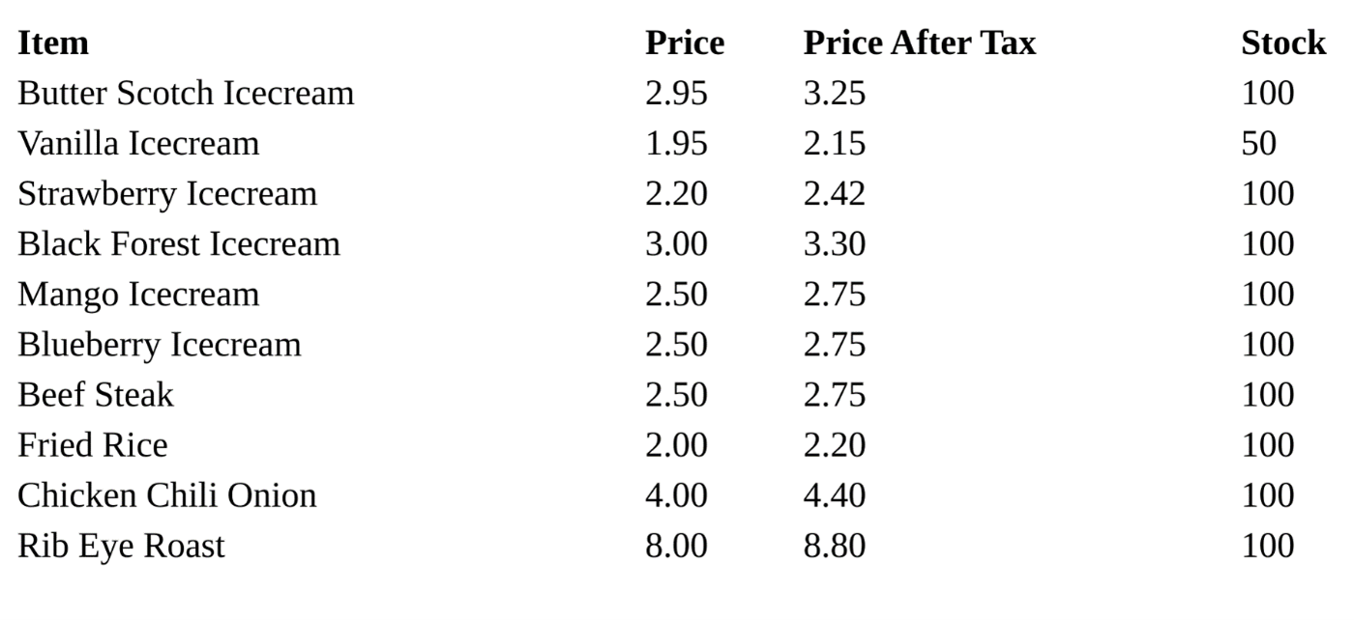

## StaticHTMLRenderer

You can use the **StaticHTMLRenderer** if any of your API endpoints need to display some HTML content without using any DTL code inside an HTML file.

### Step 1

The first step is to import the **StaticHTMLRenderer** class and **renderer\_classes** decorator like before.

from rest\_framework.renderers import TemplateHTMLRenderer

from rest\_framework.decorators import api\_view, renderer\_classes

### Step 2

Then you need to create a new function called welcome in the **views.py** file.

@api\_view(['GET'])

@renderer\_classes([StaticHTMLRenderer])

def welcome(request):

    data = '<html><body><h1>Welcome To Little Lemon API Project</h1></body></html>'

    return Response(data)

### Step 3

The final step is to map this endpoint to an API endpoint. This time, you want to display this message whenever someone visits the endpoint **http://127.0.0.1:8000/api/welcome**. To do this, you need to open the **urls.py** file and add the following line to the **urlpatterns** list:

path('welcome',views.welcome)

This greeting will now display if someone visits this endpoint.

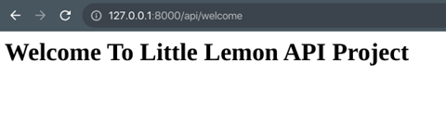

## CSV renderer

CSV, or comma-separated values, is another popular format used by API developers. Unlike JSON or XML, every field in a database record is displayed separated by a comma and every record is on a new line.

### Step 1

DRF doesn’t come with a CSV renderer class by default. So the first step is to install a popular third-party package using pipenv.

pipenv install djangorestframework-csv

### Step 2

Import this renderer in the **views.py** file.

from rest\_framework\_csv.renderers import CSVRenderer

### Step 3

Add the renderer using the **renderer\_classes** decorator to convert an API endpoint to display CSV instead of JSON. Add the following line of code in the **menu-items** function after the **@api\_view()** decorator:

@renderer\_classes([CSVRenderer])

Now if you visit the endpoint **http://127.0.0.1:8000/api/menu-items** in a REST API client like Insomnia, you’d get the following output.

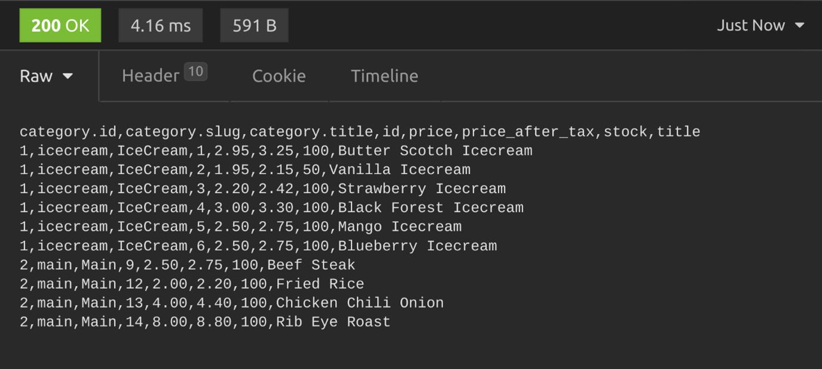

## YAML renderer

### Step 1

To display the output of your APIs in YAML, another popular data format, you need to install the **djangorestframework-yaml** using pipenv.

pipenv install djangorestframework-yaml

### Step 2

To test it with the **menu-items** function, import this YAML renderer in the **views.py** file.

from rest\_framework\_yaml.renderers import YAMLRenderer

## Step 3

Pass the **YAMLRenderer** class inside the **renderer\_classes** decorator, just below the **api\_view decorator** above the **menu-items** function.

@renderer\_classes([YAMLRenderer])

Now if you visit the endpoint **http://127.0.0.1:8000/api/menu-items** in a REST API client like Insomnia, the menu items will be visible.

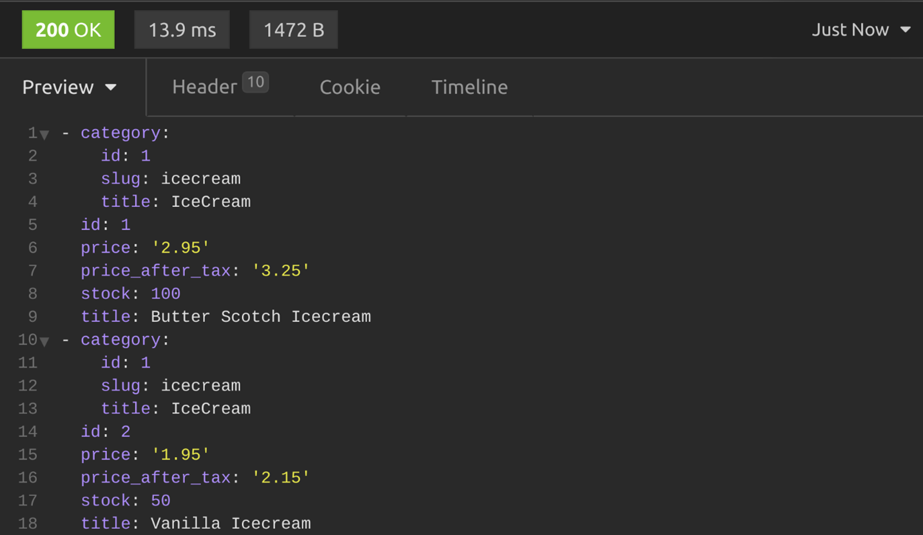

**Global settings**

Instead of importing the CSV and YAML renderer classes individually in the views.py file and then passing them to the **renderer\_classes** decorator above each function, you can make them available globally in your API project. In this way, the client can get the desired output with a valid **Accept** header.

To make these renderers available globally, add the following two lines in the **settings.py** file in the **DEFAULT\_RENDERER\_CLASSES** section.

'rest\_framework\_csv.renderers.CSVRenderer',

'rest\_framework\_yaml.renderers.YAMLRenderer',

 This is what the **DEFAULT\_RENDERER\_CLASSES** section will be like after adding those two lines.

REST\_FRAMEWORK = {

    'DEFAULT\_RENDERER\_CLASSES': [

        'rest\_framework.renderers.JSONRenderer',

        'rest\_framework.renderers.BrowsableAPIRenderer',

        'rest\_framework\_xml.renderers.XMLRenderer',

        'rest\_framework\_csv.renderers.CSVRenderer',

        'rest\_framework\_yaml.renderers.YAMLRenderer',

    ]

}

Now the client can send the following **Accept** headers to receive the API output in their desired format.

| **Response type** | **Request header** |
| --- | --- |
| CSV | **Accept: text/csv** |
| YAML | **Accept: application/yaml** |

**Conclusion**

In this reading, you have learned how to use different types of renderers in your DRF-based API project to display API output in different formats. There is a dedicated section on renderers in the DRF documentation, which you can access in the additional resources of this lesson. It showcases other types of renderers you can use with the Django REST Framework.

**Exercise: Restaurant menu API using serialization**

Open Lab

**Instructions**

**Goal**

In this lab, you will use serialization, validation and deserialization techniques to display API data in JSON and XML format using DRF.

**Objectives**

* Create HTML forms with DRF and add new items inside it
* Validate form data that has been added with DRF

**Introduction**

In this lab, you will create an API for updating the Menu of the Little Lemon restaurant.

**Scenario**

You have been tasked with creating an app and website for the Little Lemon restaurant that will allow the managers to update the inventory and price of menu items.

**Learner Instructions**

This lab requires you to modify the following files:

* **views.py**
* **urls.py** (on app-level)
* **serializers.py**
* **models.py**
* **settings.py**

Start the development server on the localhost and go to the URL to confirm the desired view on the webpage.

When required, Open the **Terminal** by selecting **New Terminal** under the **Terminal** Menu option in VSCode.

The Django project called **LittleLemon** and Django app called **LittleLemonDRF** are already in place.

**Note:** Before you begin, make sure you understand how to work with the Coursera Code Lab for the [APIS course](https://www.coursera.org/learn/apis/supplement/WXiq5/working-with-labs-in-this-course).

Follow the instructions below and ensure you check the output at every step.

**Note:** The settings for the project level and app level **urls.py** file have already been updated.

**Instructions**

**Step 1:**

Open the **models.py** file and create a class called MenuItem inside it and pass models.Model to it as a parameter.

**Step 2:**

Create the three attributes you need in the model (title, price and inventory) and assign the respective form fields to them. Additionally, pass the following arguments to those form fields:

| **Attribute** | **Form field type** | **Arguments** |
| --- | --- | --- |
| title | CharField | max\_length = 255 |
| price | DecimalField | max\_digits=6, decimal\_places=2 |
| inventory | SmallIntegerField |  |

**Step 3:**

Now create a file called **serializers.py** inside the **LittleLemonDRF** directory at the app-level.

**Step 4:**

Open the file and import:

* TheMenuItemclass from the **models** file
* The serializers package from the rest\_framework

**Step 5:**

Create a class called **MenuItemSerializer** and pass the class object **serializers.ModelSerializer** to it as an argument

**Step 6:**

Inside the **MenuItemSerializer** class, create another class called **Meta** and add the following code inside the class:

* Assign the **MenuItem** model to a variable called model
* Create a variable called **fields** and assign the list of strings with four elements to it namely:'id','title','price'and'inventory'
* Create a variable **extra\_kwargs** and assign a nested dictionary to it consisting of two items that are defined as below:

1. Key:'price'

Value: dictionary with one item that has 'min\_value' as key and 2 as value

1. Key:'inventory'

Value: dictionary with one item that has 'min\_value' as key and 0 as value

Replace appropriate keys & values in the structure of the dictionary that will appear as below:

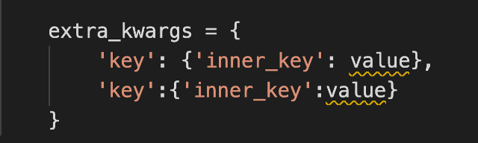

**Step 7:**

Open the **settings.py** file inside the **LittleLemon** project-level directory.

Locate the code in the screenshot below and follow the instructions provided below to update the code:

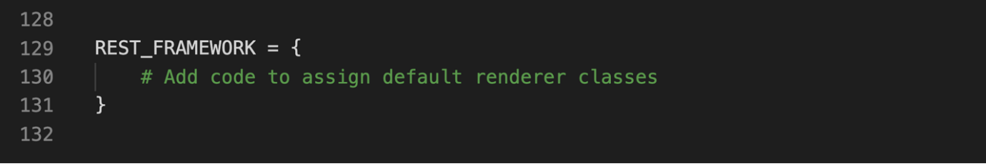

Create a string called 'DEFAULT\_RENDERER\_CLASSES' and assign a list to it containing the following items:

* 'rest\_framework.renderers.JSONRenderer'
* 'rest\_framework.renderers.BrowsableAPIRenderer'
* 'rest\_framework\\_xml.renderers.XMLRenderer'

**Note:** *Make sure you add a comma ( , ) after each of the elements added inside the list*

**Step 8:**

Open the file **views.py** and import the following to it:

* Import theMenuItemmodel from the**models**file
* ImportMenuItemSerializerfrom**serializer**file
* Importgenericsfrom the DRF packagerest\_framework

**Step 9:**

Create a class called MenuItemsView and pass generics.ListCreateAPIView to it as an argument.

**Step 10:**

Inside the MenuItemsView class:

* Assign the value of MenuItem.objects.all() to a variable called queryset
* Assign the value of MenuItemsSerializer to a variable called serializer\_class

**Step 11:**

Create another class called SingleMenuItemView and pass generics.RetrieveUpdateDestroyAPIView to it as an argument.

Inside the class SingleMenuItemView, copy the same code that you have added inside the class MenuItemsView

**Note:**  *There are two views with the same code but their implementation will be different according to the arguments we have passed to the class. In line with it, the URL configurations for both these files will also be different, one will be used to implement the****GET****method and another one for the****POST****method.*

**Step 12:** Open the file **urls.py** at the app-level directory **LittleLemonDRF** and remove the comments for the following lines of code:

# path('menu-items', views.MenuItemsView.as\_view()),

# path('menu-items/<int:pk>', views.SingleMenuItemView.as\_view()),

This will set the URL configurations for the two views you have defined.

**Step 13:**

Open the **Terminal** in **VS Code** and run the two commands to perform the migrations.



**Step 14:**

Once the migrations are performed successfully, run the command to start the server on the localhost and go to the URL:

http://127.0.0.1:8000/api/menu-items

The view will be similar to the one you have seen earlier while building the Book list project.

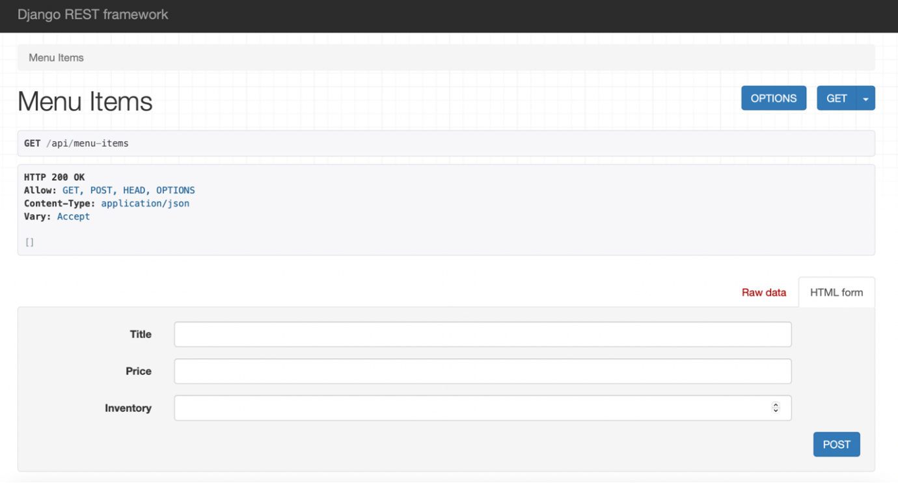

**Step 15:** Update the form to add new menu item with the details provided below:

* Title: Grilled Fish
* Price: 8.50
* Inventory: 20

Press the **POST** button at the bottom of the screen.

You should see the result of the **POST** request sent with status code **HTTP 200 OK** on the screen as below:

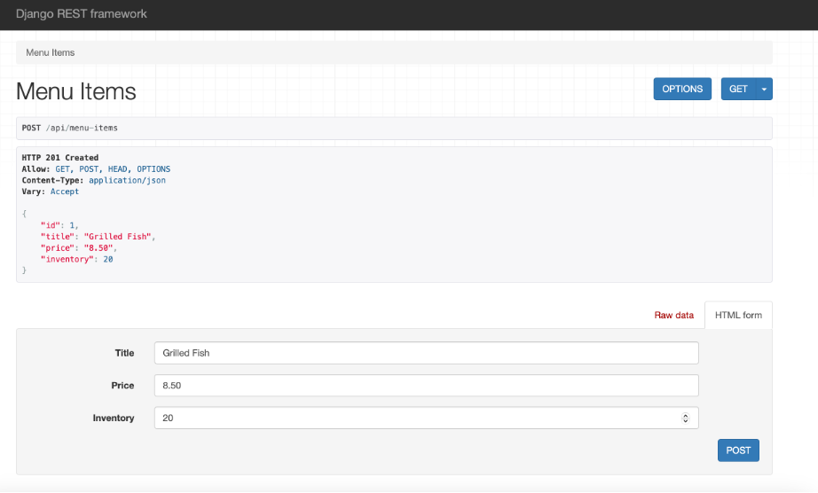

**Step 15:**

Now add four more entries inside the form in the order below:

* Title: Greek Salad
* Price: 5.00
* Inventory: 50
* Title: Bruschetta
* Price: 6.50
* Inventory: 25
* Title: Pasta Carbonara
* Price: 6.50
* Inventory: 25
* Title: Lemon Dessert
* Price: 1.5
* Inventory: -1

Once you enter the **5**th entry for **Lemon Dessert**, you should be able to see an output such as in the screenshot below. This is a basic way of performing form validation in DRF.

**Note:** Recall the extra\_kwargs values updated inside the MenuItemSerializer class.

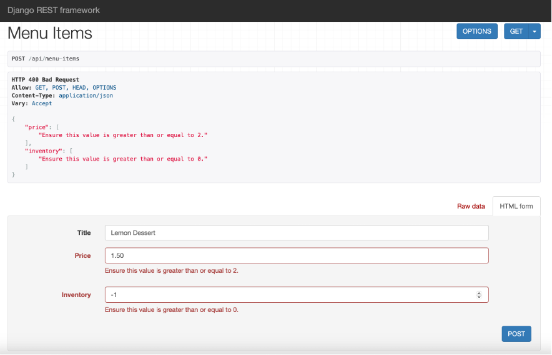

Change the values in the form to acceptable values as below:

* Title: Lemon Dessert
* Price: 4.50
* Inventory: 10

**Step 16:** Now go to the URL:

http://127.0.0.1:8000/api/menu-items/4

You will see a new red button for **DELETE** added on your web page. Additionally, notice the **POST** button has now changed to **PUT**.

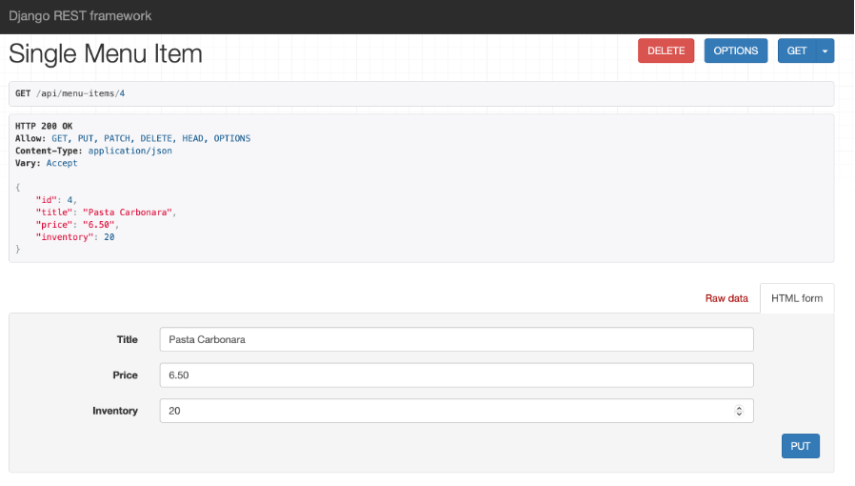

**Step 17:**

Keeping the **Title** unchanged, update the form with the following changes for the item with **id=4** which is **Pasta Carbonara**:

* Price: 7.50
* Inventory: 15

Once you press the **PUT** button, the changes will be updated across your database table.

Now press the **DELETE** button on the screen and confirm the deletion of the menu item by pressing **Delete** on the pop-up that appears.

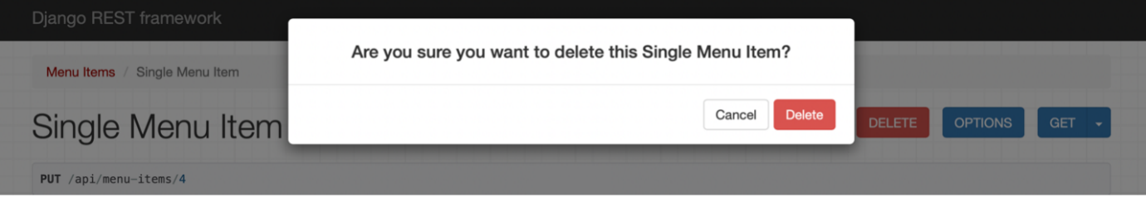

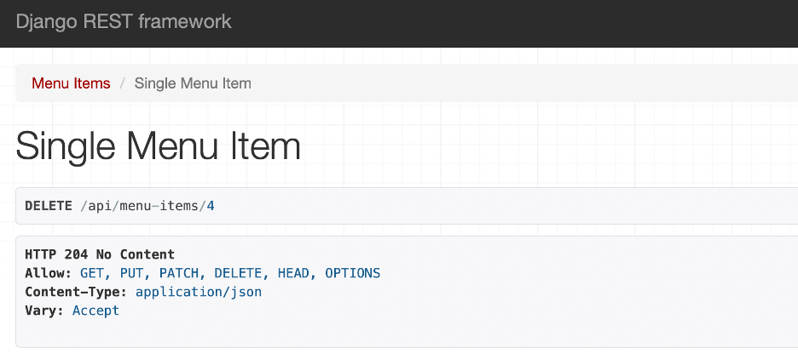

On completing this step, the form will update to show **HTTP 204 No Content status**.

Press on the **Menu Items** button in the left-top corner and you will see the entry with **id** value **4** has been deleted.

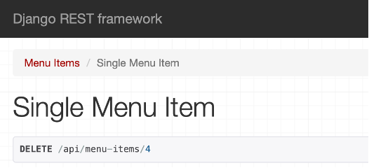

**Additional Steps:**

1. Go to the URL below to see the form data you have added in the JSON format:

http://127.0.0.1:8000/api/menu-items?format=xml

You should be able to see a screen such as:

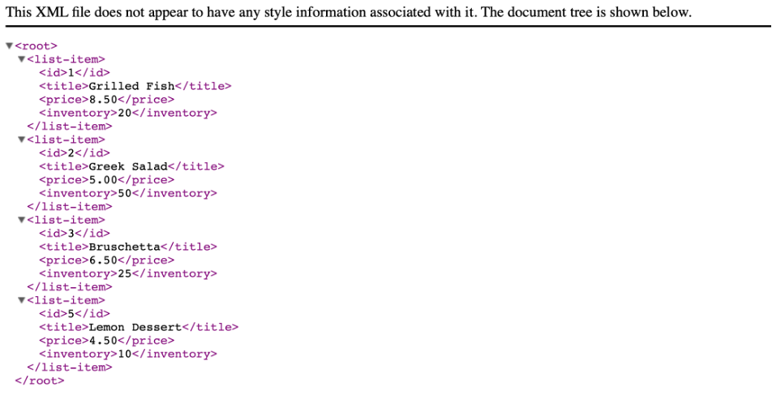

1. Go to the URL below to see the form data you have added in the XML format:

http://127.0.0.1:8000/api/menu-items?format=json

You should be able to see a screen such as:

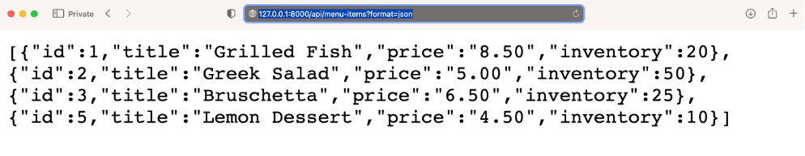

# Solution: Restaurant menu API using serialization

## Shell commands

# Activate virtual environment using pipenv

pipenv shell

pipenv install

# Making migrations

python3 manage.py makemigrations

python3 manage.py migrate

## Solution for models.py

from django.db import models

# Create your models here.

class MenuItem(models.Model):

    title = models.CharField(max\_length=255)

    price = models.DecimalField(max\_digits=6, decimal\_places=2)

    inventory = models.SmallIntegerField()

## Solution for urls.py (App-level)

from django.urls import path

from . import views

urlpatterns = [

    path('menu-items', views.MenuItemsView.as\_view()),

    path('menu-items/<int:pk>', views.SingleMenuItemView.as\_view()),

]

## Solution for views.py

from rest\_framework import generics

from .models import MenuItem

from .serializers import MenuItemSerializer

class MenuItemsView(generics.ListCreateAPIView):

    queryset = MenuItem.objects.all()

    serializer\_class = MenuItemSerializer

class SingleMenuItemView(generics.RetrieveUpdateDestroyAPIView):

    queryset = MenuItem.objects.all()

    serializer\_class = MenuItemSerializer

## Solution for serializers.py

from rest\_framework import serializers

from .models import MenuItem

class MenuItemSerializer(serializers.ModelSerializer):

    class Meta:

        model = MenuItem

        fields = ['id','title','price','inventory']

        extra\_kwargs = {

            'price': {'min\_value': 2},

            'inventory':{'min\_value':0}

        }

## Relevant code for settings.py

REST\_FRAMEWORK = {

    'DEFAULT\_RENDERER\_CLASSES': [

        'rest\_framework.renderers.JSONRenderer',

        'rest\_framework.renderers.BrowsableAPIRenderer',

        'rest\_framework\_xml.renderers.XMLRenderer',

    ]

}

# Additional resources

The following resources will be helpful as additional references in dealing with different concepts related to the topics you have covered in this section.

[XML renderer, XML support for Django REST framework](https://jpadilla.github.io/django-rest-framework-xml/)

[YAML renderer, YAML support for Django REST framework](https://jpadilla.github.io/django-rest-framework-yaml/)

[JSONP renderer, JSONP support for Django REST framework](https://jpadilla.github.io/django-rest-framework-jsonp/)

**V2.1**

**Importance of data validation**

**Introduction**

Data validation is an important step in every web application because it ensures that user data is valid and sufficient. In this reading, you will learn about different validation techniques in DRF.

**Validation**

Validation is the process of ensuring that user-submitted data is in the correct format, meets the requirements and is safe to add to the database. The serializers in DRF provide different features which you can use to validate these data while building your APIs. Before jumping into the details let’s examine some user inputs while adding or modifying the menu items in the Little Lemon API project and how they should be validated.

| **Field** | **Value** | **Status** |
| --- | --- | --- |
| **price** | 0 | Invalid, because the price of a menu item cannot be 0 |
| **stock** | negative value | Invalid, because stock of a menu item cannot be lower than 0 |
| **title** | Duplicate values | Invalid, because there should not be more than one menu item with the same name or title |

Besides these common validations, every project has additional requirements. For example, in the Little Lemon project, you can set it so that the price can’t be less than 2.0. And if someone tries to add items with a price below 2.0, it will raise an error. Some of the validation functionalities in DRF will now be discussed.

**Validation in DRF**

There are two serializers in the **serializers.py** file, **MenuItemSerializer** and **CategorySerializer**.

from rest\_framework import serializers

from decimal import Decimal

from .models import MenuItem, Category

class CategorySerializer (serializers.ModelSerializer):

    class Meta:

        model = Category

        fields = ['id','slug','title']

class MenuItemSerializer(serializers.ModelSerializer):

    stock =  serializers.IntegerField(source='inventory')

    price\_after\_tax = serializers.SerializerMethodField(method\_name = 'calculate\_tax')

    category\_id = serializers.IntegerField(write\_only=True)

    category = CategorySerializer(read\_only=True)

    class Meta:

        model = MenuItem

        fields = ['id','title','price','stock', 'price\_after\_tax','category','category\_id']

    def calculate\_tax(self, product:MenuItem):

        return product.price \* Decimal(1.1)

What follows are four different ways in which to modify some fields in the **MenuItemSerializer**.

### Method 1: Conditions in the field

For the price field, the validation rule is that it should not accept prices less than 2.0. To achieve that result, add the following line before the Meta class in the **MenuItemSerializer**.

price = serializers.DecimalField(max\_digits=6, decimal\_places=2, min\_value=2)

If you make a **POST** call to the menu-items endpoint, with the price set to 1, DRF will display the error that the price should be greater than or equal to 2. The validation works.

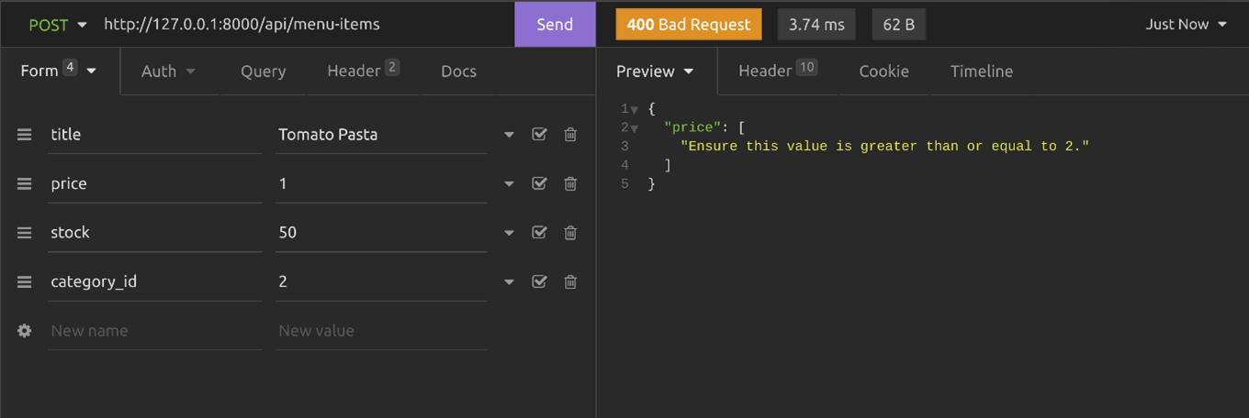

### Method 2: Using keyword arguments in the Meta class

If the field is not declared above the Meta field, you can still validate it using keyword arguments in the Meta class. For this method, you need to remove the line you added in the previous section. Add an **extra\_kwargs** section in the Meta class with the following code. This **extra\_kwargs** section allows you to add additional properties and validations for every field in the serializer.

class Meta:

        model = MenuItem

        fields = ['id','title','price','stock', 'price\_after\_tax','category','category\_id']

        extra\_kwargs = {

            'price': {'min\_value': 2},

        }

If you send the previous **POST** call, you will see the same error displayed in Method 1.

You can add additional validation so that the stock cannot go below 0. Add the following line in the **extra\_kwargs** section in the Meta class.

'stock':{'source':'inventory', 'min\_value': 0}

Here is the complete code of **MenuItemSerializer** class.

class MenuItemSerializer(serializers.ModelSerializer):

    price\_after\_tax = serializers.SerializerMethodField(method\_name = 'calculate\_tax')

    category\_id = serializers.IntegerField(write\_only=True)

    category = CategorySerializer(read\_only=True)

    class Meta:

        model = MenuItem

        fields = ['id','title','price','stock', 'price\_after\_tax','category','category\_id']

        extra\_kwargs = {

            'price': {'min\_value': 2},

            'stock':{'source':'inventory', 'min\_value': 0}

        }

    def calculate\_tax(self, product:MenuItem):

        return product.price \* Decimal(1.1)

If you send a negative stock value in an HTTP **POST** call, DRF will give you an error like in the screenshot below.

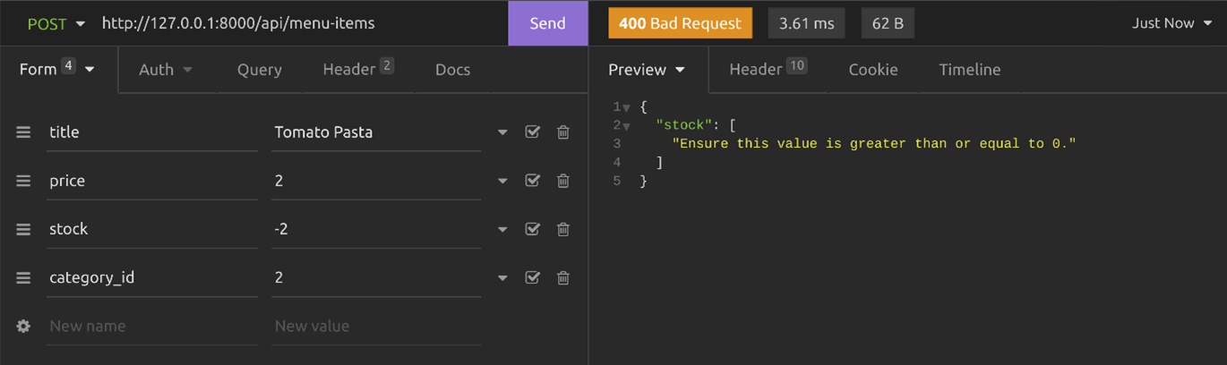

### Method:3 Using validate\_field() method

Serializers in DRF provide you with another clean way of validating user input by writing **valid\_field()** methods, where you replace the field with an actual field name. If the field name is price, the method name has to be **validate\_price()**. If the field name is stock, then the method name has to be **validate\_stock()**.

Add the following two methods above the Meta class in the **MenuItemSerializer.**

def validate\_price(self, value):

        if (value < 2):

            raise serializers.ValidationError('Price should not be less than 2.0')

def validate\_stock(self, value):

        if (value < 0):

            raise serializers.ValidationError('Stock cannot be negative')

In these methods, the user-submitted data is passed as a value. As the API developer you need to check if the value meets the requirement, otherwise, raise the **ValidationError** with a message.

Test this by sending a **POST** request with invalid values in the price and stock fields. You should get the error message displayed in the screenshot below.

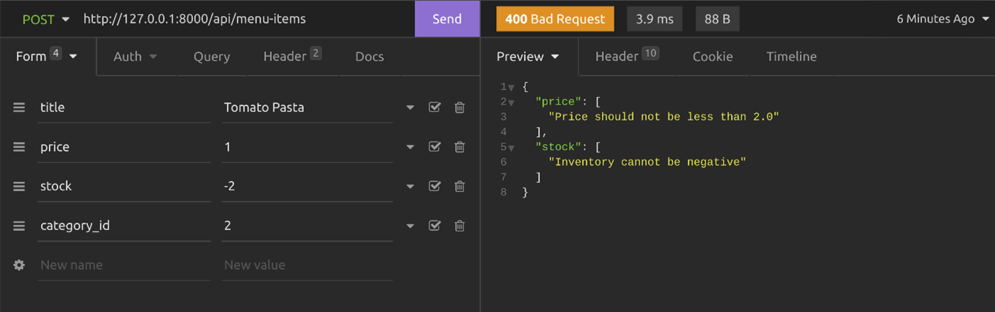

### Method 4: Using the validate() method

You can add a **validate()** method in the serializer and validate multiple field values at once. DRF will pass all input values to this method. Here’s an example of how to validate the price and inventory values using a **validate()** method.

**Note:** To follow this method you need to remove the previous two methods **validate\_stock** and **validate\_price** **in the serializer.**

Add the following code above the Meta class in the **MenuItemSerializer**.

def validate(self, attrs):

        if(attrs['price']<2):

            raise serializers.ValidationError('Price should not be less than 2.0')

        if(attrs['inventory']<0):

            raise serializers.ValidationError('Stock cannot be negative')

        return super().validate(attrs)

**Note:**  You used the actual field name for validating the stock which is inventory. If you send a **POST** request to the **menu-items** endpoint, you will see an error like the screenshot below.

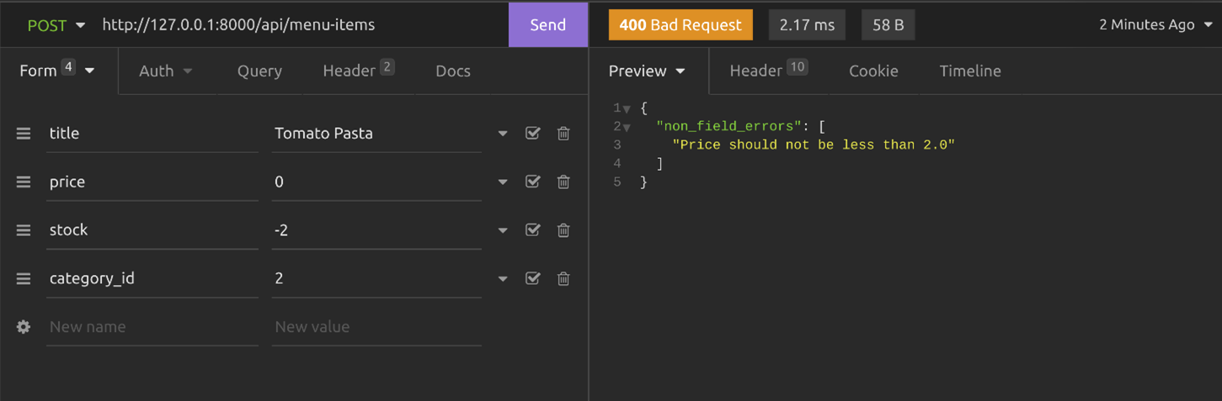

## Unique validation

Sometimes API developers need to make sure that there is no duplicate entry made by the clients. In such cases, unique validators become useful. Using this validator, you can ensure the uniqueness of a single field or combination of fields. Let’s examine how to use this validator. For a single field, use **UniqueValidator** class and for the combination of fields, use **UniqueTogetherValidator**.

### UniqueValidator

First, import the classes.

from rest\_framework.validators import UniqueValidator

Or

from rest\_framework.validators import UniqueTogetherValidator

 To make sure that the title field remains unique in the **MenuItems** table, you can add the following code in the **extra\_kwargs** section in the Meta class. Here's an example of using **UniqueValidator** for the title field.

extra\_kwargs = {

            'title': {

                'validators': [

                    UniqueValidator(

                        queryset=MenuItem.objects.all()

                    )

                ]

            }

        }

Or you can add it when declaring a field above Meta class, like this.

title = serializers.CharField(

        max\_length=255,

        validators=[UniqueValidator(queryset=MenuItem.objects.all())]

    )

 If the client sends a duplicate entry, they will see an error as below.

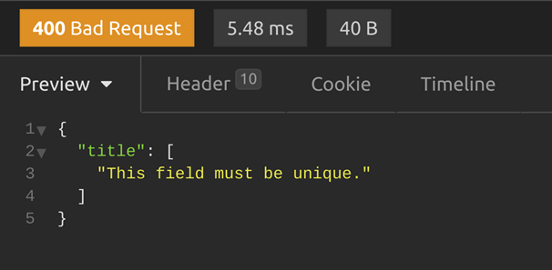

### UniqueTogetherValidator

When you want to use **UniqueTogetherValidator** validator, the code will be a little different. Here’s a sample code that will make the combination of **title** and **price** field unique. With this validation, there will be no duplicate entry of an item with the same price. This code goes directly inside the Meta class.

validators = [

            UniqueTogetherValidator(

                queryset=MenuItem.objects.all(),

                fields=['title', 'price']

            ),

        ]

If the client sends a duplicate entry, they will see an error as below.

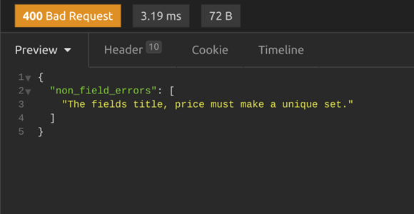

**Conclusion**

In this reading, you learned about the importance of data validation and four different methods that you can follow to modify certain fields in the **MenuItemSerializer** to validate data in DRF.

# V2.2

# Data sanitization

## Introduction

Sanitization is the process of cleaning data from potential threats. Without proper sanitization, your API project can be exploited using common attacks like SQL injection. Additionally, client applications can suffer attacks like cross-site scripting or session hijacking via injecting JavaScript. For such cases, doing data validation is not enough. While Django performs different types of sanitization behind the scenes, you can set in motion additional sanitization processes to meet project-specific requirements.

In this reading, you will learn how to avoid script injection and SQL Injection using data sanitization techniques in DRF.

## Sanitize HTML and JavaScript

Unless it is intended, you should always check if the user client added an HTML tag inside the data and neutralized it by converting special HTML characters into HTML entities. This is because hackers can use **<script>** tags to inject JavaScript and **<img>** tags to add unwanted trackers.

Imagine someone inputs **Tomato Pasta <script>alert(‘hello’)</script>** as a menu item. If you don’t sanitize the data, the script tag will successfully execute when you display this menu title. Attackers can inject malicious scripts in this way. An alert like **(‘hello’)** cannot do any harm, but attackers can inject malicious code which can be harmful.

There is a popular third-party package called bleach that can help you to clean this. It will convert all HTML special characters like **<’, ‘>** and other tags to HTML entities so that the browser doesn’t execute them as HTML anymore.

## Install bleach

### Step 1

Install the bleach package using pipenv first.

pipenv install bleach

### Step 2

Import the bleach module in the **serializers.py** file.

import bleach

### Step 3

Sanitize the field data using both the **validate\_field()** and **validate()** methods. Inside these validation methods, you have to use the **clean()** function provided by the bleach module to clean up the input data.

To sanitize the title field, write a **validate\_title()** method above the Meta class in the **MenuItemSerializer**.

def validate\_title(self, value):

        return bleach.clean(value)

### Test it

If you send a **POST** request to the **menu-items** endpoint with HTML tags in the title field, the input data submitted by the client or user will be sanitized properly. Note how the script tag has been converted to HTML entities in the screenshot below.

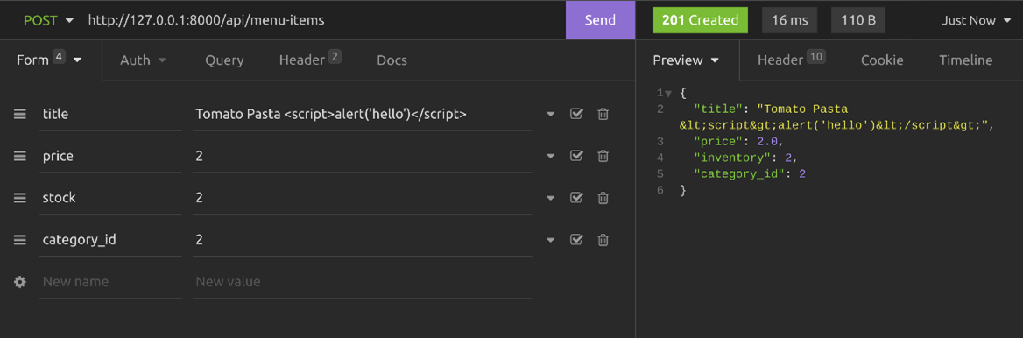

Without sanitization, the input data will be saved in the database as it was submitted.

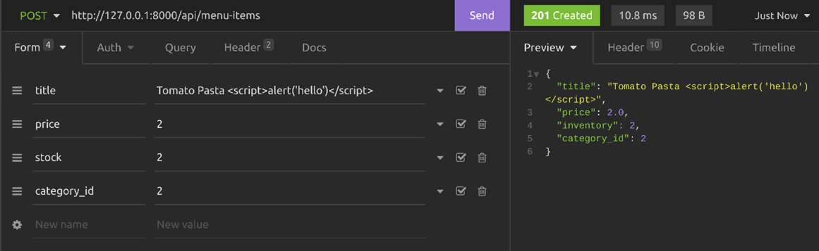

You can also sanitize the title field inside the validate method using this line of code.

attrs['title'] = bleach.clean(attrs['title'])

This way, you can sanitize multiple fields from one single place. Here is the complete **validate()** method inside the **MenuItemSerializer**.

def validate(self, attrs):

        attrs['title'] = bleach.clean(attrs['title'])

        if(attrs['price']<2):

            raise serializers.ValidationError('Price should not be less than 2.0')

        if(attrs['inventory']<0):

            raise serializers.ValidationError('Stock cannot be negative')

        return super().validate(attrs)

## Preventing SQL injection

SQL injection is commonly used by attackers by injecting SQL queries in the input data to perform malicious actions in the database.

Preventing SQL injection is comparatively easy. Although it is usually not advisable to run raw SQL there are cases where it’s necessary. Still, if you really need to run raw SQL, you must escape the parameters using string placeholders.  You should never keep the placeholder inside quotations because then you will be at risk of SQL injection. Below are one correct and two incorrect examples of preventing SQL injection.

**Note:** Always avoid running raw SQL queries unless it is absolutely necessary.

### Correct way: Using parameterized query and no quotation

limit = request.GET.get(‘limit’)

MenuItem.objects.raw('SELECT \* FROM LittleLemonAPI\_menuitem LIMIT %s', [limit])

### Incorrect: Using string formatting

limit = request.GET.get(‘limit’)

MenuItem.objects.raw('SELECT \* FROM LittleLemonAPI\_menuitem LIMIT %s' % limit)

### Incorrect: Using a string placeholder inside quotation

limit = request.GET.get(‘limit’)

MenuItem.objects.raw(“SELECT \* FROM LittleLemonAPI\_menuitem LIMIT ‘%s' “, [limit])

## Conclusion

In this reading, you learned that it is important to sanitize data to protect data from potential threats such as script injection and SQL injection. You now know about a few practical ways to sanitize your data in DRF.

# V3.1

# More on filtering and pagination

## Introduction

You already know how to use filtering and pagination using function-based views in your DRF project. But, there are also some interesting filtering classes available in DRF which can help you to quickly implement these features in a class-based view. In this reading, you will learn how to use these built-in classes for filtering, searching and pagination.

## Scaffolding the project

### Step 1

To scaffold the project you have to use a class-based view extending the **ModelViewSet** to quickly implement a functional CRUD API endpoint for the menu items. To create this class-based view you should add the following code lines in the **views.py** file.

from rest\_framework.response import Response from rest\_framework import viewsets from .models import MenuItem from .serializers import MenuItemSerializer

class MenuItemsViewSet(viewsets.ModelViewSet):

    queryset = MenuItem.objects.all()

    serializer\_class = MenuItemSerializer

### Step 2

The second step is to open the **urls.py** file and map the **MenuItemViewSet** class to the **menu-items** endpoint. You only map the **GET** methods.

from django.urls import path

from . import views

urlpatterns = [

    path('menu-items',views.MenuItemsViewSet.as\_view({'get':'list'})),

    path('menu-items/<int:pk>',views.MenuItemsViewSet.as\_view({'get':'retrieve'})),

]

### Step 3

The final step is to open the **settings.py** file and add **OrderingFilter** and **SearchFilter** classes as **DEFAULT\_FILTER\_BACKENDS** in the **REST\_FRAMEWORK** section.

REST\_FRAMEWORK = {

    'DEFAULT\_RENDERER\_CLASSES': [

        'rest\_framework.renderers.JSONRenderer',

        'rest\_framework.renderers.BrowsableAPIRenderer',

        'rest\_framework\_xml.renderers.XMLRenderer',

    ],

    'DEFAULT\_FILTER\_BACKENDS': [

        'django\_filters.rest\_framework.DjangoFilterBackend',

        'rest\_framework.filters.OrderingFilter',

        'rest\_framework.filters.SearchFilter',

    ],

}

After completing these steps you can list all menu items by visiting **http://127.0.0.1:8000/api/menu-items** and any single menu item by visiting **http://127.0.0.1:8000/api/menu-items/1**.

## Ordering and sorting

To implement sorting by the price and inventory fields you can use DRF’s built-in ordering classes. You can do this by specifying these two fields in the **ordering\_fields** list in the **MenuItemsViewSet** class.

class MenuItemsViewSet(viewsets.ModelViewSet):

    queryset = MenuItem.objects.all()

    serializer\_class = MenuItemSerializer

    ordering\_fields=['price','inventory']

 If you visit **http://127.0.0.1:8000/api/menu-items** you’d notice a new filter button on the top right-hand side like in this screenshot.

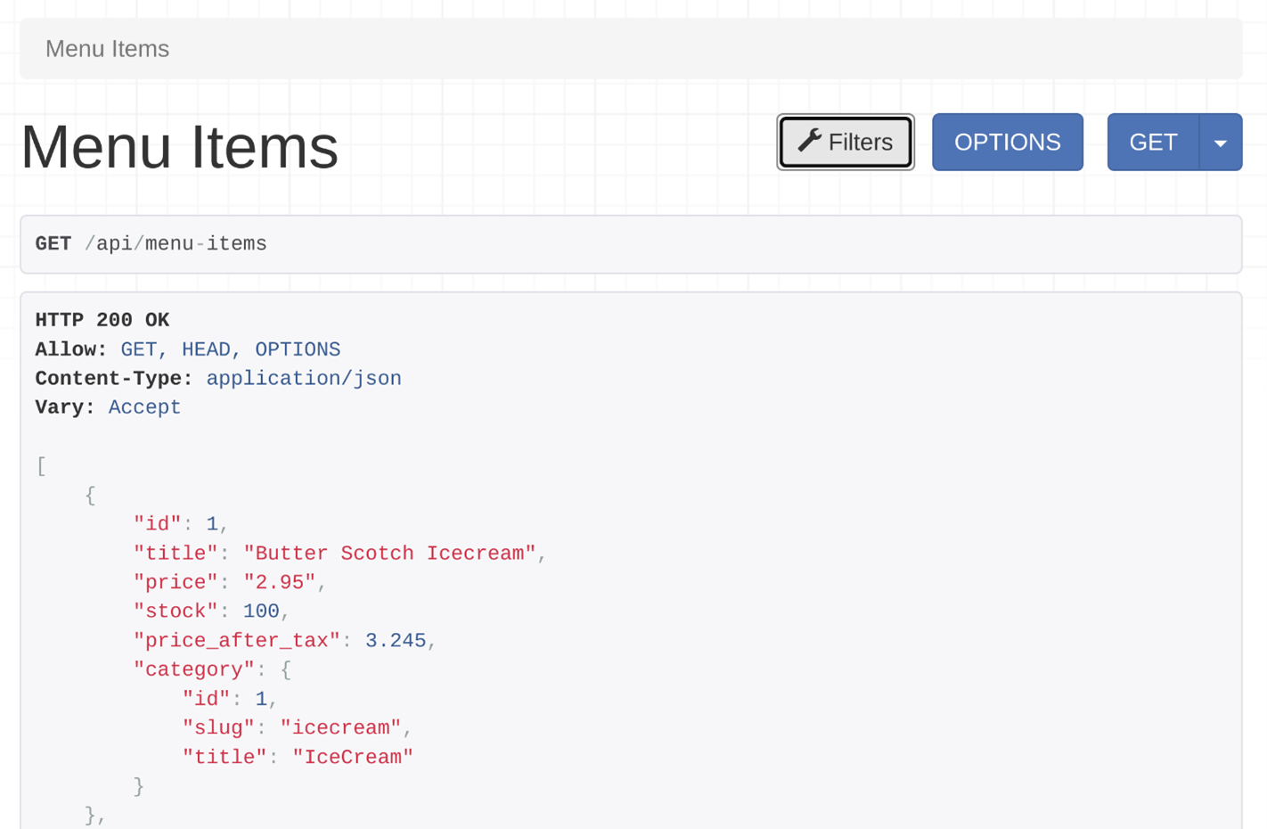

If you click on that button, a popup will appear where you can get the ordering options.

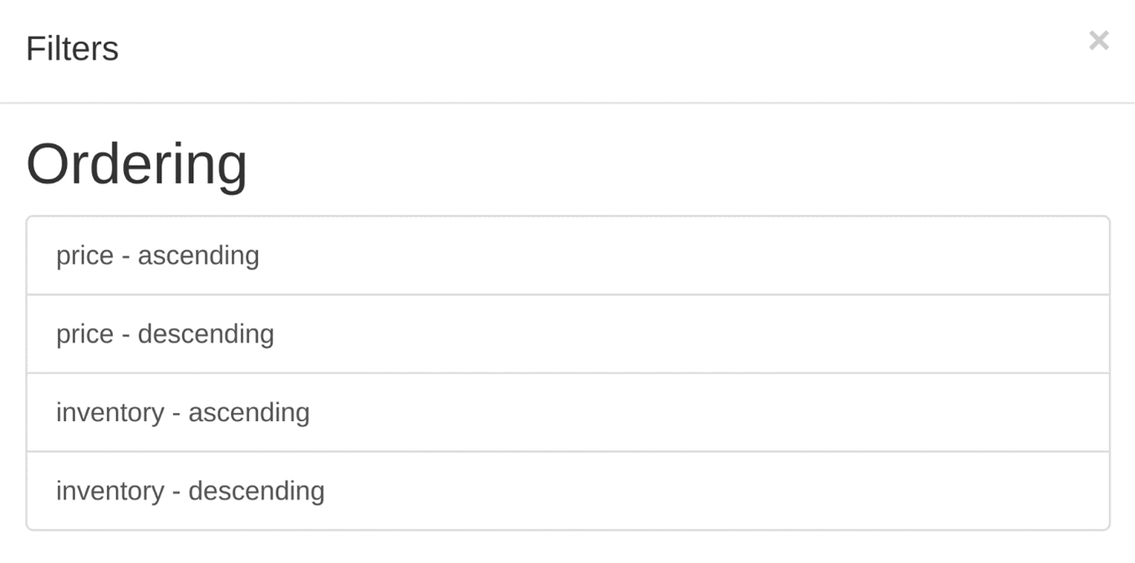

You can click on any of these options to sort the **/api/menu-items** API output by order and inventory in ascending or descending order. You can also sort the output by both fields by using **ordering=price,inventory** query string, like this: **http://127.0.0.1:8000/api/menu-items?ordering=price,inventory**.

**Pagination**

Using DRF’s built-in pagination classes makes paginating the API result very easy. Add these two lines in the **REST\_FRAMEWORK** section in the **settings.py** file.

'DEFAULT\_PAGINATION\_CLASS': 'rest\_framework.pagination.PageNumberPagination',

'PAGE\_SIZE': 2

The **PAGE\_SIZE** property tells DRF how many items to show per page. Now if you were to visit the menu items endpoint you’d notice how the output has been paginated in the browsable API interface, and how the output data format has changed. Under the filter button, there are page numbers as well. Only two records per page show because that’s the setting in the **settings.py** file.

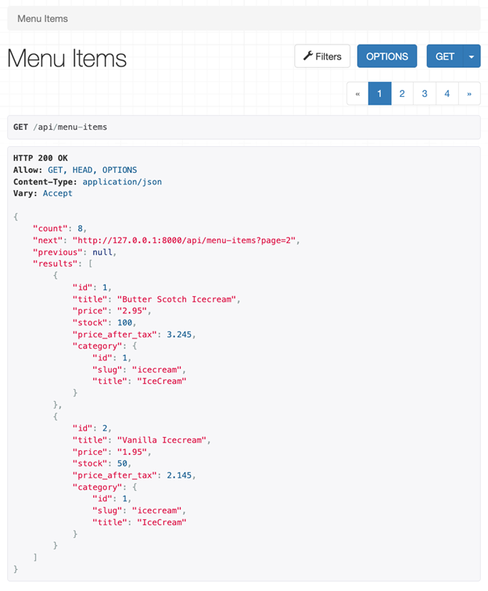

**Search**

You can add search capability so that API clients can search by title field. To do that, you add **search\_fields=['title']** in the **MenuItemsViewSet** class.

class MenuItemsViewSet(viewsets.ModelViewSet):

    queryset = MenuItem.objects.all()

    serializer\_class = MenuItemSerializer

    ordering\_fields=['price','inventory']

    search\_fields=['title']

 When you open the **menu-items** endpoint and click on the filter button there will be a new search field. You can use both ordering and searching together.

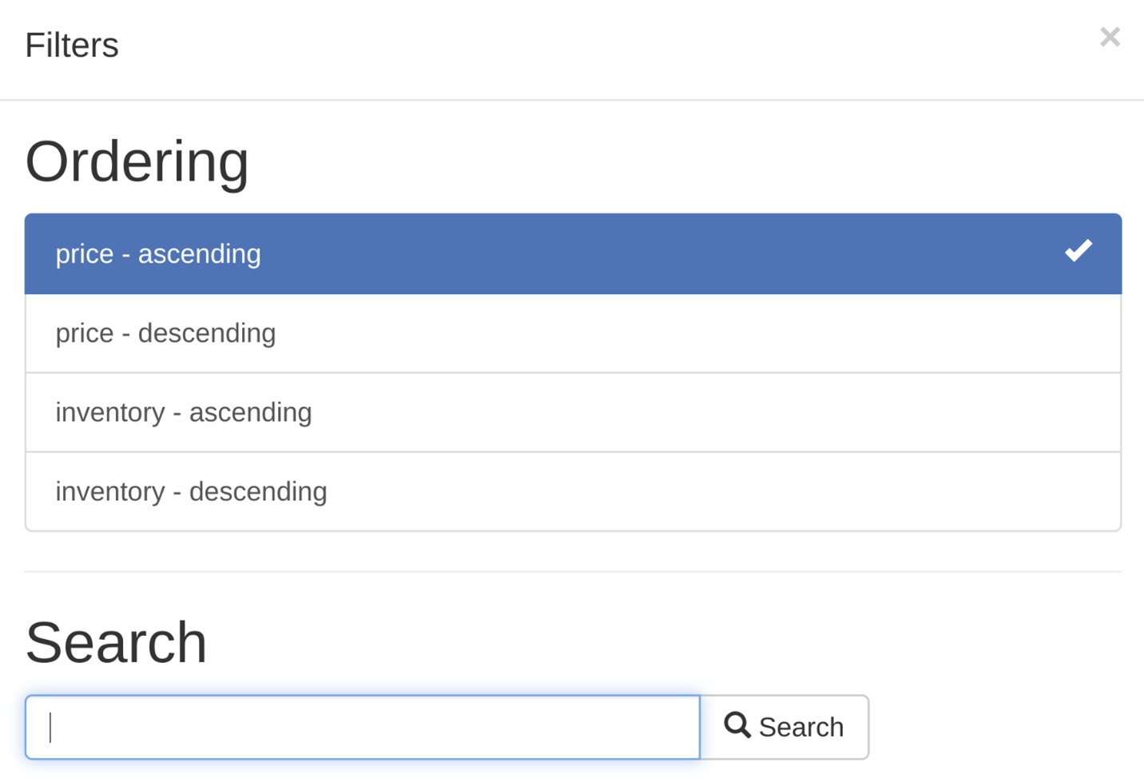

You can type anything, and DRF will search inside the title field and display the output accordingly. The default **lookup\_field** value for searching in DRF is **icontains**. If the client searches for **ILLA** it will match every menu item where the title has **ILLA** in a case-insensitive fashion. So both Vanilla and VANILLA would come up as search results.

**Searching in the nested fields**

What if the API client also wants to search a category title, like **Icecream** or **main**? In the **serializers.py** file, the category was set as a related field to the **MenuItem** model in the **MenuItemSerializer** class, and the clients will be searching in the title field of the category model.

The naming convention for searching in the related model is, **RelatedModelName\_FieldName**. Here, the related model name is **category** and the field name is **title**.   So, to search in the title field of the category model, you need to pass **category\_\_title** in the **search\_fields** list.

class MenuItemsViewSet(viewsets.ModelViewSet):

    queryset = MenuItem.objects.all()

    serializer\_class = MenuItemSerializer

    ordering\_fields=['price','inventory']

    search\_fields=['title','category\_\_title']

By adding these lines of code, the API clients will be able to search for text in both menu item titles and category titles. Notice that the pagination and ordering still work together with the search feature.

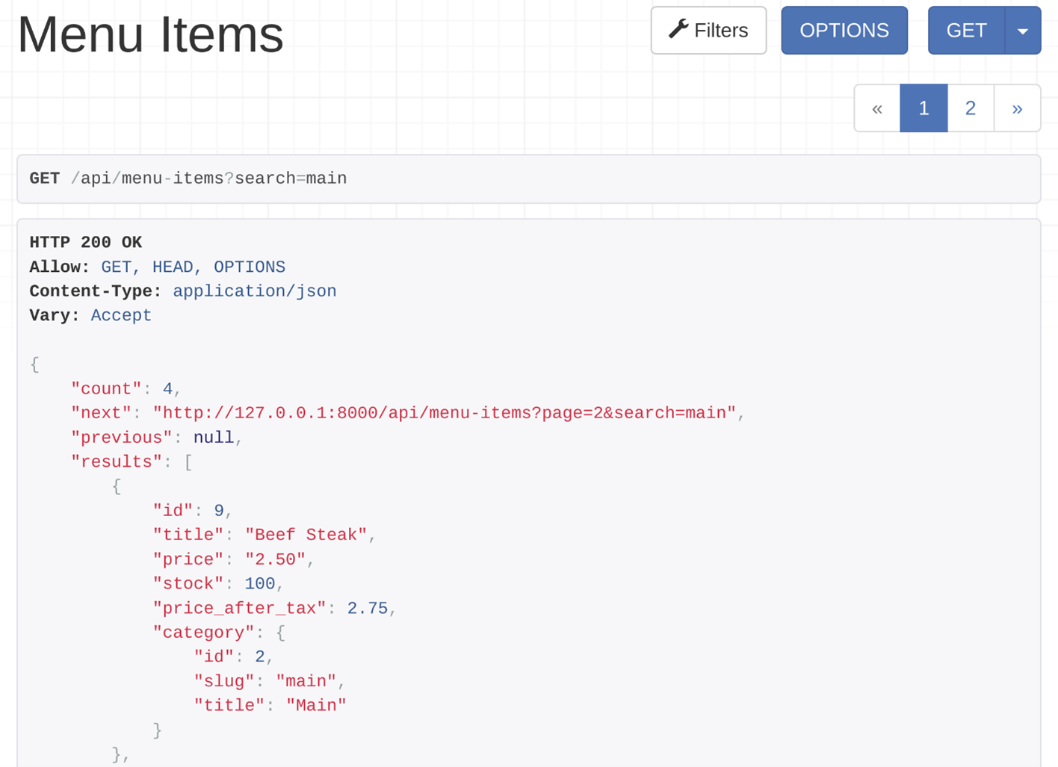

**Conclusion**

In this reading, you learned how to implement complex features like filtering, pagination and searching with just a few lines of code in a class-based view using the built-in filtering and pagination classes in DRF.

**Exercise: Restaurant menu API - filtering, ordering and searching**

Open Lab

**Instructions**

**Goal**

Add functionalities such as pagination, ordering and searching in HTML form using DRF

**Objectives**

* Create HTML forms and add new items
* Add pagination settings for DRF form
* Add filtering options such as ordering and searching

**Introduction**

In this lab, you will create a model called **Category** and another model called **Menu** that has a many-to-one relationship with the model **Category**. You will use DRF to add searching and ordering functionalities. You will also learn how to generate a view consisting of a specific number of items from a table that will be displayed on a page.

**Scenario**

Adrian and Mario are the owners of Little Lemon restaurant and they have a website for their business. While the basic functionalities are already in place, Mario also wants a feature on their website that will help them keep track of their inventory and update the prices of menu items with ease. As a developer hired to update the website, it's your job to help the owners by building this functionality in their website.

**Learner Instructions**

This lab will require you to modify the following files:

* views.py
* serializers.py
* models.py
* settings.py
* urls.py (app-level)

Start the development server on the local host and go to the URL to confirm the desired view is on the webpage.

When required, Open the **Terminal** by selecting **New Terminal** under Terminal in the Menu bar of VS Code.

The Django project called **LittleLemon** and Django app called **LittleLemonDRF** are already in place.

**Note:** Before you begin, make sure you understand how to work with the Coursera Code Lab for the [APIS course](https://www.coursera.org/learn/apis/supplement/WXiq5/working-with-labs-in-this-course).

Follow the instructions below and ensure you check the output at every step.

**Note:** The settings for project level and app level **urls.py** file have already been updated.

**Step 1:**

Open the **models.py** file and create a class called Category inside it and pass models.Model to it as a parameter.

Create the three attributes you need in the model and assign the respective form fields to them. Additionally, pass the following arguments to those form fields.

| **Attribute** | **Form field type** | **Arguments** |
| --- | --- | --- |
| slug | SlugField |  |
| title | CharField | max\_length = 255 |

**Step 2:**

Create another class called MenuItem inside it and pass models.Model to it as a parameter.

Create the three attributes in the model and assign the respective form fields to them.

Additionally, pass the following arguments to those form fields.

| **Attribute** | **Form field type** | **Arguments** |
| --- | --- | --- |
| title | SlugField |  |
| price | CharField | max\_length = 255 |
| inventory | SmallIntegerField | max\_digits=6decimal\_places=2 |

Now add a fourth attribute labeled category and assign to it the value of class models.ForeignKey() with the following arguments passed to it:

* Category
* on\_delete = models.PROTECT
* default = 1

**Step 3:**

Now open the file called **serializers.py** inside the app level **LittleLemonDRF** directory and remove the commenting for all the following lines:

# from rest\_framework import serializers

# from .models import MenuItem, Category

# class CategorySerializer (serializers.ModelSerializer):

#     class Meta:

#         model = Category

#         fields = ['id','title']

**Note:** The import statements required are effectively added. Additionally, class CategorySerializer is already declared and updated with relevant code.

**Step 4:**

Create another class called MenuItemSerializer and pass the class object serializers.ModelSerializer to it as an argument.

**Step 5:**

Inside the MenuItemSerializer class:

* Create a variable called category\_id and assign to it the value of function serializers.IntegerField() with the following argument passed inside the function:
  + write\_only=True
* Create another variable called category and assign to it the value of function CategorySerializer() with the following argument passed inside the function:
  + read\_only=True

**Step 6:**

Now create another class called Meta inside MenuItemSerializer :

* Assign theMenuItemmodel to a variable calledmodel
* Create a variable calledfieldsand assign to it a list of strings with six elements namely:

'id', 'title', 'price', 'inventory', 'category' and 'category\_id'

**Step 7:**

Open the **settings.py** file inside the project-level directory **LittleLemon**.

Locate the code in the screenshot and follow the instructions provided below to update the code.



You will add three configurations inside REST\_FRAMEWORK this time.

1. Create a string'DEFAULT\_FILTER\_CLASSES'and assign a list to it containing the following string items.

* 'rest\_framework.filters.OrderingFilter'
* 'rest\_framework.filters.SearchFilter'

**Note:** Make sure to add a comma after each element added to the list.

1. Create a string like'DEFAULT\_PAGINATION\_CLASS'

* Add a colon ()
* Add another string'rest\_framework.pagination.PageNumberPagination'
* Add a comma ()

1. Create a string'PAGE\_SIZE'

* Add a colon ()
* Add2
* Add a comma ()

**Step 8:**

Open the **views.py** file. Remove the commenting for all the lines below:

# from rest\_framework import generics

# from .models import MenuItem, Category

# from .serializers import MenuItemSerializer, CategorySerializer

# class CategoriesView(generics.ListCreateAPIView):

#     queryset = Category.objects.all()

#     serializer\_class = CategorySerializer

**Note:** All the import statements required are effectively added. Additionally, the class CategoriesView is already declared and updated with the relevant code.

**Step 9:**

Create a class called MenuItemsView and pass generics.ListCreateAPIView to it as an argument.

**Step 10:**

Inside the MenuItemsView class:

* Create a variable called queryset and assign the value of MenuItem.objects.all()
* Create a variable called serializer\_class and assign the value of MenuItemSerializer
* Create a variable called ordering\_fields and assign to it a list that contains two elements:
  + 'price'
  + 'inventory'
* Create a variable called filterset\_fields and assign to it a list that contains two elements:
  + 'price'
  + 'inventory'
* Create a variable called search\_fields and assign to it a list that contains one elements:
  + 'category'

**Note:** Make sure you save all the files that are updated.

**Step 11:**

Open the file **urls.py** and remove the comments for the lines below:

# path('category', views.CategoriesView.as\_view()),

# path('menu-items', views.MenuItemsView.as\_view()),

**Step 12:** Open the **Terminal** in VS Code and run both commands to perform migrations.

**Step 13:**

Once the migrations are performed successfully, run the command to start the server on localhost and go to the URL:

http://127.0.0.1:8000/api/category

**Step 14:** Update the data entries in the form as follows:

**- Title: Main**

**- Title: Desserts**

**- Title: Appetizers**

On updating, the entries should appear as below:

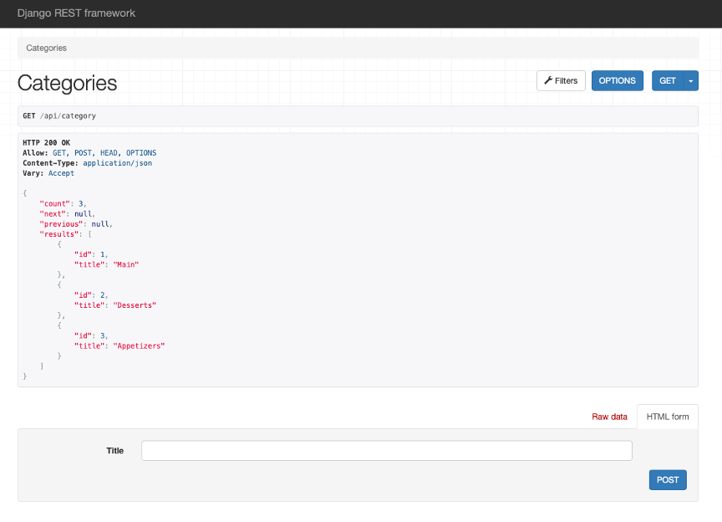

**Note:** Take a note of the id number associated with the category name as you will be using it later.

**Step 15:**

Now go to the URL for **menu-items** by adding the link inside the browser:

http://127.0.0.1:8000/api/menu-items

Now enter the details of the following menu items in the bottom section of the webpage, one at a time:

* Title: Beef Pasta
* Price: 6
* Inventory: 20
* Category: 1
* Title: Tomato Pasta
* Price: 4.00
* Inventory: 15
* Category: 1
* Title: Lemon Dessert
* Price: 4.5
* Inventory: 25
* Category: 2
* Title: Grilled Fish
* Price: 5.5
* Inventory: 10
* Category: 3
* Title: Bruschetta
* Price: 9
* Inventory: 10
* Category: 1
* Title: Greek Salad
* Price: 7.5
* Inventory: 20
* Category: 3
* Title: Cheese sticks
* Price: 5.5
* Inventory: 30
* Category: 3
* Title: Tiramisu
* Price: 6
* Inventory: 28
* Category: 2
* Title: Strawberry Cheesecake
* Price: 6.5
* Inventory: 15
* Category: 2

**[Note for IDs and reviewers: 9 entries to be added in total to be updated later]**

Make sure you add all the entries and click on the upper right-hand corner **Menu Items** for a consolidated view of the items added.

**Step 16:**

Notice the grouping of items that has been performed by DRF and the page numbers that have been added. Each page consists of **2** menu items.

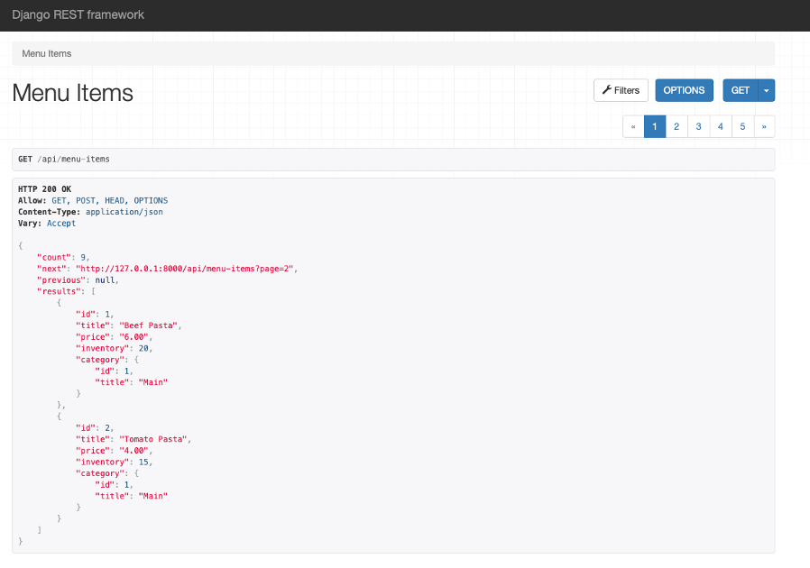

Keep the server running and open the **settings.py** file inside VS Code and go to REST\_FRAMEWORK configuration option you modified earlier.

Update the settings for PAGE\_SIZE from 2 to 3 and save the file.

Refresh the webpage. You should be able to see **3** menu items visible on the webpage this time.

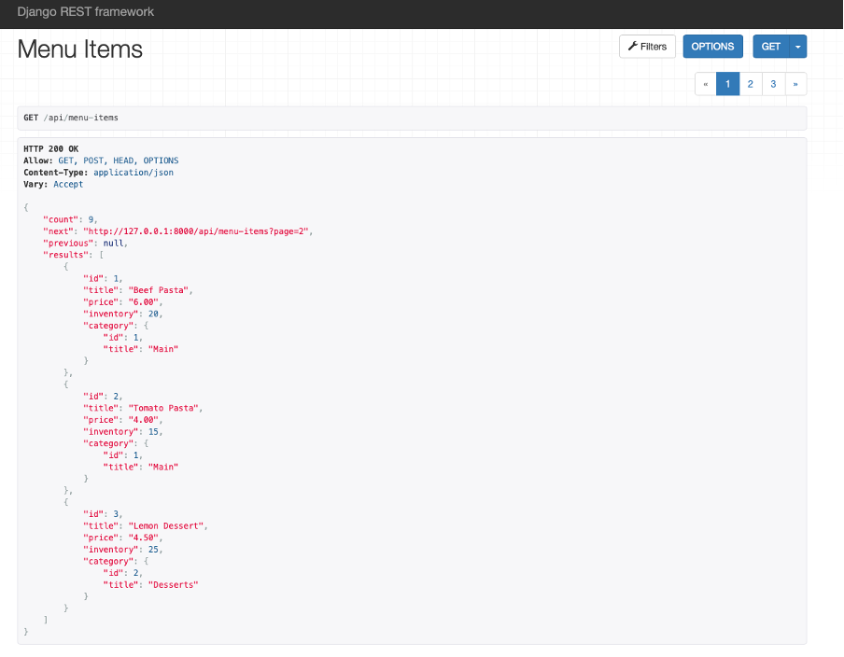

You can navigate the other page numbers displayed on the webpage.

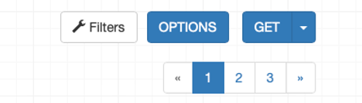

**Step 17:**

Now click on the **Filter** button that you can see on the page and under the options listed, click on the option **price – ascending**.

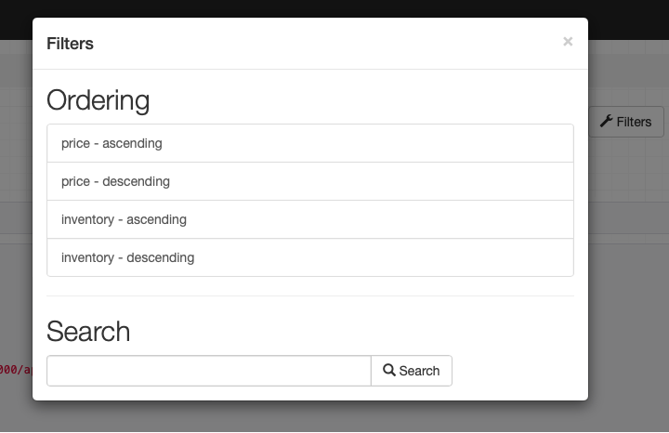

Scroll through the items listed and note the price listed is set to ascending order of value.

You can try different order options from the list and note the changes in the order of the menu items displayed.

**Step 18:**

Click on the **Filter** option again and below the **Search** option, enter the value **"Pasta"** in the text field and click on the Search button to the right.

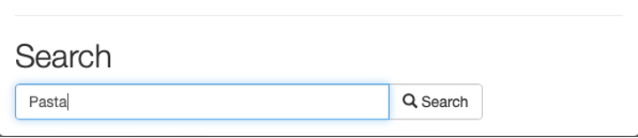

The result displayed should return all the relevant items that contain the substring **"pasta"** inside it.

Notice that the specific total count has also been updated to **2**.

Also, note how the search results displayed are case-insensitive and will return results irrespective of the case used.

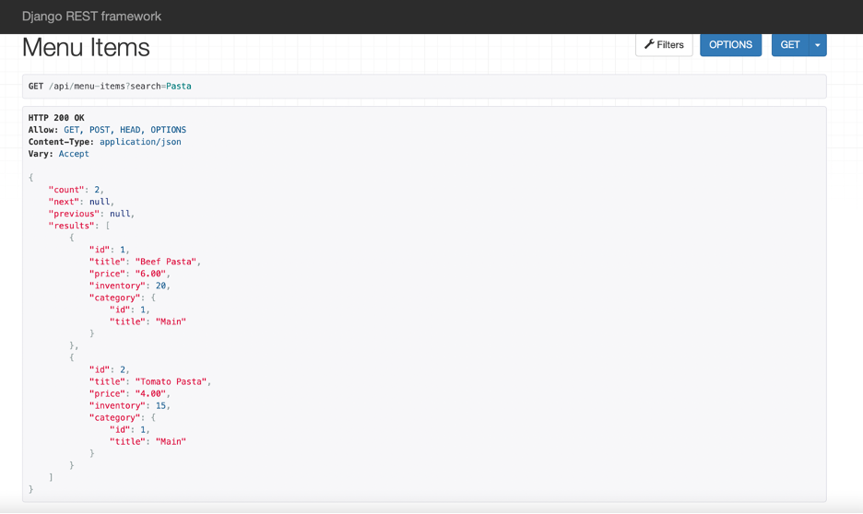

**Step 19:**

Now go to the **Search** option inside the Filter one more time and search for the term **main** inside it.

The count of results displayed this time will be **null.** This shows that the search only displays items present for the options configured inside the view function which in this case will be the 'title' inside the Menu model. The term **main** , which is a type of **category**, will not be a part of the search. Other entries such as entering **4.00** in the search box will also return **null,** as the count with empty list as the result. And will return an empty list showing "count" as **0**.

**Concluding Thoughts**

In this lab, you practiced configuring the settings for pagination in DRF. You have also learned how to add filtering options such as ordering and searching inside the form data. Finally, you used DRF to implement models having a many-to-one relationship.

# Solution: Restaurant menu API - filtering, ordering and searching

## Shell commands

# Activate virtual environment using pipenv

pipenv shell

pipenv install

# Making migrations

python3 manage.py makemigrations

python3 manage.py migrate

## Solution for models.py

from django.db import models

class Category(models.Model):

    slug = models.SlugField()

    title = models.CharField(max\_length=255)

    def \_\_str\_\_(self)-> str:

        return self.title

class MenuItem(models.Model):

    title = models.CharField(max\_length=255)

    price = models.DecimalField(max\_digits=6, decimal\_places=2)

    inventory = models.SmallIntegerField()

    category = models.ForeignKey(Category, on\_delete=models.PROTECT, default=1)

    def \_\_str\_\_(self)-> str:

        return self.title

## Solution for urls.py (App-level)

from django.urls import path

from . import views

urlpatterns = [

    path('categories', views.CategoriesView.as\_view()),

    path('menu-items', views.MenuItemsView.as\_view()),

]

## Solution for views.py

from rest\_framework import generics

from .models import MenuItem, Category

from .serializers import MenuItemSerializer, CategorySerializer

class CategoriesView(generics.ListCreateAPIView):

    queryset = Category.objects.all()

    serializer\_class = CategorySerializer

class MenuItemsView(generics.ListCreateAPIView):

    queryset = MenuItem.objects.all()

    serializer\_class = MenuItemSerializer

    ordering\_fields = ['price', 'inventory']

    filterset\_fields = ['price', 'inventory']

    search\_fields = ['title']

## Solution for serializers.py

from rest\_framework import serializers

from .models import MenuItem, Category

class CategorySerializer (serializers.ModelSerializer):

    class Meta:

        model = Category

        fields = ['id','title']

class MenuItemSerializer(serializers.ModelSerializer):

    category\_id = serializers.IntegerField(write\_only=True)

    category = CategorySerializer(read\_only=True)

    class Meta:

        model = MenuItem

        fields = ['id','title','price','inventory','category','category\_id']

## Relevant solution for settings.py

REST\_FRAMEWORK = {

    'DEFAULT\_FILTER\_BACKENDS': [

        'rest\_framework.filters.OrderingFilter',

        'rest\_framework.filters.SearchFilter',

    ],

    'DEFAULT\_PAGINATION\_CLASS': 'rest\_framework.pagination.PageNumberPagination',

    'PAGE\_SIZE': 3

}

# Additional resources

[Overview of security in Django](https://docs.djangoproject.com/en/4.1/topics/security/)

[Memcached: Open source, high-performance, distributed memory object caching system](https://memcached.org/)

[Redis: Open source, in-memory data store used by developers as a database, cache, streaming engine and message broker](https://redis.io/)

# V7.1

# API throttling for class-based views

## Introduction

You already learned about the basics of rate limiting or throttling earlier in the course. But, in this reading, you will learn how to quickly implement throttling in class-based views. You will also learn about how some real-world services use this API throttling to protect their API endpoints from abuse.

## Project scaffolding

Use a class-based view to extend the **ModelViewSet** to quickly implement a functional CRUD API endpoint for the menu items. To create this class-based view add these lines in the **views.py** file.

from rest\_framework.response import Response from rest\_framework import viewsets from .models import MenuItem from .serializers import MenuItemSerializer

class MenuItemsViewSet(viewsets.ModelViewSet):

    queryset = MenuItem.objects.all()

    serializer\_class = MenuItemSerializer

Open the **urls.py** file and map this **MenuItemViewSet** class to the **menu-items** API endpoint. Map only the **GET** methods.

from django.urls import path

from . import views

urlpatterns = [

    path('menu-items',views.MenuItemsViewSet.as\_view({'get':'list'})),

    path('menu-items/<int:pk>',views.MenuItemsViewSet.as\_view({'get':'retrieve'})),

]

Now you can list all menu items by visiting **http://127.0.0.1:8000/api/menu-items** and any single menu item by visiting **http://127.0.0.1:8000/api/menu-items/1**.

## Add support for throttling

DRF comes with excellent throttling classes that you can use straight out of the box. To do this, add the following lines in the **settings.py** in the **REST\_FRAMEWORK** section.

'DEFAULT\_THROTTLE\_CLASSES': [

        'rest\_framework.throttling.AnonRateThrottle',

        'rest\_framework.throttling.UserRateThrottle'

],

Now you can implement throttling in your API project.

## Throttling for class-based views

Class-based views don’t use the **throttle\_classes** decorator like function-based views. To use throttling, you need to pass the throttle classes to a public class property called throttle\_classes. First import the necessary classes in the **views.py** file.

from rest\_framework.throttling import UserRateThrottle, AnonRateThrottle

Then create a public property called **throttle\_classes** with either one or both of these two classes, **UserRateThrottle** or **AnonRateThrottle**.

class MenuItemsViewSet(viewsets.ModelViewSet):

    throttle\_classes = [AnonRateThrottle, UserRateThrottle]

    queryset = MenuItem.objects.all()

    serializer\_class = MenuItemSerializer

Now the **menu-items** API endpoints will be throttled for both anonymous and authenticated users. You can define the throttling rate for both in the **settings.py** file. If you want to limit the API calls to 5 per minute for anonymous users and 10 per minute for authenticated users, then add the following lines in the **REST\_FRAMEWORK** section, as you learned in a previous video.

'DEFAULT\_THROTTLE\_RATES': {

        'anon': '2/minute',

        'user': '10/minute'

}

To test if the throttling is working properly, go to the **http://127.0.0.1:8000/api/menu-items** endpoint three times. After the second visit, the client will see an error message.

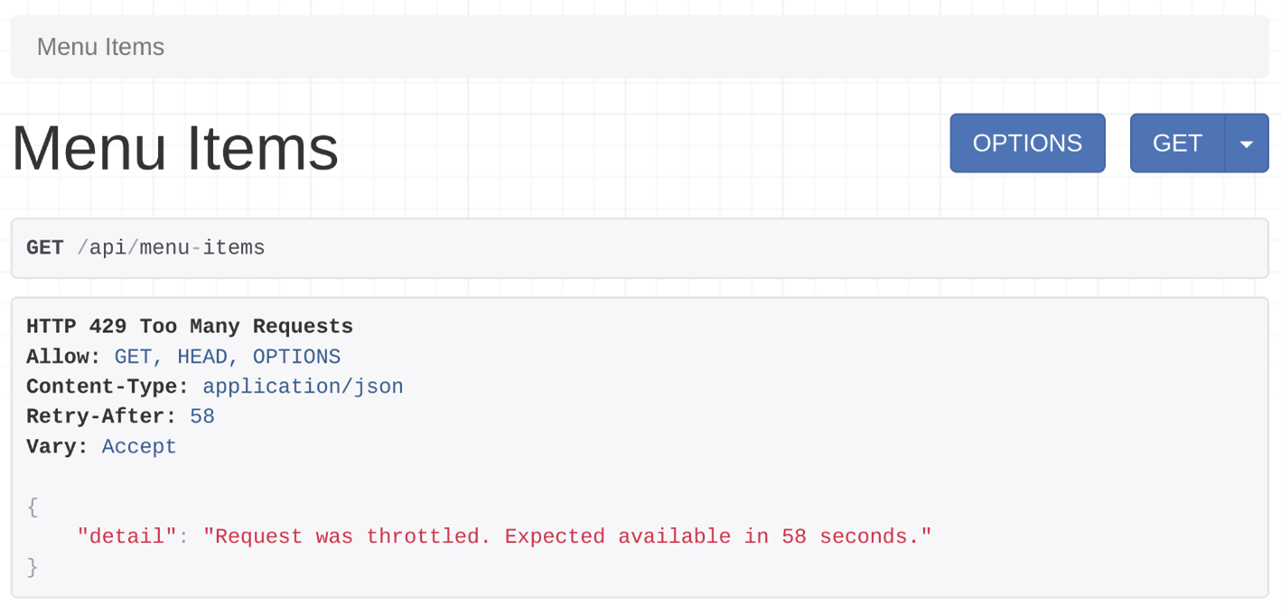

API users with a valid token will see the same message after 10 successful calls to this endpoint.

**Conditional throttling**

It’s very easy to implement conditional throttling in class-based views. With conditional throttling, you can throttle API endpoints only for the specific HTTP methods, like **GET** calls, or **POST** calls.

For example, you can have conditional throttling that throttles **POST** calls, but not **GET** calls. You can do this by overriding the **get\_throttles** method. In a class-based view that extends a **ModelViewSet** class, the **POST** call is handled by **create** methods. Similarly, the **GET** call is handled by the **list** method. Add the following lines of code to implement conditional throttling in the **MenuItemsViewSet** class.

class MenuItemsViewSet(viewsets.ModelViewSet):

    queryset = MenuItem.objects.all()

    serializer\_class = MenuItemSerializer

    def get\_throttles(self):

        if self.action == 'create':

            throttle\_classes = [UserRateThrottle]

        else:

            throttle\_classes = []

        return [throttle() for throttle in throttle\_classes]

**Note**: The **throttle\_classes** is not used as a public attribute this time, which means the following line from the previous code example was removed.

throttle\_classes = [AnonRateThrottle, UserRateThrottle]

Instead, this checks if the router called the **create** action, which handles the **POST** request. If that action is called, implement the throttling class **UserRateThrottle**. The **POST** calls will be limited to 10 calls per minute to this **menu-items** endpoint.

## Custom throttling classes

You can use the custom throttling classes you created earlier in the course, like **TenCallsPerMinute** in the **throttles.py** file. All you have to do is import this class and then add it in the **throttle\_classes** attribute, and you are done.

from .throttles import TenCallsPerMinute

And then

throttle\_classes = [TenCallsPerMinute]

**Real world examples of API rate limits**

Here are some popular services and their current rate limit. This can help you to get some idea of how others are using such features in their API projects.

| **Service** | **Anonymous** | **Authenticated** |
| --- | --- | --- |
| Facebook graph API | X | 200/hour |
| Instagram API | X | 200/hour |
| Instagram messenger API | X | 100/second |
| WhatsApp messaging API | X | 80/second |

**Conclusion**

In this reading, you learned how to implement throttling in class-based views and also how to create conditional throttling.

**Exercise: User account management**

**Goal**

In this exercise, you will use authentication and validation mechanisms inside DRF. You need to do this activity using **VS code** and **Insomnia** on your computer. If you haven't set up your development environment yet, revisit [Installing VS code](NULL), [Setting up tools and environment](https://www.coursera.org/teach/apis/g98MzcdAEeyduw6ktL3Xvw/content/item/supplement/6thhh) and [Create a Django Project using pipenv](https://www.coursera.org/teach/apis/g98MzcdAEeyduw6ktL3Xvw/content/item/lecture/sn2Ez/video-subtitles).

**Objectives**

By the end of this exercise, you will be able to:

* Add form validators to form data
* Perform token and session authentication while using a DRF form
* Use the Djoser and **authtoken** packages for default routes
* Use the Django admin panel for creating new users and tokens

**Introduction**

The Little Lemon website has grown in popularity since it was launched. While there are many benefits to the website, fake reviews are a cause for concern. The owners understand the need for better security for their review system.

You are tasked with adding some measures to prevent the misuse of the review system on the Little Lemon website.

**Instructions**

This lab will require you to modify the following files:

* **views.py**
* **serializers.py**
* **settings.py**
* **admin.py**

You must start the development server on the local host and go to the URL to confirm the desired view on the webpage.

When required, Open the **Terminal** by selecting **New Terminal** under **Terminal** on your **VSCode**.

For your convenience, the Django project called **LittleLemon** and Django app called **LittleLemonDRF** have already been created for you. Download the zip file and save the unzipped content inside a project directory on your local machine. Open the project folder inside VS Code and navigate to the directory containing 'Pipfile' inside your command line. If you are unsure how to set up a Django project reference the optional reading about [Creating a Django project](https://www.coursera.org/teach/apis/g98MzcdAEeyduw6ktL3Xvw/content/item/supplement/oQrdH) which includes all the necessary steps and code snippets.

[User account\_Lab files](https://d3c33hcgiwev3.cloudfront.net/i2GlsblkSBa3vaQw_aC7Yw_17df8a1d0b54427988d738dc7da8bce1_User-account_Lab-files.zip?Expires=1691539200&Signature=WWEPg0iQE4cRYfMMWV2R9MrQDpyYUAf~TfQ35Lqso6EMz-Rde9bQDCNKABvDEEGB252AMJMf~e0HzkvktRkqhltr4MGDclJM3Hzv3P~QprYu1V6hsbeKUvdE42fdwC3ECw94Fhfc9jg6F2apRDY93yLDJijsVHbJHIBUd89orN4_&Key-Pair-Id=APKAJLTNE6QMUY6HBC5A" \t "_blank)

[ZIP File](https://d3c33hcgiwev3.cloudfront.net/i2GlsblkSBa3vaQw_aC7Yw_17df8a1d0b54427988d738dc7da8bce1_User-account_Lab-files.zip?Expires=1691539200&Signature=WWEPg0iQE4cRYfMMWV2R9MrQDpyYUAf~TfQ35Lqso6EMz-Rde9bQDCNKABvDEEGB252AMJMf~e0HzkvktRkqhltr4MGDclJM3Hzv3P~QprYu1V6hsbeKUvdE42fdwC3ECw94Fhfc9jg6F2apRDY93yLDJijsVHbJHIBUd89orN4_&Key-Pair-Id=APKAJLTNE6QMUY6HBC5A" \t "_blank)

 Follow the instructions below and ensure you check the output at every step.

***Note:*** *The settings for project level and app level* **urls.py** *file have already been updated.*

**Initial instructions**

Now run a command on Terminal to initialize the pipenv environment such as:

**pipenv shell**

Open the Pipfile created and ensure the dependencies for the project are already added.

Run a command on the Terminal to install the dependencies such as:

**pipenv install**

**Note:** *You should be able to see the prompt inside the Terminal now has a suffix of round brackets. Follow the steps below to complete the exercise.*

**Step 1:**

Open the **models.py** file and create a class called **Rating** inside it and pass **models.Model** to it as a parameter.

Create the two attributes in the model and assign the respective form fields to them.

Additionally, pass the following arguments to those form fields:

| **Attribute** | **Form field type** | **Arguments** |
| --- | --- | --- |
| **menuitem\_id** | **SmallIntegerField** |  |
| **rating** | **SmallIntegerField** |  |

Now add a third attribute labeled **category** and assign it the value of **models.ForeignKey()** with the following arguments passed to it:

* **User**
* **on\_delete=models.CASCADE**

**Step 2:**

Create a file called **serializers.py** inside the app level **LittleLemonDRF** directory. Add the code below inside the file:

from rest\_framework import serializers

from .models import Rating

from rest\_framework.validators import UniqueTogetherValidator

from django.contrib.auth.models import User

class RatingSerializer (serializers.ModelSerializer):

    user = serializers.PrimaryKeyRelatedField(

    queryset=User.objects.all(),

    default=serializers.CurrentUserDefault()

    )

**Note:** *The import statements required have already been added. Additionally, the class* **RatingSerializer** *is already declared and updated with the relevant code. Take note of the user variable created and the contents of the code because you will be using it.*

**Step 3:**

Create another class called **Meta** inside **RatingSerializer** and add the following code inside the class:

* Assign the **Rating** model to a variable called **model**
* Create a **fields** variable and assign a list to it that contains the following three string elements: **user**, **menuitem\_id** and **rating**

**Note:** *The order of list elements must be maintained.*

* Create a variable called **validators** and assign to it a list that contains:
  + A **UniqueTogetherValidator** class that has the following arguments passed to it:
    - a **queryset** variable that is assigned the value of **Rating.objects.all()**
    - a **fields** variable that contains three list elements that are strings like: **user**, **menuitem\_id** and **rating**
* Create a variable called **extra\_kwargs** that has a dictionary assigned to it containing one item that has the following key-value pair:
  + Key: **rating**
  + Value: A dictionary containing the following two items:
    - **max\_value** as key and **5** as value
    - **min\_value** as key and **0** as value

**Note:** *Make sure you add a comma after the inner dictionary.*

**Step 4:**

Open the **settings.py** file inside the project-level directory **LittleLemon**.

Locate the code in the screenshot and follow the instructions provided below to update the code:

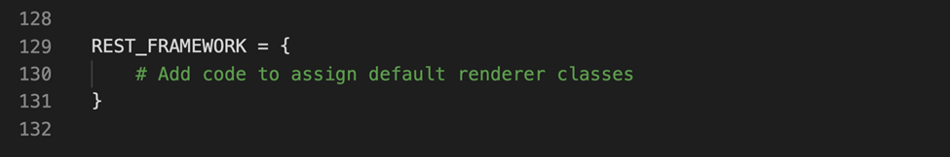

You will be adding three configurations inside the **REST\_FRAMEWORK** this time:

* Create a string called **DEFAULT\_AUTHENTICATION\_CLASSES** and assign a list to it containing the following items:
  + **rest\_framework.authentication.TokenAuthentication**
  + **rest\_framework.authentication.SessionAuthentication**

**Note:** *Make sure you add a comma after every list item.*

**Step 5:**

Now look for the configuration settings for **INSTALLED\_APPS** namespace inside the **settings.py** file and update the list with the following string elements:

* **rest\_framework.authtoken**
* **djoser**

**Note:** *Make sure you add a comma after every new element added to the list.*

**Step 6:**

Open the **views.py** file.

**Note:** *All the import statements required are already added. Additionally, the class* **RatingsView** *is* *already declared and updated with the relevant code.*

Create a function inside the class **RatingsView** called **get\_permissions()** and pass a single argument inside it called **self**.

 Inside the **get\_permissions()** function, add the following code:

if(self.request.method=='GET'):

    return []

return [IsAuthenticated()]

Make sure you save all the files that have been updated.

## Step 7:

Run a command to create a **superuser** in Django.

**Tip:** The command to create a **superuser** in Django is: **python3 manage.py createsuperuser**

 Enter the following details inside the prompts that appear:

* **Username:** admin
* **Email:** admin@littlelemon.com
* **Password:** lemon@789!

## Step 8:

Open the file **urls.py** and remove the commenting for the line below:

# path('ratings', views.RatingsView.as\_view()),

**Step 9:**

Open the **Terminal** in **VS Code** and run both the commands to perform the migrations.

**Step 10:**

Once the migrations are performed successfully, run the command to start the server on the localhost and go to the URL: **http://127.0.0.1:8000/admin**

Enter the details of the credentials for the superuser you have created in **step 8** and log into the Django admin panel. The Django Admin home page should appear as below:

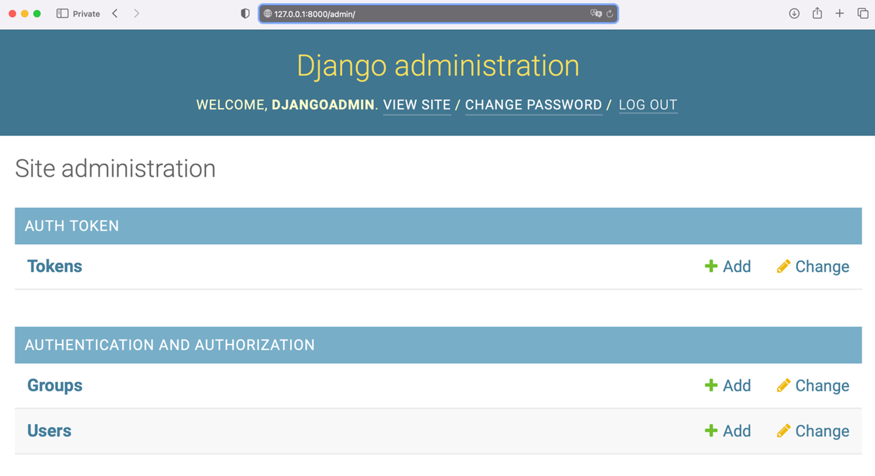

**Step 11:**

Click on **Users** and click on **Add User** again. Enter the following details for the new user:

* **Username:** Adrian
* **Email:** adrian@littlelemon.com
* **Password:** lemon@adr!

 Press the **Save** button and add another user and enter the following details for the second user:

* **Username:** Mario
* **Email:** mario@littlelemon.com
* **Password:** lemon@mar!

 Press the **Save** button once again and add a third user with the following details:

* **Username:** Sana
* **Email:** sana@littlelemon.com
* **Password:** lemon@san!

 Press the **Save** button. Ignore the information on the user details screen that appears and press the **Home** button in the left-hand corner of the page.

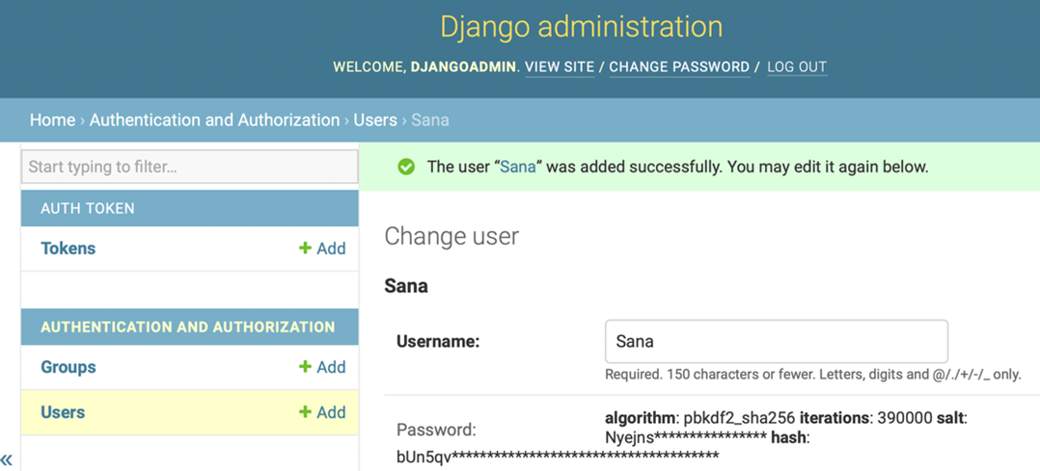

**Step 12:**

Now press the **Tokens** option listed under **Auth Tokens** and press **Add Token**.

**Step 13:**

Select **Adrian** from the dropdown menu and press the **Save** button.

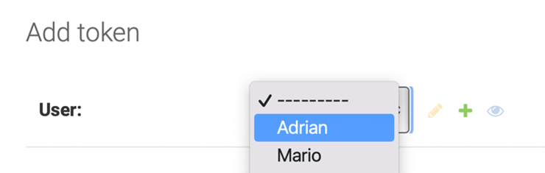

A screen will appear that contains Adrian's details along with a unique **key** generated for him. Follow the same process to generate **tokens** for the users **Mario** and **Sana**. Copy and save these tokens because you will use them later on in **Insomnia.**

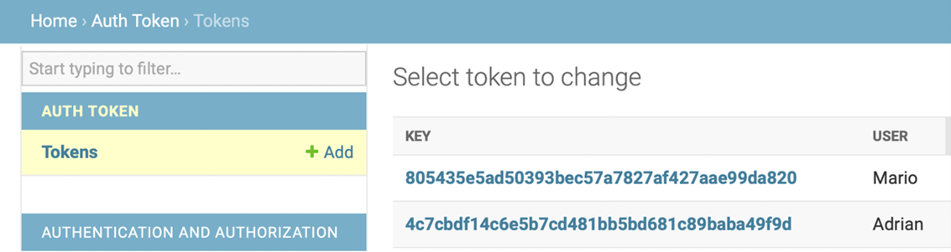

**Step 14:**

Now open the API request client, **Insomnia** and perform the following actions:

* Create a **POST** request to the URL: **http://127.0.0.1:8000/api/ratings**

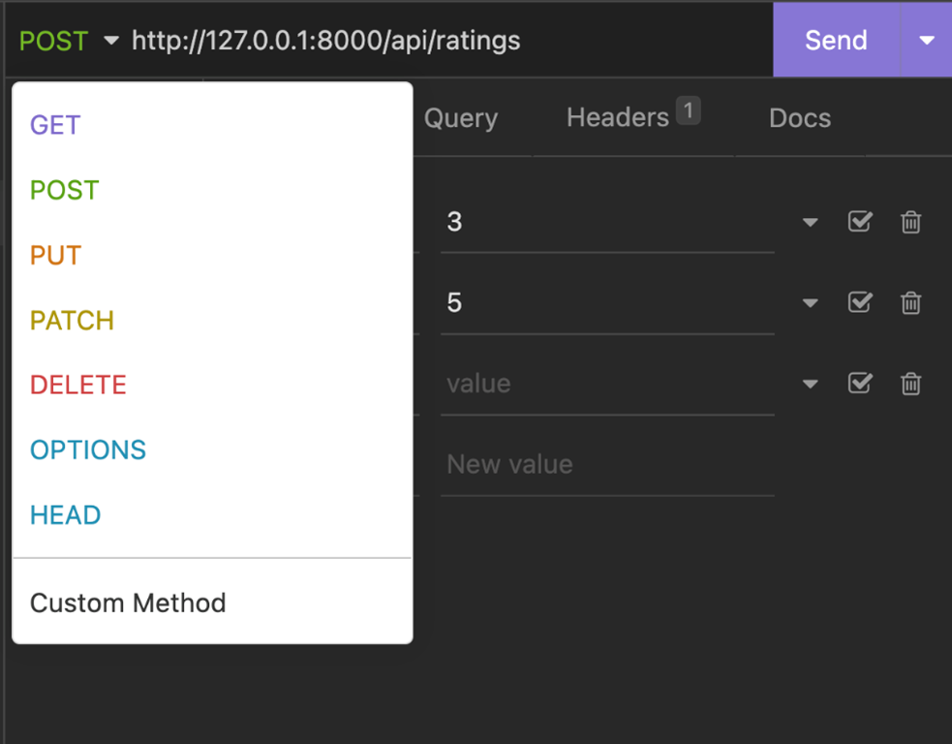

Click on Body and select **FORM URL Encoded** as the data structure.

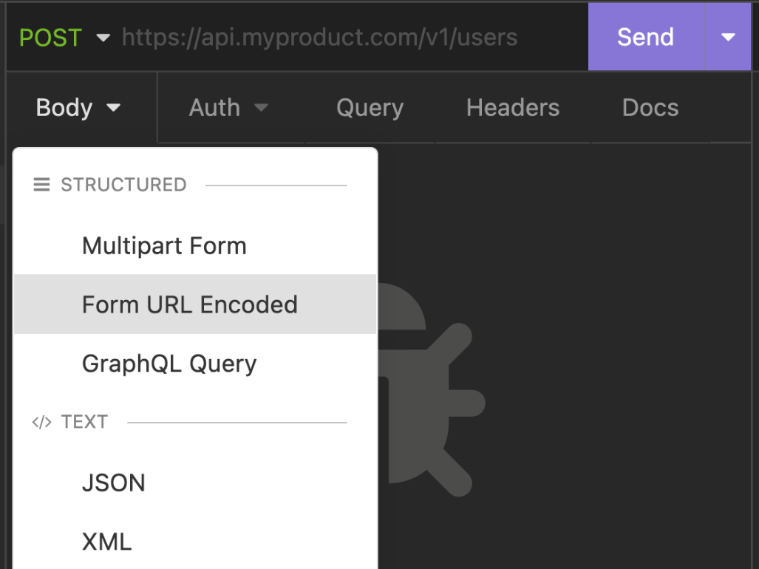

* Add the following details inside it:
  + **menuitem\_id: 3**
  + **rating: 4**

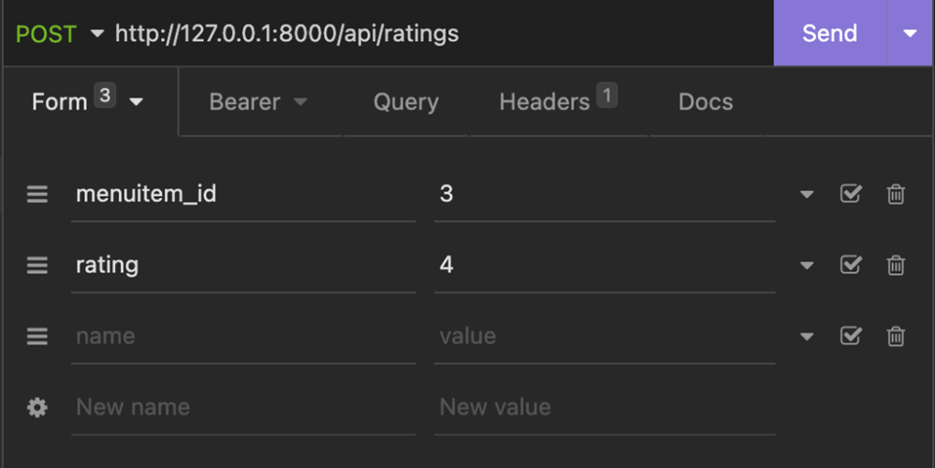

* Under the **Bearer** section add the token value. For example, for **Adrian** ad the token **4c7cbdf14c6e5b7cd481bb5bd681c89baba49f9d**
* Also select the checkbox next to **Enabled** and update the Prefix with the value **Token.**

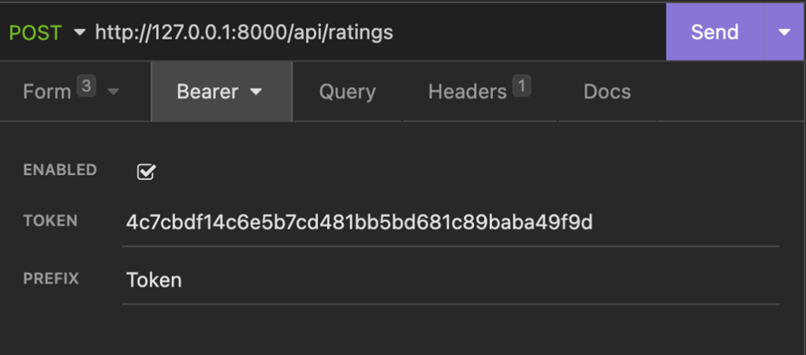

* Press the **Send** button to generate the **POST** request. It will generate JSON output like in the screenshot below.

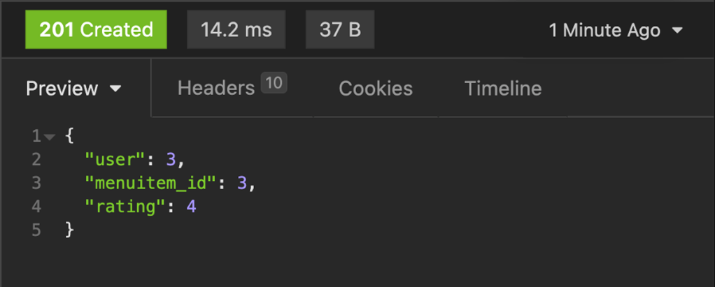

**Step 15:**

Now keep the value of **menuitem\_id** unchanged but change the rating to **5**. It should generate JSON output that is different to before, such as in the screenshot below. The error denotes the throttling limits you have placed on the number of reviews a user can add in a certain amount of time. It means that any given user can add at most one rating for a specific menu item and a unique set must be created for a combination of a user and a menu item.

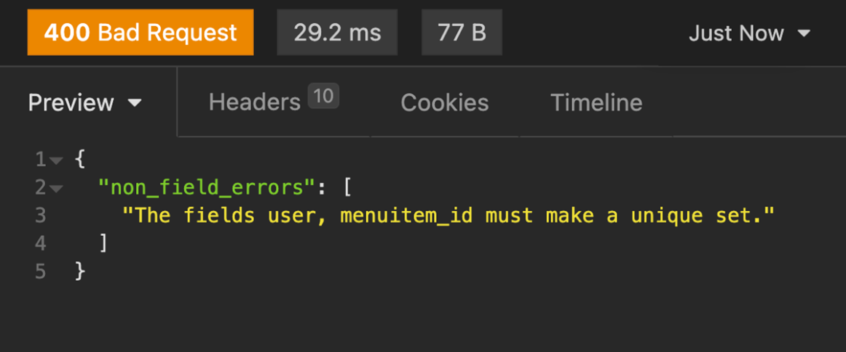

**Step 16:**

Update the **token id** with the user **Sana** and use the same values with which you encountered an error, such as **menuitem\_id** with value **3** and a rating value of **5**. This should update the user review without any issue because it is now a new rating given by another user.

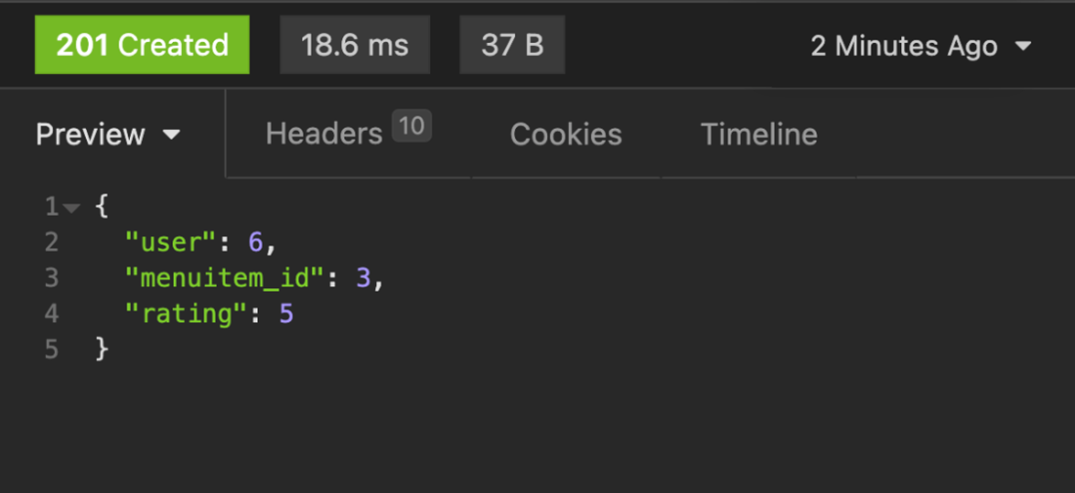

**Step 17:**

Switch the screen and go back to the webpage on your browser with the URL:

**http://127.0.0.1:8000/api/ratings**

 Refresh the page to see if the entries for the reviews are updated.

**Concluding Thoughts**

In this exercise, you learned how to create default routes using Djoser and basic authentication and security mechanisms by implementing throttling functionalities in DRF.

# Solution: User account management

## Shell commands

# Activate virtual environment using pipenv

pipenv shell

pipenv install

# Making migrations

python3 manage.py makemigrations

python3 manage.py migrate

Solution for models.py

from django.db import models

from django.contrib.auth.models import User

class Rating(models.Model):

user = models.ForeignKey(User, on\_delete=models.CASCADE)

menuitem\_id =  models.SmallIntegerField()

rating = models.SmallIntegerField()

Solution for admin.py

from django.contrib import admin

from .models import Rating

# Register your models here.

admin.site.register(Rating)

Solution for urls.py (App-level) from django.urls import path

from . import views

urlpatterns = [

path('ratings', views.RatingsView.as\_view()),

]

Solution for views.py

from rest\_framework import generics

from rest\_framework.permissions import IsAuthenticated

from .models import Rating

from .serializers import RatingSerializer

class RatingsView(generics.ListCreateAPIView):

queryset = Rating.objects.all()

serializer\_class = RatingSerializer

def get\_permissions(self):

    if(self.request.method=='GET'):

        return []

    return [IsAuthenticated()]

Solution for serializers.py

from rest\_framework import serializers

from .models import Rating

from rest\_framework.validators import UniqueTogetherValidator

from django.contrib.auth.models import User

class RatingSerializer (serializers.ModelSerializer):

user = serializers.PrimaryKeyRelatedField(

        queryset=User.objects.all(),

        default=serializers.CurrentUserDefault()

)

class Meta:

    model = Rating

    fields = ['user', 'menuitem\_id', 'rating']

validators = [

    UniqueTogetherValidator(

        queryset=Rating.objects.all(),

        fields=['user', 'menuitem\_id']

    )

]

extra\_kwargs = {

    'rating': {'min\_value': 0, 'max\_value':5},

}

Relevant solution for settings.py

REST\_FRAMEWORK = {

'DEFAULT\_AUTHENTICATION\_CLASSES': (

    'rest\_framework.authentication.TokenAuthentication',

    'rest\_framework.authentication.SessionAuthentication',

),

}

# Additional resources

[Djoser documentation](https://djoser.readthedocs.io/en/latest/)

[Djoser source code](https://github.com/sunscrapers/djoser)

[Simple JWT: A JSON Web Token authentication plugin for the Django REST framework](https://django-rest-framework-simplejwt.readthedocs.io/en/latest/)

[Simple JWT source code](https://github.com/jazzband/djangorestframework-simplejwt)

# V2.1

# Project structure and API routes

## Introduction

This reading is an overview of the scope of the project, all the necessary endpoints, and notes that you will have to implement in the final project. This reading will help you to successfully complete the project so read it carefully and reference it while developing your API project to help you keep on track.

## Scope

You will create a fully functioning API project for the Little Lemon restaurant so that the client application developers can use the APIs to develop web and mobile applications. People with different roles will be able to browse, add and edit menu items, place orders, browse orders, assign delivery crew to orders and finally deliver the orders.

The next section will walk you through the required endpoints with an authorization level and other helpful notes. Your task is to create these endpoints by following the instructions.

## Structure

You will create one single Django app called LittleLemonAPI and implement all API endpoints in it. Use pipenv to manage the dependencies in the virtual environment. Review the video about [Creating a Django Project using pipenv.](https://www.coursera.org/teach/apis/g98MzcdAEeyduw6ktL3Xvw/content/item/lecture/sn2Ez/video-subtitles)

## Function or class-based views

You can use function- or class-based views or both in this project. Follow the proper API naming convention throughout the project. Review the video about [Function- and class-based views](https://www.coursera.org/teach/apis/g98MzcdAEeyduw6ktL3Xvw/content/item/lecture/4BASB/video-subtitles) as well as the video about [Naming conventions](https://www.coursera.org/teach/apis/g98MzcdAEeyduw6ktL3Xvw/content/item/lecture/1jSCM/video-subtitles).

## User groups

Create the following two user groups and then create some random users and assign them to these groups from the Django admin panel.

* Manager
* Delivery crew

Users not assigned to a group will be considered customers. Review the video about [User roles](https://www.coursera.org/teach/apis/g98MzcdAEeyduw6ktL3Xvw/content/item/lecture/12F4H/video-subtitles).

## Error check and proper status codes

You are required to display error messages with appropriate HTTP status codes for specific errors. These include when someone requests a non-existing item, makes unauthorized API requests, or sends invalid data in a **POST**, **PUT** or **PATCH** request. Here is a full list.

| **HTTP Status code** | **Reason** |
| --- | --- |
| **200 - Ok** | For all successful **GET**, **PUT**, **PATCH** and **DELETE** calls |
| **201 - Created** | For all successful **POST** requests |
| **403 - Unauthorized** | If authorization fails for the current user token |
| **401 – Forbidden** | If user authentication fails |
| **400 – Bad request** | If validation fails for **POST**, **PUT**, **PATCH** and **DELETE** calls |
| **404 – Not found** | If the request was made for a non-existing resource |

## API endpoints

Here are all the required API routes for this project grouped into several categories.

### User registration and token generation endpoints

You can use Djoser in your project to automatically create the following endpoints and functionalities for you.

| **Endpoint** | **Role** | **Method** | **Purpose** |
| --- | --- | --- | --- |
| **/api/users** | No role required | **POST** | Creates a new user with name, email and password |
| **/api/users/users/me/** | Anyone with a valid user token | **GET** | Displays only the current user |
| **/token/login/** | Anyone with a valid username and password | **POST** | Generates access tokens that can be used in other API calls in this project |

When you include Djoser endpoints, Djoser will create other useful endpoints as discussed in the [Introduction to Djoser library for better authentication](https://www.coursera.org/learn/apis/lecture/bldmJ/introduction-to-djoser-library-for-better-authentication) video.

## Menu-items endpoints

| **Endpoint** | **Role** | **Method** | **Purpose** |
| --- | --- | --- | --- |
| **/api/menu-items** | Customer, delivery crew | **GET** | Lists all menu items. Return a **200 – Ok** HTTP status code |
| **/api/menu-items** | Customer, delivery crew | **POST**, **PUT**, **PATCH**, **DELETE** | Denies access and returns **403 – Unauthorized** HTTP status code |
| **/api/menu-items/{menuItem}** | Customer, delivery crew | **GET** | Lists single menu item |
| **/api/menu-items/{menuItem}** | Customer, delivery crew | **POST**, **PUT**, **PATCH**, **DELETE** | Returns **403 - Unauthorized** |
|  |  |  |  |
| **/api/menu-items** | Manager | **GET** | Lists all menu items |
| **/api/menu-items** | Manager | **POST** | Creates a new menu item and returns **201 - Created** |
| **/api/menu-items/{menuItem}** | Manager | **GET** | Lists single menu item |
| **/api/menu-items/{menuItem}** | Manager | **PUT**, **PATCH** | Updates single menu item |
| **/api/menu-items/{menuItem}** | Manager | **DELETE** | Deletes menu item |

## User group management endpoints

| **Endpoint** | **Role** | **Method** | **Purpose** |
| --- | --- | --- | --- |
| **/api/groups/manager/users** | Manager | **GET** | Returns all managers |
| **/api/groups/manager/users** | Manager | **POST** | Assigns the user in the payload to the manager group and returns **201-Created** |
| **/api/groups/manager/users/{userId}** | Manager | **DELETE** | Removes this particular user from the manager group and returns **200 – Success** if everything is okay.  If the user is not found, returns **404 – Not found** |
| **/api/groups/delivery-crew/users** | Manager | **GET** | Returns all delivery crew |
| **/api/groups/delivery-crew/users** | Manager | **POST** | Assigns the user in the payload to delivery crew group and returns **201-Created** HTTP |
| **/api/groups/delivery-crew/users/{userId}** | Manager | **DELETE** | Removes this user from the manager group and returns **200 – Success** if everything is okay.  If the user is not found, returns  **404 – Not found** |

## Cart management endpoints

| **Endpoint** | **Role** | **Method** | **Purpose** |
| --- | --- | --- | --- |
| **/api/cart/menu-items** | Customer | **GET** | Returns current items in the cart for the current user token |
| **/api/cart/menu-items** | Customer | **POST** | Adds the menu item to the cart. Sets the authenticated user as the user id for these cart items |
| **/api/cart/menu-items** | Customer | **DELETE** | Deletes all menu items created by the current user token |

## Order management endpoints

| **Endpoint** | **Role** | **Method** | **Purpose** |
| --- | --- | --- | --- |
| **/api/orders** | Customer | **GET** | Returns all orders with order items created by this user |
| **/api/orders** | Customer | **POST** | Creates a new order item for the current user. Gets current cart items from the cart endpoints and adds those items to the order items table. Then deletes all items from the cart for this user. |
| **/api/orders/{orderId}** | Customer | **GET** | Returns all items for this order id. If the order ID doesn’t belong to the current user, it displays an appropriate HTTP error status code. |
| **/api/orders** | Manager | **GET** | Returns all orders with order items by all users |
| **/api/orders/{orderId}** | Customer | **PUT**, **PATCH** | Updates the order. A manager can use this endpoint to set a delivery crew to this order, and also update the order status to 0 or 1.  If a delivery crew is assigned to this order and the **status = 0**, it means the order is out for delivery.  If a delivery crew is assigned to this order and the **status = 1**, it means the order has been delivered. |
| **/api/orders/{orderId}** | Manager | **DELETE** | Deletes this order |
| **/api/orders** | Delivery crew | **GET** | Returns all orders with order items assigned to the delivery crew |
| **/api/orders/{orderId}** | Delivery crew | **PATCH** | A delivery crew can use this endpoint to update the order status to 0 or 1. The delivery crew will not be able to update anything else in this order. |

## Additional step

Implement proper filtering, pagination and sorting capabilities for **/api/menu-items** and **/api/orders** **endpoints**. Review the videos about [Filtering and searching](https://www.coursera.org/teach/apis/g98MzcdAEeyduw6ktL3Xvw/content/item/lecture/h7QUx/video-subtitles) and [Pagination](https://www.coursera.org/teach/apis/g98MzcdAEeyduw6ktL3Xvw/content/item/lecture/mEYFj/video-subtitles) as well as the reading [More on filtering and pagination](https://www.coursera.org/teach/apis/g98MzcdAEeyduw6ktL3Xvw/content/item/supplement/oCL3M).

## Throttling

Finally, apply some throttling for the authenticated users and anonymous or unauthenticated users. Review the video [Setting up API throttling](https://www.coursera.org/teach/apis/g98MzcdAEeyduw6ktL3Xvw/content/item/lecture/rPE4B/video-subtitles) and the reading [API throttling for class-based views](https://www.coursera.org/teach/apis/g98MzcdAEeyduw6ktL3Xvw/content/item/supplement/1h6WO) for guidance.

## Conclusion

Now that you have a better idea of the scope of this project with the essential API endpoints, it’s time to start coding. Good luck!

By working through the lessons in this course, you've learned the necessary skills and knowledge to develop back-end APIs for the Little Lemon project. You were provided with code snippets and your task was to use these, plus any of your own code, to complete an API project for the Little Lemon restaurant.

You will now take part in a peer-review exercise in which you will submit your completed APIs for two of your peers to review. You will also be required to review two of your peers' projects.

Detailed criteria are covered in the grading criteria overview below.

## Review criteria

**less**

When you submit your assignment, other learners in the course will review and grade your work. These are the criteria they’ll use to evaluate your APIs.

In this project, your APIs need to make it possible for your end-users to perform certain tasks and your reviewer will be looking for the following functionalities.

1. The admin can assign users to the manager group

2. You can access the manager group with an admin token

3. The admin can add menu items

4. The admin can add categories

5. Managers can log in

6. Managers can update the item of the day

7. Managers can assign users to the delivery crew

8. Managers can assign orders to the delivery crew

9. The delivery crew can access orders assigned to them

10. The delivery crew can update an order as delivered

11. Customers can register

12. Customers can log in using their username and password and get access tokens

13. Customers can browse all categories

14. Customers can browse all the menu items at once

15. Customers can browse menu items by category

16. Customers can paginate menu items

17. Customers can sort menu items by price

18. Customers can add menu items to the cart

19. Customers can access previously added items in the cart

20. Customers can place orders

21. Customers can browse their own orders

You'll also need to give feedback on and grade the assignments of two other learners using the same criteria.

## Example Submissions

**less**

Here are some examples to help you understand what your assignment should look like.

### **Browsing** menu-items **endpoint using the browser:**

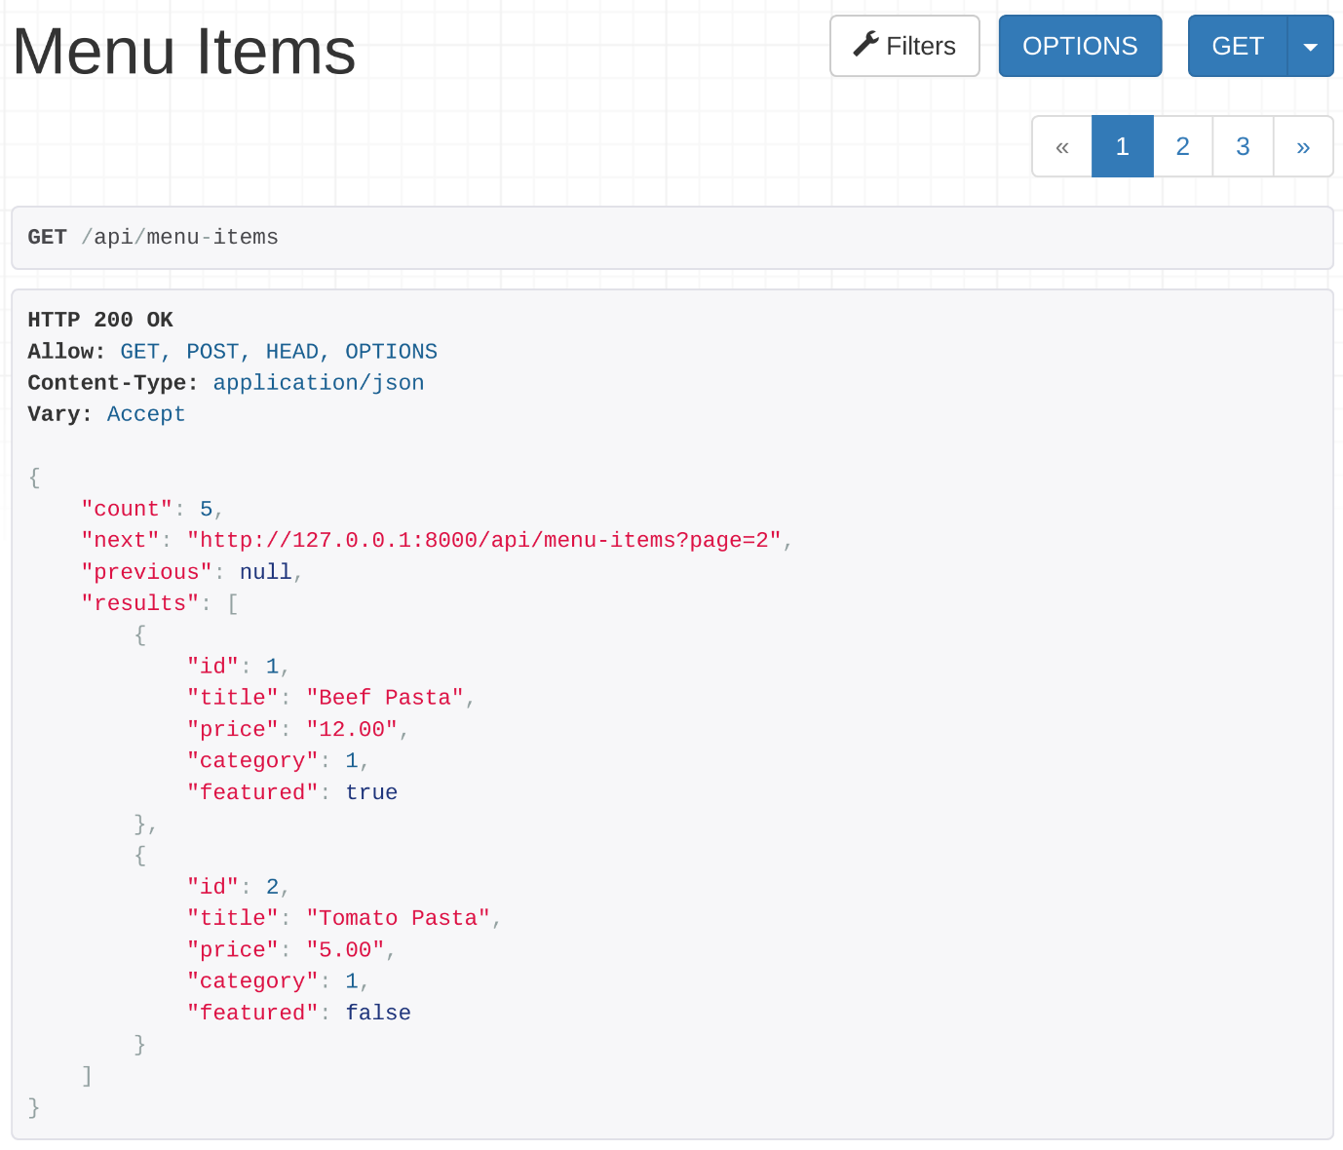

### Making an HTTP GET call to menu-items endpoint:

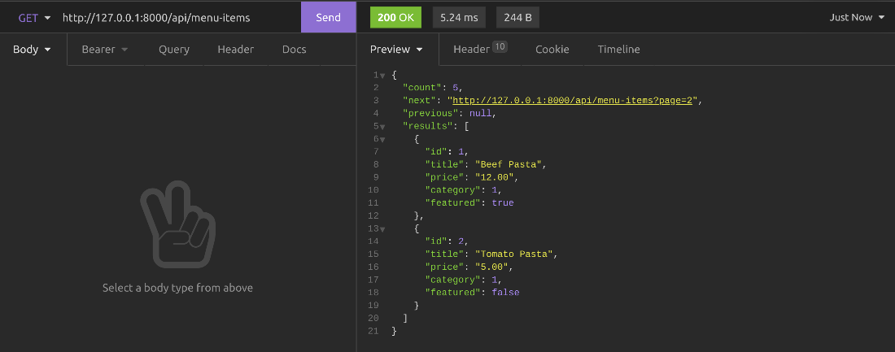

### Adding a user as a manager with admin token:

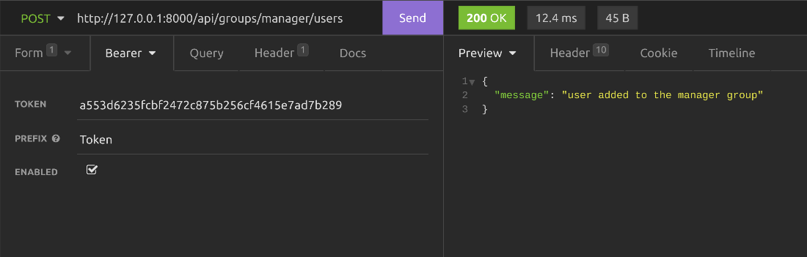

### The HTTP body content to add a user to the manager group with an admin token:

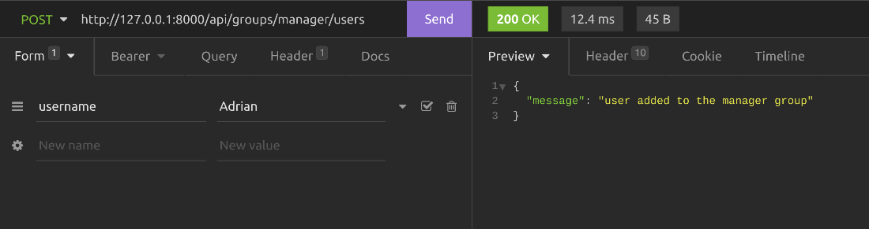

## How to create and submit your assignment

**less**

You need to use pipenv to create the virtual environment and to manage the dependencies.Your APIs should be created using Django, DRF and Djoser. You need to use SQLite as the database for this project. You can develop your APIs using VS Code and test them using your browser or Insomnia.

Name the project directory **LittleLemon** and the app **LittleLemonAPI**. Ensure that you follow this naming convention to make the reviewing process easier.

You will be required to submit your APIs by uploading a zipped folder that contains your code.

**Important note:** Include the sqlite database file db.sqlite3 in your project submission and share the superuser’s username and password of all the other users you have created. Write these usernames and passwords in a notes.txt file and keep it inside the project directory and then zip the project.

To learn more about how to zip and unzip folders visit the [Mac](https://support.apple.com/en-ie/guide/mac-help/mchlp2528/mac) or [Windows](https://support.microsoft.com/en-us/windows/zip-and-unzip-files-f6dde0a7-0fec-8294-e1d3-703ed85e7ebc) support page.

## How to review you peers

**less**

Once you have submitted your file, you are required to review two peer submissions. You can view the peers that you need to review in the “Peers to review” section. You need to download their zipped project folder and unzip it. Then, prepare the virtual environment and install all dependencies using the following commands.

**cd LittleLemon**

**pipenv shell**

**pipenv install**

**python manage.py makemigrations**

**python manage.py migrate**

**python manage.py runserver**

Then log into the Django admin panel and create superuser and user groups and randomly assign them into these groups, the same way you did in your own project.

## Examples of Good Feedback

**less**

The focus of your feedback should be on the functionality of the APIs.

Follow the prompts and look for the expected output. If you notice any errors in the functionality of any of the elements of the APIs, you will have the opportunity to provide guidance to your peers on how they might fix the error.

An example of good feedback would be:

“On the whole, the APIs performed as expected; however, customers couldn’t log in using their username and password and get access tokens. I would suggest reviewing the code you have written to ensure that the Djoser package was installed and configured correctly. You could revisit the video, [**Introduction to Djoser library for better authentication**](https://www.coursera.org/teach/apis/g98MzcdAEeyduw6ktL3Xvw/content/item/lecture/bldmJ/video-subtitles) in Module 3, lesson 2.

# Peer-review solution

## Shell commands

**pipenv shell**

**pipenv install**

**python manage.py makemigrations**

**python manage.py migrate**

**python manage.py runserver**

## Solution for settings.py

REST\_FRAMEWORK = {

    'DEFAULT\_FILTER\_BACKENDS': [

        'rest\_framework.filters.OrderingFilter',

        'rest\_framework.filters.SearchFilter',

    ],

    'DEFAULT\_AUTHENTICATION\_CLASSES': (

        'rest\_framework.authentication.TokenAuthentication',

        'rest\_framework.authentication.SessionAuthentication',

    ),

    'DEFAULT\_PAGINATION\_CLASS': 'rest\_framework.pagination.PageNumberPagination',

    'PAGE\_SIZE': 2

}

## Solution for models.py

from django.db import models

from django.contrib.auth.models import User

class Category(models.Model):

    slug = models.SlugField()

    title = models.CharField(max\_length=255, db\_index=True)

class MenuItem(models.Model):

    title = models.CharField(max\_length=255, db\_index=True)

    price = models.DecimalField(max\_digits=6, decimal\_places=2, db\_index=True)

    featured = models.BooleanField(db\_index=True)

    category = models.ForeignKey(Category, on\_delete=models.PROTECT)

class Cart(models.Model):

    user = models.ForeignKey(User, on\_delete=models.CASCADE)

    menuitem = models.ForeignKey(MenuItem, on\_delete=models.CASCADE)

    quantity = models.SmallIntegerField()

    unit\_price = models.DecimalField(max\_digits=6, decimal\_places=2)

    price = models.DecimalField(max\_digits=6, decimal\_places=2)

    class Meta:

        unique\_together = ('menuitem', 'user')

class Order(models.Model):

    user = models.ForeignKey(User, on\_delete=models.CASCADE)

    delivery\_crew = models.ForeignKey(

        User, on\_delete=models.SET\_NULL, related\_name="delivery\_crew", null=True)

    status = models.BooleanField(default=0, db\_index=True)

    total = models.DecimalField(max\_digits=6, decimal\_places=2, default=0)

    date = models.DateField(db\_index=True)

class OrderItem(models.Model):

    order = models.ForeignKey(

        Order, on\_delete=models.CASCADE, related\_name='order')

    menuitem = models.ForeignKey(MenuItem, on\_delete=models.CASCADE)

    quantity = models.SmallIntegerField()

    price = models.DecimalField(max\_digits=6, decimal\_places=2)

    class Meta:

        unique\_together = ('order', 'menuitem')

## Solution for serializers.py

from rest\_framework import serializers

from django.contrib.auth.models import User

from decimal import Decimal

from .models import Category, MenuItem, Cart, Order, OrderItem

class CategorySerializer (serializers.ModelSerializer):

    class Meta:

        model = Category

        fields = ['id', 'title', 'slug']

class MenuItemSerializer(serializers.ModelSerializer):

    category = serializers.PrimaryKeyRelatedField(

        queryset=Category.objects.all()

    )

    # category = CategorySerializer(read\_only=True)

    class Meta:

        model = MenuItem

        fields = ['id', 'title', 'price', 'category', 'featured']

class CartSerializer(serializers.ModelSerializer):

    user = serializers.PrimaryKeyRelatedField(

        queryset=User.objects.all(),

        default=serializers.CurrentUserDefault()

    )

    def validate(self, attrs):

        attrs['price'] = attrs['quantity'] \* attrs['unit\_price']

        return attrs

    class Meta:

        model = Cart

        fields = ['user', 'menuitem', 'unit\_price', 'quantity', 'price']

        extra\_kwargs = {

            'price': {'read\_only': True}

        }

class OrderItemSerializer(serializers.ModelSerializer):

    class Meta:

        model = OrderItem

        fields = ['order', 'menuitem', 'quantity', 'price']

class OrderSerializer(serializers.ModelSerializer):

    orderitem = OrderItemSerializer(many=True, read\_only=True, source='order')

    class Meta:

        model = Order

        fields = ['id', 'user', 'delivery\_crew',

                  'status', 'date', 'total', 'orderitem']

class UserSerilializer(serializers.ModelSerializer):

    class Meta:

        model = User

        fields = ['id','username','email']

## Solutions for views.py

from rest\_framework import generics

from rest\_framework.permissions import IsAuthenticated

from .models import Category, MenuItem, Cart, Order, OrderItem

from .serializers import CategorySerializer, MenuItemSerializer, CartSerializer, OrderSerializer, UserSerilializer

from rest\_framework.response import Response

from rest\_framework.permissions import IsAdminUser

from django.shortcuts import  get\_object\_or\_404

from django.contrib.auth.models import Group, User

from rest\_framework import viewsets

from rest\_framework import status

class CategoriesView(generics.ListCreateAPIView):

    queryset = Category.objects.all()

    serializer\_class = CategorySerializer

    def get\_permissions(self):

        permission\_classes = []

        if self.request.method != 'GET':

            permission\_classes = [IsAuthenticated]

        return [permission() for permission in permission\_classes]

class MenuItemsView(generics.ListCreateAPIView):

    queryset = MenuItem.objects.all()

    serializer\_class = MenuItemSerializer

    search\_fields = ['category\_\_title']

    ordering\_fields = ['price', 'inventory']

    def get\_permissions(self):

        permission\_classes = []

        if self.request.method != 'GET':

            permission\_classes = [IsAuthenticated]

        return [permission() for permission in permission\_classes]

class SingleMenuItemView(generics.RetrieveUpdateDestroyAPIView):

    queryset = MenuItem.objects.all()

    serializer\_class = MenuItemSerializer

    def get\_permissions(self):

        permission\_classes = []

        if self.request.method != 'GET':

            permission\_classes = [IsAuthenticated]

        return [permission() for permission in permission\_classes]

class CartView(generics.ListCreateAPIView):

    queryset = Cart.objects.all()

    serializer\_class = CartSerializer

    permission\_classes = [IsAuthenticated]

    def get\_queryset(self):

        return Cart.objects.all().filter(user=self.request.user)

    def delete(self, request, \*args, \*\*kwargs):

        Cart.objects.all().filter(user=self.request.user).delete()

        return Response("ok")

class OrderView(generics.ListCreateAPIView):

    queryset = Order.objects.all()

    serializer\_class = OrderSerializer

    permission\_classes = [IsAuthenticated]

    def get\_queryset(self):

        if self.request.user.is\_superuser:

            return Order.objects.all()

        elif self.request.user.groups.count()==0: #normal customer - no group

            return Order.objects.all().filter(user=self.request.user)

        elif self.request.user.groups.filter(name='Delivery Crew').exists(): #delivery crew

            return Order.objects.all().filter(delivery\_crew=self.request.user)  #only show oreders assigned to him

        else: #delivery crew or manager

            return Order.objects.all()

        # else:

        #     return Order.objects.all()

    def create(self, request, \*args, \*\*kwargs):

        menuitem\_count = Cart.objects.all().filter(user=self.request.user).count()

        if menuitem\_count == 0:

            return Response({"message:": "no item in cart"})

        data = request.data.copy()

        total = self.get\_total\_price(self.request.user)

        data['total'] = total

        data['user'] = self.request.user.id

        order\_serializer = OrderSerializer(data=data)

        if (order\_serializer.is\_valid()):

            order = order\_serializer.save()

            items = Cart.objects.all().filter(user=self.request.user).all()

            for item in items.values():

                orderitem = OrderItem(

                    order=order,

                    menuitem\_id=item['menuitem\_id'],

                    price=item['price'],

                    quantity=item['quantity'],

                )

                orderitem.save()

            Cart.objects.all().filter(user=self.request.user).delete() #Delete cart items

            result = order\_serializer.data.copy()

            result['total'] = total

            return Response(order\_serializer.data)

    def get\_total\_price(self, user):

        total = 0

        items = Cart.objects.all().filter(user=user).all()

        for item in items.values():

            total += item['price']

        return total

class SingleOrderView(generics.RetrieveUpdateAPIView):

    queryset = Order.objects.all()

    serializer\_class = OrderSerializer

    permission\_classes = [IsAuthenticated]

    def update(self, request, \*args, \*\*kwargs):

        if self.request.user.groups.count()==0: # Normal user, not belonging to any group = Customer

            return Response('Not Ok')

        else: #everyone else - Super Admin, Manager and Delivery Crew

            return super().update(request, \*args, \*\*kwargs)

class GroupViewSet(viewsets.ViewSet):

    permission\_classes = [IsAdminUser]

    def list(self, request):

        users = User.objects.all().filter(groups\_\_name='Manager')

        items = UserSerilializer(users, many=True)

        return Response(items.data)

    def create(self, request):

        user = get\_object\_or\_404(User, username=request.data['username'])

        managers = Group.objects.get(name="Manager")

        managers.user\_set.add(user)

        return Response({"message": "user added to the manager group"}, 200)

    def destroy(self, request):

        user = get\_object\_or\_404(User, username=request.data['username'])

        managers = Group.objects.get(name="Manager")

        managers.user\_set.remove(user)

        return Response({"message": "user removed from the manager group"}, 200)

class DeliveryCrewViewSet(viewsets.ViewSet):

    permission\_classes = [IsAuthenticated]

    def list(self, request):

        users = User.objects.all().filter(groups\_\_name='Delivery Crew')

        items = UserSerilializer(users, many=True)

        return Response(items.data)

    def create(self, request):

        #only for super admin and managers

        if self.request.user.is\_superuser == False:

            if self.request.user.groups.filter(name='Manager').exists() == False:

                return Response({"message":"forbidden"}, status.HTTP\_403\_FORBIDDEN)

        user = get\_object\_or\_404(User, username=request.data['username'])

        dc = Group.objects.get(name="Delivery Crew")

        dc.user\_set.add(user)

        return Response({"message": "user added to the delivery crew group"}, 200)

    def destroy(self, request):

        #only for super admin and managers

        if self.request.user.is\_superuser == False:

            if self.request.user.groups.filter(name='Manager').exists() == False:

                return Response({"message":"forbidden"}, status.HTTP\_403\_FORBIDDEN)

        user = get\_object\_or\_404(User, username=request.data['username'])

        dc = Group.objects.get(name="Delivery Crew")

        dc.user\_set.remove(user)

        return Response({"message": "user removed from the delivery crew group"}, 200)

## Solution for application urls.py

from django.urls import path

from . import views

urlpatterns = [

    path('categories', views.CategoriesView.as\_view()),

    path('menu-items', views.MenuItemsView.as\_view()),

    path('menu-items/<int:pk>', views.SingleMenuItemView.as\_view()),

    path('cart/menu-items', views.CartView.as\_view()),

    path('orders', views.OrderView.as\_view()),

    path('orders/<int:pk>', views.SingleOrderView.as\_view()),

    path('groups/manager/users', views.GroupViewSet.as\_view(

        {'get': 'list', 'post': 'create', 'delete': 'destroy'})),

    path('groups/delivery-crew/users', views.DeliveryCrewViewSet.as\_view(

        {'get': 'list', 'post': 'create', 'delete': 'destroy'}))

]

## Solution for main urls.py

from django.contrib import admin

from django.urls import path, include

urlpatterns = [

    path('admin/', admin.site.urls),

    path('api/',include('LittleLemonDRF.urls')),

    path('auth/', include('djoser.urls')),

    path('auth/', include('djoser.urls.authtoken')),

]

# Next steps

Congratulations! You've taken another step toward improving your knowledge, skills, and qualifications. By completing this course you've acquired and practiced the core skills needed to write and test APIs. The next course is Full-stack and in it, you'll develop a working knowledge of how to create a full-stack Django app. You’ll start by setting up an environment for a local practical project, and refactoring the front and back-ends of an existing application. You will then have the opportunity to create the front and back-ends of a new application using your full-stack developer skills. Be sure to take the next course. It’s your chance to gain further insight into the world of software development.